Idioms List
The following is an extensive list of 1500+ common English Idioms with their meanings.

Idioms (A)
List of English idioms that start with A.
A Bit Much: More than is reasonable; a bit too much
A Bite at The Cherry: A good opportunity that isn’t available to everyone
A Busy Bee: A busy, active person who moves quickly from task to task.
A Cat Has Nine Lives: Cats seem to get away with dangerous things
A Cat in Gloves Catches No Mice: You can’t get what you need if you’re too careful.
A Cat Nap: A short sleep during the day
A Cold Day In July: (Something that) will never happen
A Cold Fish: Someone who is not often moved by emotions, who is regarded as being hard and unfeeling.
A Cut Above: Slightly better than
A Cut Below: Inferior to; somewhat lower in quality than
A Day Late And A Dollar Short: Too delayed and insignificant to have much effect
A Dog in The Manger: A person who selfishly prevent others from using, enjoying or profiting from something even though he/ she cannot use or enjoy it himself.
A Few Sandwiches Short Of A Picnic: Abnormally stupid, not really sane
A Good Deal: To a large extent, a lot
A Great Deal: To a very large extent
A Guinea Pig: Someone who is part of an experiment or trial
A Hair’s Breadth: A very small distance or amount
A Home Bird: Somebody who prefers to spend his social and free time at home.
A Hundred And Ten Percent: More than what seems to be the maximum
A Lame Duck: A person or enterprise (often a business) that is not a success and that has to be helped.
A Leg Up: An advantage, a boost
A Lemon: A vehicle that does not work properly
A Life Of Its Own: An indepdendent existence
A Little Bird Told Me: I don’t wish to divulge where I got the information
A Little Bird Told Me: I got this information from a source I cannot reveal.
A Little from Column A, a Little from Column B: A course of action drawing on several different ideas or possibilities
A Lone Wolf: Someone who is not very social with other people
A Lot on One’s Plate: A lot to do
A Million and One: Very many
A Notch Above: Superior to; higher in quality
A Penny for Your Thoughts: What are you thinking?
A Penny Saved is A Penny Earned: Every small amount helps to build one’s savings
A Picture Is Worth a Thousand Words: A visual presentation can communicate something very effectively
A Plum Job: An easy and pleasant job that also pays well
A Rare Bird: Somebody or something of a kind that one seldom sees.
A Scaredy-Cat: Someone who is excessively scared or afraid.
A Second Bite At The Cherry: A Second chance to do something
A Sight for Sore Eyes: Someone that you’re pleased to see
A Sitting Duck: A person or object in a vulnerable position that is easy to attack or injure.
A Snowball’s Chance in Hell: Little to no likelihood of occurrence or success
A Stitch in Time Saves Nine: Fix something quickly, because if you don’t, it will just get more difficult to fix
A Stone’s Throw: A very short distance
A Storm in a Teacup: Unnecessary anger or worry about an unimportant or trivial matter
A Tall Order: A difficult task
A Week Is A Long Time In _____: In the field mentioned, the situation may change rapidly
About Time: Far past the desired time
About To: On the point of, occurring imminently
Above And Beyond: More than is expected or required
Above Board: Openly, without deceit. Honestly, reputably.
Above The Law: Exempt from the laws that apply to everyone else.
Above The Salt: Of high standing or honor
Above Water: Not in extreme difficulty. Especially said of finances
Accident Of Birth: Luck in something due to family good fortune
Accident Waiting To Happen: A dangerous way of setting up or organizing something
According To Hoyle: Properly, in accordance with established procedures
Ace In The Hole: A hidden advantage
Ace Up One’s Sleeve: A surprise advantage of which others are not aware.
Acid Test: A crucial event that determines the worth of something
Acknowledge The Corn: Admit to a mistake, especially a small one; point out one’s own shortcomings, or another’s
Acquired Taste: Something one learns to appreciate only after trying it repeatedly
Across The Board: In relation to all categories, for everyone
Across The Pond: On or to the other side of the Atlantic Ocean.
Act High and Mighty: Be arrogant, presume that one is better than others
Act Of Congress: Hard to get, said of authorization
Act One’s Age: To be mature, not childish
Actions Speak Louder Than Words: One’s character and intentions are shown more accurately by one’s actions than by one’s words.
Achilles’ Heel: The weak point of an otherwise powerful person or organization
Add Fuel To The Fire: Worsen already existing tension
Add Insult To Injury: Compound a defeat with humiliation or mockery
Add Insult to Injury: Humiliate someone in addition to doing damage to him or her
After One’s Own Heart: Similar in a pleasing way
After The Fact: Too late; after something is completed or finalized
After The Lord Mayor’s Show (UK): Anticlimactic; occurring after something impressive
Against The Clock: Forced to hurry to meet a deadline
Against the Clock: In a very limited amount of time; with a shortage of time being the main problem
Against The Grain: Contrary to one’s natural inclinations
Against The Run Of Play: A typical of the way a game has been going
Age Before Beauty: Something said by a younger woman to an older one, for instance allowing her to pass through a doorway
Agree To Disagree: Accept or set aside a disagreement
Agreement In Principle: In a negotiation, an agreement in which not all details have been worked out
Aha Moment: Sudden realization, the point at which one suddenly understands something
Ahead Of One’s Time: Offering ideas not yet in general circulation; highly creative
Ahead Of The Curve: Innovative, devising new ideas in advance of others
Ahead Of The Curve: Offering ideas not yet in general circulation; highly creative
Ahead Of The Game: Making faster progress than anticipated; ahead of schedule
Air Rage: Angry behavior inside an airplane
Airy Fairy: whimsical, nonsensical, impractical
Albatross Around One’s Neck: Something from one’s past that acts as a hindrance
Alive and Kicking: In good health despite health problems
All Along: For the entire time something has been happening
All And Sundry: Everyone(separately) Each one.
All Bark And No Bite: Tending to make verbal threats but not deliver on them
All Bets Are Off: What seemed certain is now unclear
All Dressed Up And Nowhere To Go: Prepared (with clothing or otherwise) for an event that does not occur
All Ears: Listening willingly, waiting for an explanation
All Eyes And Ears: Attentive
All Eyes Are On: Watching alertly or attentively. Having prominent eyes. Everyone is paying attention to
All Fur Coat And No Knickers: Superficially attractive, physically or otherwise
All Hands on Deck: Everyone must help.
All Hat And No Cattle: Pretentious, full of bluster
All Hell Breaks Loose: The situation becomes chaotic.
All In A Day’s Work (Excl.): That’s what I’m here for; although I have accomplished something, it is part of what I’m expected to do
All In Good Time: Eventually; at a more favorable time in the future. This phrase encourages one to be patient.
All in One Piece: Safely
All It’s Cracked Up To Be: As good as claims or reputation would suggest
All Mouth And No Trousers: Superficial, engaging in empty, boastful talk, but not of real substance
All Over But The Shouting: Certain to end in a specific way
All Over Hell’S Half Acre: All over the place; everywhere.
All Over The Board: Everywhere, in many different locations
All Over The Map: Everywhere; in many different locations
All Over The Place: Everywhere; in many different locations
All Rights Reserved: Said of a published work; all reproduction rights are asserted by the copyright holder
All Roads Lead to Rome: There is more than one effective way to do something; many different methods will produce the same result
All Set: Ready, prepared, finished
All Sizzle And No Steak: Failing to live up to advance promotion or reputation
All Talk and No Trousers: Prone to empty boasts
All Told: With everything taken into consideration
All That Jazz: Similar things, similar qualities, et cetera
All The Marbles: The entire prize or reward
All The Rage: Very fashionable
All the Rage: Very much in fashion
All The Same: Anyway; nevertheless; nonetheless.
All The Tea In China: Great wealth, a large payment
All Things Being Equal: In the event that all aspects of a situation remain the same
All Things Considered: Taking all factors into consideration
All Thumbs: Clumsy
All Very Well: True to a certain extent
All Wet: Completely mistaken
Along The Lines Of: In general accordance with, in the same general direction as
Amateur Hour: A display of incompetence
Amber Gambler: Someone who accelerates to try to cross an intersection before a traffic light turns red
Amber Nectar: Beer
American Dream (The): The belief among Americans that hard work leads to material success
An Apple a Day Keeps the Doctor Away: Eating healthy foods will keep one from getting sick (and needing to see a doctor)
An Axe: To Grind A grievance, a disagreement with someone that justifies confrontation.
An Early Bird: A person who gets up early in the morning, or who starts work earlier than others.
An Eye for an Eye: Justice in which reparation or vengeance exactly matches the harm caused to the victim
An Offer One Can’t Refuse: An extremely attractive offer
Ancient History: Something, such as a disagreement, that happened long ago and ought to be forgotten
And All That: Et cetera, and so on.
And Counting: And the number just mentioned is increasing (or decreasing)
And Change: And an additional amount of money that’s less than the next round number
And His Mother: An intensifier for an inclusive noun or phrase such as everyone, everybody
And So Forth: Indicates that a list continues in a similar manner, etc.
And So On: Indicates that a list continues in a similar manner, etc.
And The Like: And other similar items, etc.
And Then Some: And even more than what has just been mentioned
Another Nail In One’s Coffin: Something that leads to someone’s death, literally or figuratively.
Answer Back: Respond impertinently; to talk back.
Ants In Your Pants: Restlessness
Any Port in a Storm: If you’re in trouble, you’ll turn to anything that improves the situation.
Any Tom, Dick or Harry: Any ordinary person
Angel’s Advocate: Someone who takes a positive outlook on an idea or proposal
Angle For: Aim toward something, try to obtain something, often indirectly or secretly
Apple of One’s Eye: A favorite person or thing, a person especially valued by someone
Apple of Someone’s Eye: The person that someone loves most of all and is very proud of
Apples and Oranges: Of two different classes, not comparable
Apples and Oranges: Of two different classes, not comparable
Arm Candy: An attractive woman accompanying a powerful or famous man at a social event
Armed to the Teeth: Carrying many weapons
Around the Clock: At all times
As American as Apple Pie: Very or typically American
As Far as I Can Throw (someone): Only slightly
As Fit as A Fiddle: To be healthy and physically fit
As Pale as A Ghost: Extremely pale
As Pale as Death: Extremely pale
As Poor as a Church Mouse: Very poor
As Red as A Cherry: Very red
Asleep at the Wheel (Switch): not paying attention to one’s work; not doing one’s job diligently.
At Death’s Door: Very near death
At Each Other’s Throats: Constantly and strongly arguing
At Loggerheads: In a state of persistent disagreement
At Loggerheads: In a state of persistent disagreement.
At Sixes and Sevens: Someone is in a state of confusion or not very well organized.
At the Drop of a Hat: Spontaneously, suddenly
At the Eleventh Hour: It happens when it is almost too late.
At the End of One’s Rope (Tether): Running out of endurance or patience
At the End of the Day: In the final analysis; when all is said and done
At Wit’s End: Frustrated because all measures to deal with something have failed
List of Common English Idioms – Image 1
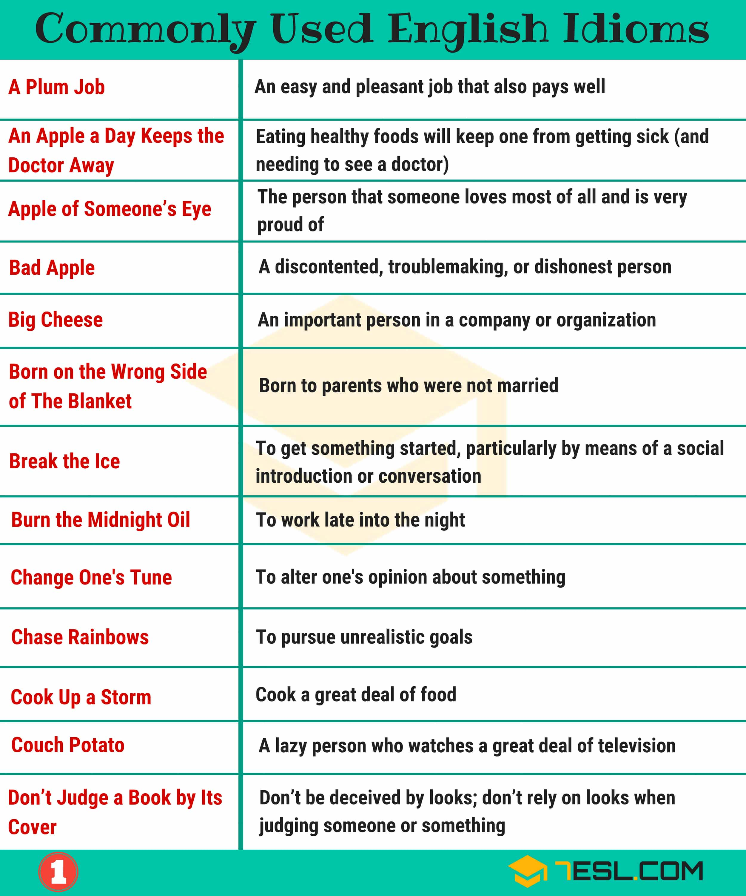Pin

Idioms (B)
List of English idioms that start with B.
Babe In Arms: A baby being carried
Babe In The Woods: An innocent, naive person
Babe Magnet: A man to whom women are attracted
Baby Blues: Blue eyes.
Baby Boomer: A person born in the years following World War II, when there was a temporary marked increase in the birth rate
Babysitter Test: An evaluation of the ease of use of household appliances, especially remote control devices
Back And Forth: Dialogue, negotiations
Back At You: Same to you (used to return a greeting or insult)
Back Burner (On The): Not urgent; set aside until later
Back Forty: Remote, inaccessible land
Back in the Day: Formerly, when I was younger, in earlier times
Back Of Beyond: A remote location
Back Office: Support services for a business
Back on One’s Feet: Physically healthy again
Back to Square One: Back to the start
Back to Square One: Forced to begin something again
Back to the Drawing Board: Forced to begin something again
Back to the Salt Mine(s): We have to go back to work.
Back to the Salt Mines: It’s time for me (us) to go back to work
Back the Wrong Horse: To support the losing side
Backing and Filling: Delaying a decision by making small changes or arguing about small details
Backseat Driver: A passenger in a car who gives unwanted advice to the driver is called a backseat driver.
Backseat Driver: Someone who likes to give (often annoying) advice to the driver of a car, or the leader of some other enterprise
Bad Apple: A discontented, trouble making, or dishonest person
Bad Blood: Enmity or hatred that stems from something in the past
Bad Egg: Someone who is not to be trusted
Bad Taste In One’s Mouth: Unease, a feeling that something unspecified is wrong in a situation
Bag of Tricks: A set of methods or resources
Bail Out: To rescue someone from a bad situation, to shield someone from the consequences of his or her actions
Ball and Chain: 1. One’s spouse (derogatory but often affectionate); 2. an ongoing burden
Ballpark Figure: A rough estimate
Banner Year: A year marked by strong successes
Bang for Your Buck: Value for money
Bang for Your Buck: Value for your money
Bang One’s Head Against the Wall (Against a Brick Wall):Try repeatedly to do something without making progress
Baptism by Fire: A difficult task given right after one has assumed new responsibilities
Bar Fly (or Barfly): Someone who spends much of his or her time in bars
Bare One’s Heart (Soul): To confess one’s deepest secrets
Bark Up the Wrong Tree: Pursue a mistaken approach or belief; be wrong in a course of action
Basket Case: So upset or stunned that one is unable to function; in a hopeless condition
Bat/Play for Both Teams: To be bisexual.
Bat/Play for the Other Team: To be homosexual.
Batten Down the Hatches: Prepare for a storm
Batten Down the Hatches: Prepare for a storm
Be A Barrel of Laughs: To be fun, funny, and pleasant.
Be A Cold Day In Hell: (Something that) will never happen
Be An Item: Two people are an item when they are having a romantic relationship
Be Footloose and Fancy-Free: To be free of responsibilities, including romantic commitments
Be Head Over Heels (In love): Be in love with somebody very much
Be in Seventh Heaven: Extremely happy
Be in Two Minds (about something): To not be certain about something, or to have difficulty in making a decision
Be Like Chalk and Cheese: Things or people who are very different and have nothing in common
Be Lovey – Dovey: Expressing your love in public by constantly kissing and hugging
Be on the Mend: Be improving after an illness
Be Snowed Under: Be extremely busy with work or things to do
Bean Counters: Accountants, finance professionals in an organization
Bean Counters: Accountants, finance professionals in an organization
Beat Around the Bush: To speak in a roundabout way in order to avoid confronting an unpleasant topic
Beat Someone To The Draw: To accomplish or obtain something more quickly than someone else
Beat Someone to the Punch: Do something before or faster than someone else
Beat the Drum for (Something): Speak in favor of something to try to generate support
Beauty Is Only Skin Deep: External appearance is a superficial basis for judging someone
Bed of Roses: A comfortable situation
Bedroom Eyes: An expression of the eyes that seems to invite sex
Bee in One’s Bonnet: Someone who has a bee in their bonnet has an idea which constantly occupies their thoughts.
Beggar Thy Neighbor: To do something beneficial for oneself without worrying about how it affects others
Behind the Eight (or 8) Ball: At a serious disadvantage
Behind the Scenes: In a way not apparent to the public
Behind the Times: Old-fashioned
Bell the Cat: Take on a difficult or impossible task
Bells And Whistles: Attractive but unnecessary features of a product
Belly Laugh: Loud, hearty laughter
Bend an Elbow: Drink alcoholic beverages at a tavern
Best (Greatest) Thing Since Sliced Bread: An innovative development
Best of Both Worlds: Combining two qualities that are usually separate
Bet One’s Bottom Dollar (On Something): Be certain that something will happen
Bet the Farm: Risk everything; spend all one’s money on something in hopes of success
Better late Than Never: It implies that a belated achievement is better than not reaching a goal at all.
Between a Rock and a Hard Place: Caught between two undesirable options
Between the Devil and the Deep Blue Sea: In a difficult position
Beyond the Pale: Too morally or socially extreme to accept
Beyond the Shadow of a Doubt: Absolutely certain
Big Apple: An informal name for New York City
Big Brother: Government, viewed as an intrusive force in the lives of citizens; government spying
Big Cheese: An important person in a company or organization
Big Deal: An important event or accomplishment
Big Fish: An important person
Big Picture: A wide perspective; a broad view of something
Big time: If you do something big time, you do it to a great degree.
Birds of a Feather: People having similar characters, backgrounds, interests, or beliefs.
Bird’s-Eye View: A view from above; a broad perspective on something
Bite Off More Than You Can Chew: Try to do more than one is capable of doing
Bite the Bullet: To do something even though it involves pain, discomfort, or difficulty
Bite the Hand That Feeds You: Act badly toward someone who has helped you
Bitter Pill to Swallow: An unpleasant fact that one must accept
Black and White: A clear distinction between good and bad, positive and negative
Black Eye: A mark of shame
Black Sheep: A person who does not fit into a group, especially a family
Black-and-Blue: Bruised, showing signs of having been physically harmed
Blank Check: Permission to spend or do whatever one wishes; carte blanche
Blind Date: When two people who have never seen each other before go on a date
Blinded by Love: When a person is so madly in love with somebody that they can’t see the person’s faults or negative characteristics
Blood and Thunder: A dramatic, spectacular performance
Blow Away the Cobwebs: If something blows away the cobwebs, it makes you feel more lively and refreshes your ideas.
Blow Hot and Cold: Shift one’s level of enthusiasm repeatedly
Blow Off Steam: To express anger and frustration in a way that does no damage
Blow One’s Top: Lose one’s temper
Blow One’s Stack: To lose one’s temper and explode in anger
Blow the Cobwebs Away (or Out of Something): Make space for fresh ideas, encourage something new
Blow the Whistle: Reporting an illegal or unacceptable activity to the authorities
Blow Up: Explode
Blow Your Own Trumpet: Brag; emphasize one’s own contributions
Blue Blood (adj. blue-blooded): Person of aristocratic background
Blue Eyed Boy: A person who is a favorite of those in authority; someone whose mistakes are forgiven
Blue Light Special: 1. a temporary sale at a discount store. 2. a traffic stop by the police.
Bob’s Your Uncle: The rest is easy; you’re almost finished
Bolt From the Blue: Something completely unexpected
Bone Dry: Completely dry, totally without moisture
Born on The Wrong Side of the Blanket: Born to parents who were not married
Borrow Trouble: Take needless risks, invite problems
Bottom of the Barrel: Low-quality choices
Boy Toy: A young man who is the lover of an older, often wealthier woman (see toyboy)
Boys will be Boys: A phrase of resignation used when boys get into trouble or are stereotypically reckless or rowdy
Brainstorm: To generate many ideas quickly
Break a Leg: Good luck! This is used for a stage performer-or for anyone else who is about to give some kind of a performance, such as an important speech
Break Out in A Cold Sweat: To perspire from fever or anxiety
Break the Bank: Exhaust one’s financial resources
Break The Ice: To get something started, particularly by means of a social introduction or conversation
Break up/ Split up (With Somebody): End the relationship
Bring Home the Bacon: Earn money for one’s family
Bringing a Knife to a Gunfight: Underequipped or unprepared
Brush Under the Carpet: Attempt to temporarily conceal a problem or error
Bucket List: Things you want to see or do before you die
Bull in a China Shop: A clumsy or tactless person
Bump in the Road: A temporary problem, a small setback
Bundle Up: Put on lots of warm clothing
Burn One’s Bridges: Leave a job or a relationship on such bad terms that one does not stay in contact
Burn the Candle at Both Ends: To work too hard, with possible bad consequences for one’s health
Burn the Candle at Both Ends: Work very long hours
Burn the Midnight Oil: To work late into the night
Burn the Midnight Oil: Working late into the night
Bury (Hide) One’s Head In the Sand: Ignoring something that’s obviously wrong, not facing reality
Bury the Hatchet: Make peace, agree to end a dispute
Business as Usual: A normal situation (whether related to business or not), typically restored after some change
Busman’s Holiday (UK): A working vacation
Busman’s Holiday: A vacation where you do the same thing you do at work, a working vacation
Busted Flush: A failure, someone or something that seemed promising but did not develop well
Butter Wouldn’t Melt in (Someone’s): Mouth This person is cool in manner, prim and proper
Buy a Pig in a Poke: To buy something with no prior inspection
Buy Time: Cause a delay in something with the aim of improving one’s position
By a Whisker: By a very short distance
By All Means: Of course, certainly
By Hook or by Crook: By some possibly dishonest means
By the Skin of One’s Teeth: Barely escaping disaster
By Word of Mouth: Via personal communications rather than written media
List of Common English Idioms – Image 2
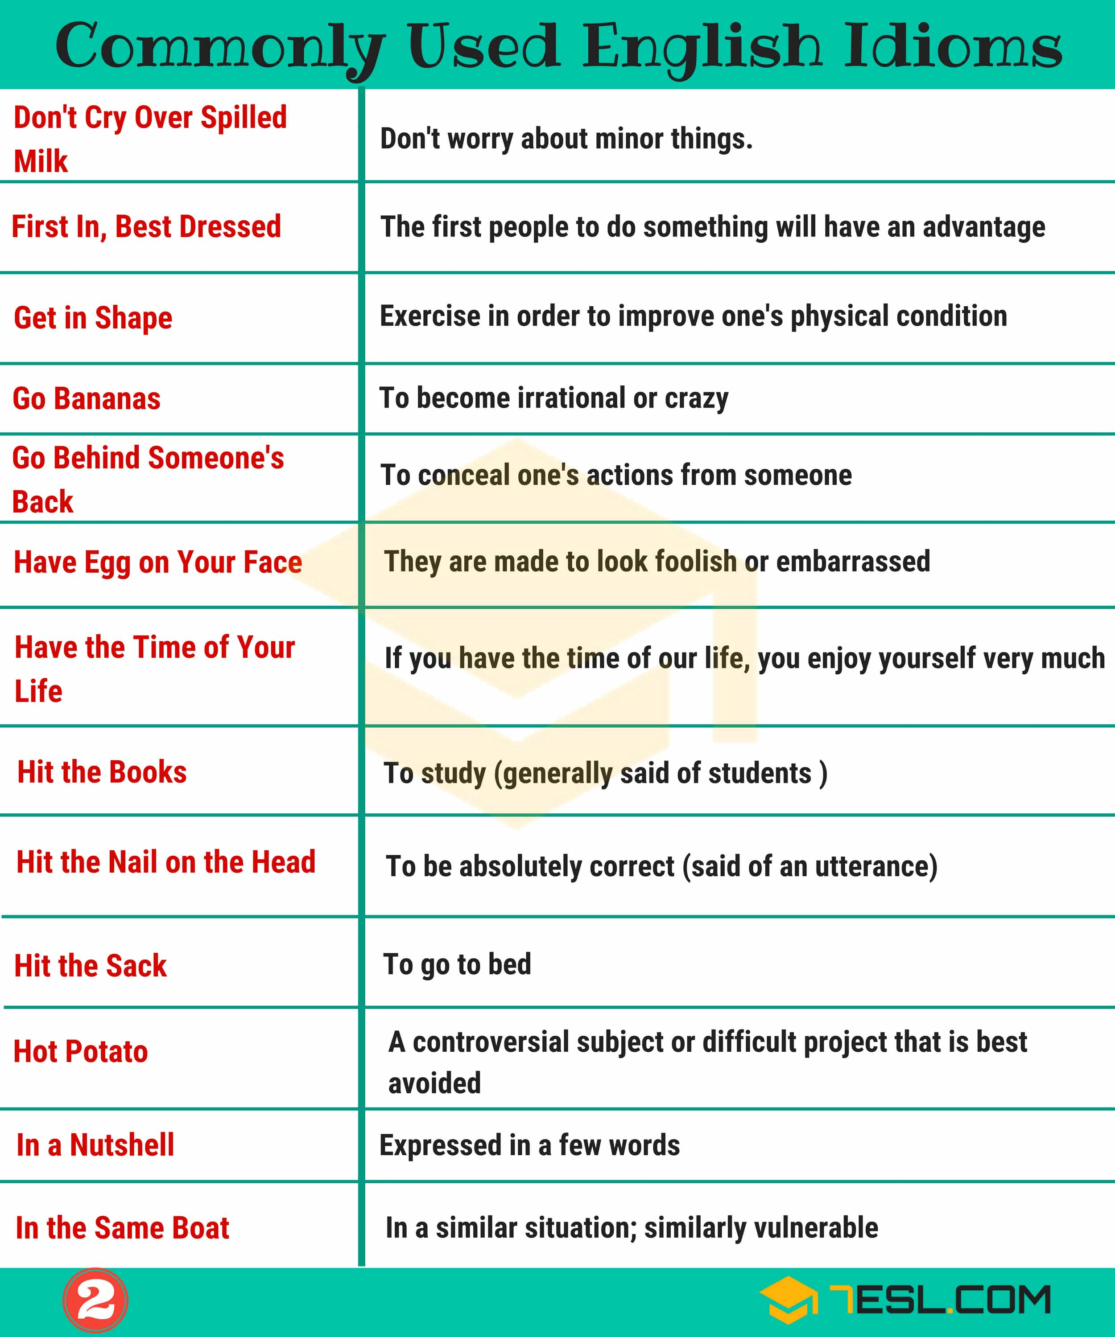Pin

Idioms (C)
List of English idioms that start with C.
Call a Spade a Spade: To speak frankly and directly about a problem
Call It a Day: Decide that one has worked enough on something for the day
Call It a Night: End an evening’s activities and go home
Call the Shots: Make the important decisions in an organization
Call the Tune: Making important decisions and controlling a situation.
Can’t See the Forest for the Trees: Is unable to maintain a wider perspective
Can’t Swing A Dead Cat In (Place): Without Hitting A (Thing) There are many examples of [thing] in this [place].
Carrot-and-Stick (Approach): A tactic in which rewards are offered, but there is also the threat of punishment
Carry a Torch (for): To continue to be in love with someone even after a relationship has ended
Carry Coals To Newcastle: Supply something that is unneeded; engage in useless labor
Carry the Can: To take the blame for something one did not do
Cash In One’s Chips: 1. To take advantage of a quick profit 2. To die
Cash-Strapped: In need of money
Cast the First Stone: To be the first to criticize or attack someone
Castle in the Air: An impractical plan
Cat Fight: A fight between two women
Cat Got Your Tongue?: Don’t you have anything to say?
Cat on a hot tin roof: Be extremely nervous
Cat-and-Mouse (adj.): In a toying way; playful in an unpleasant way
Catch One’s Death of Cold: To become very ill (with a cold/flu etc.)
Catch Some Rays: To sit or lie outside in the sun
Catch Someone’s Eye: Attract someone’s attention
Catch-22: A difficult situation from which there is no escape because options for avoiding it involve contradictions
Cat’s Paw: A person being used by someone else, a tool
Caught Red-Handed: Apprehended while committing a crime
Circle the Wagons: To prepare as a group to defend against attack, adopt a defensive posture
Claim to Fame: Unusual feature or offering
Clean Up Nicely: Look good when one is dressed up. Usually said of women
Clear the Air: Defuse tension, be honest about conflict so as to reduce it
Clip Someone’s Wings: Reduce someone’s privileges or freedom
Close, But No Cigar: You are very close but not quite correct.
Cock and Bull Story: A far-fetched story, probably untrue
Cock-A-Hoop: Elated, excited
Cold Day in Hell: A condition for something that would be extremely unlikely to occur
Come By Something Honestly: Acquire something honestly, or inherit it
Come Clean: To confess; to admit to wrongdoing
Come Hell or High Water: No matter what happens
Come Out in the Wash: To be resolved with no lasting negative effect
Come Out of the Closet: Reveal a secret about oneself, usually that one is gay (homosexual)
Come Out Swinging: Respond to something very aggressively
Come Rain and Shine: Do regularly, whatever the circumstances
Come to Grips With: To acknowledge a problem as a prelude to dealing with it
Come to Terms With (Something): Feel acceptance toward something bad that has happened
Coming Down the Pike: Likely to occur in the near future
Cook Someone’s Goose: To insure someone’s defeat, to frustrate someone’s plans
Cook Up a Storm: Cook a great deal of food
Cooking Up a Storm: Cooking a great deal of food
Cool as A Cucumber: Calm and composed even in difficult or frustrating situations; self-possessed
Cool Cat: Someone who has the respect of their peers in a young, casual way.
Cool Your Heels: Wait
Couch Potato: A lazy person who watches a great deal of television
Crash a Party: To attend a party without being invited
Crickets: Silence
Cross to Bear: A problem one must deal with over a long time, a heavy burden
Crunch Time: A period of high pressure when one has to work hard to finish something
Crunch the Numbers: Do calculations before making a decision or prediction
Cry Over Spilt (USA: Spilled): Milk To waste energy moaning about something that has already happened
Cry Wolf (verb): To issue a false alarm, to ask for help when none is needed
Cry Your Eyes Out: Cry hard for a very long time
Cry Your Eyes Out: Cry hard for a very long time
Curiosity Killed The Cat: Stop asking questions, don’t be too curious
Cut (Someone) To the Quick: To deeply hurt someone emotionally
Cut Corners: Economize by reducing quality; take shortcuts
Cut It Fine: To do something at the last moment
Cut Off Your Nose to Spite Your Face: To act in a proud way that ultimately damages your own cause
Cut Someone Some Slack: Avoid treating someone strictly or severely
Cut to the Chase: Get to the point; explain the most important part of something quickly; skip the preliminaries
Cut the Gordian Knot: To solve a complex problem in a simple way
Cut the Mustard: Do something adequately
Cut Your Teeth on Something: To learn basic skills in a field
Cutting-Edge: Very novel, innovative
Champagne taste on a beer budget: Expensive or extravagant tastes or preferences that are beyond one’s economic means.
Change Horses in Midstream: Change plans or leaders in the middle of a process
Change of Heart: A change in one’s opinion or outlook
Change One’s Tune: To alter one’s opinion about something.
Changing of the Guard: A change in leadership at an organization
Chase Rainbows: To pursue unrealistic goals
Cheap Shot: An unfair attack; a statement that unfairly attacks someone’s weakness
Cherry-Pick: To present evidence selectively to one’s own advantage
Cherry-Pick: To select the best or most desirable
Chew the Fat: Chat for a considerable length of time
Chickens Come Home To Roost: The negative consequences of previous actions reveal themselves
Child’s Play: A very easy task
Chill Out: Do something that helps them to calm down and relax for a while.
Chin Music: Meaningless talk
Chin Up/ Keep Your Chin Up: Cheer up; try to be cheerful and strong
Chip off the Old Block: Someone who resembles a direct ancestor, usually the father
Chomp (Champ) at the Bit: Be eager to do something
Chomp at the Bit: To be eager to do something
Chop Chop: Quickly, without delay
Chop Shop: A shop where stolen cars are disassembled for parts
Chuck a Wobbly: To act in an emotional way
English Idioms Examples with Idiom Meaning | Image 2
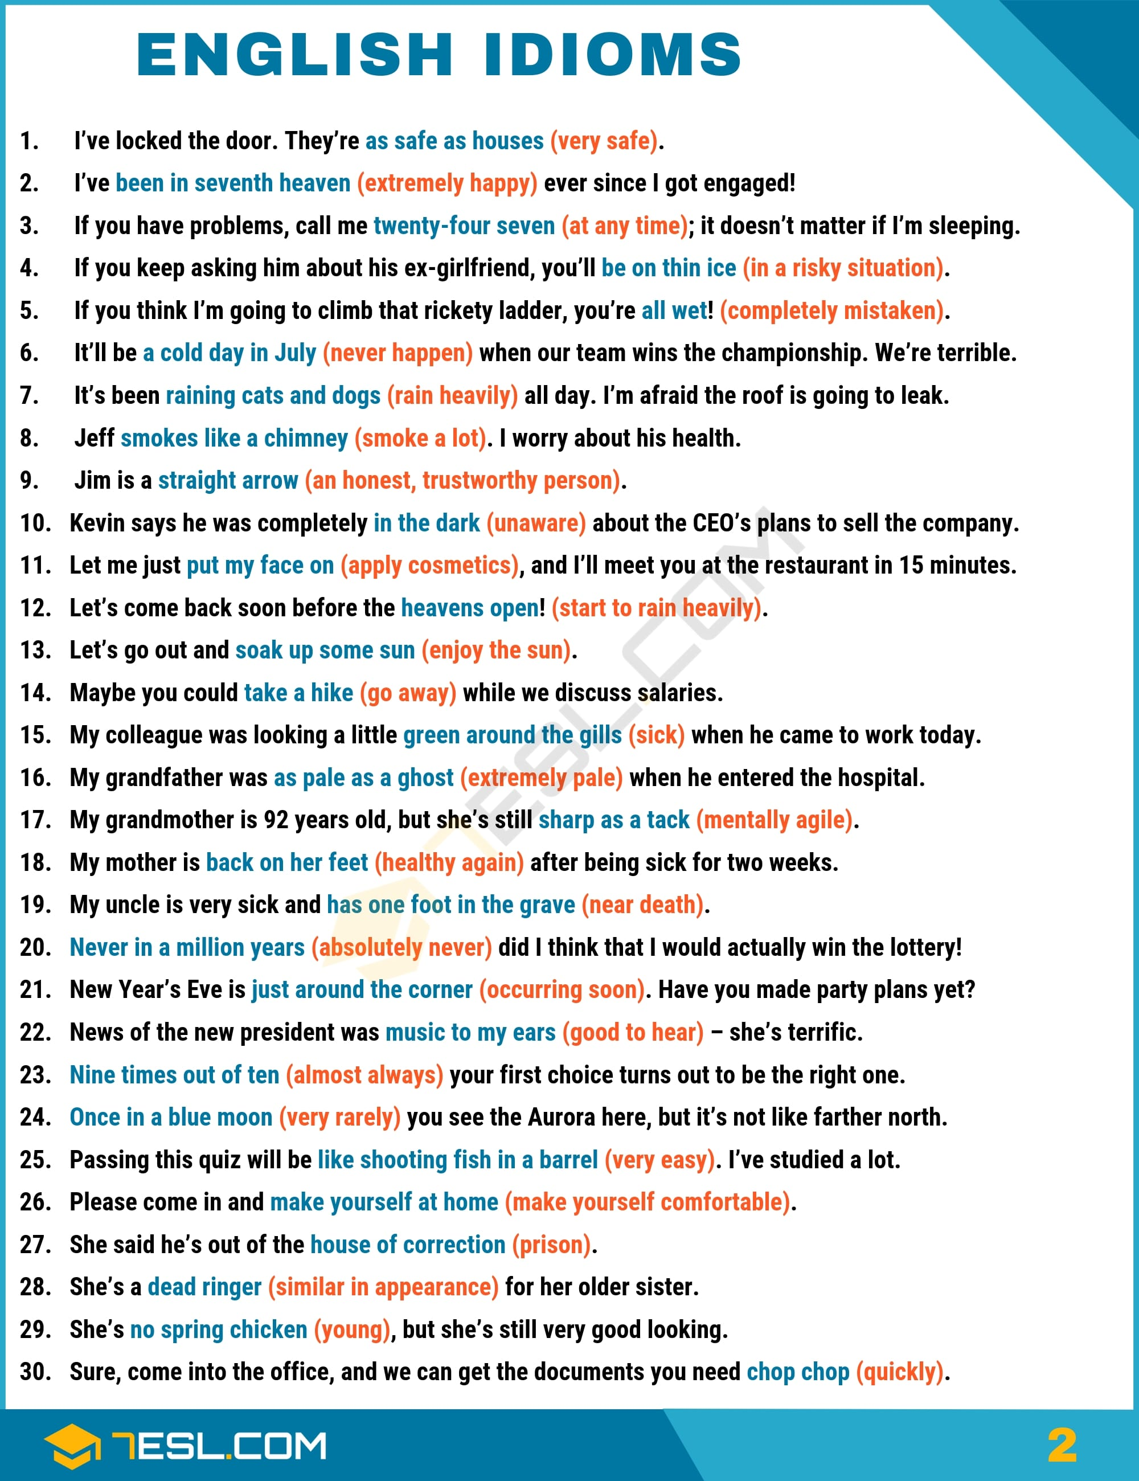Pin

Idioms (D)
List of English idioms that start with D.
Da Man (Slang): An accomplished or skillful person. Generally used in the compliment “”You da man!””
Dance to Someone’s Tune: Consistently follow someone’s directions or influence
Dance with the Devil: Knowingly do something immoral
Dark Horse: A surprise candidate or competitor, especially one who comes from behind to make a strong showing
Darken Someone’s Door (Step): Make an unwanted visit to someone’s home
Dead Ahead: Directly ahead, either in a literal or a figurative sense
Dead as the Dodo: Completely extinct; totally gone
Dead Eye: A good shooter, a good marksman
Dead Heat: An exact tie in a race or competition
Dead of Winter: The coldest, darkest part of winter
Dead ringer: Very similar in appearance
Dead Run: Running as fast as possible
Dead Shot: A good shooter, a good marksman
Deep Pockets: The new owner has deep pockets, so fans are hoping the football team will improve next year with new players
Deliver the Goods: Provide what is expected
Devil’s Advocate: Someone who argues a point not out of conviction, but in order to air various points of view
Dirty Look: A facial manner that signifies disapproval
Do 12-Ounce Curls: Drink beer
Dodge a Bullet: To narrowly escape disaster
Doesn’t Amount to a Hill of Beans: Is unimportant, is negligible
Dog Days of the Summer: The hottest day of summer
Dog in the Manger: A person who prevents others from using something, even though the person himself or herself does not want it
Dog-and-Pony Show: A flashy presentation, often in a marketing context
Dog-Eat-Dog: Intensely competitive
Don’t Judge a Book by Its Cover: Don’t be deceived by looks; don’t rely on looks when judging someone or something
Don’t Cry Over Spilled Milk: Don’t worry about minor things.
Don’t Look a Gift Horse in the Mouth: Do not question the value of a gift. The expression comes from the practice of determining the age and health of a horse by looking at its teeth.
Double-Dip: Improperly get income from two different sources
Double-Edged Sword: Something that can be helpful or harmful; something beneficial that also has a downside
Down in the Dumps: Depressed, sad
Down the Road: In the future (in your lifetime)
Drag One’s Feet (or Heels): To do something reluctantly and slowly
Drag Your Feet: Do something very reluctantly; delay doing something
Drain the Lizard: Urinate
Draw a Blank: Be unable to remember something
Draw a Line in the Sand: Issue an ultimatum; specify an absolute limit in a conflict
Draw a Line Under (Something): To conclude something and move on to something else
Draw a Long Bow: Exaggerate, lie
Draw the Line: To set a limit to what one will accept
Dressed Up to the Nines: Someone is wearing very smart or glamorous clothes
Drink the Kool-Aid: Accept a set of ideas uncritically, often dangerous ones
Drive a Hard Bargain: To arrange a transaction so that it benefits oneself.
Drive a Hard Bargain: To negotiate effectively
Drive a Wedge Between: Try to split factions of a united group by introducing an issue on which they disagree
Drive Someone Up the Wall: Deeply irritate someone
Drop a Line: To write a letter or send an email
Drop the Ball: Fail to fulfill one’s responsibilities; make a mistake
Dry Run: A practice execution of a procedure
Dutch Courage: Alcohol drunk with the intention of working up the nerve to do something
Dutch Uncle: A highly critical person
Dyed-In-The-Wool (adj.): Consistent in an affiliation or opinion over a long period; inveterate

Idioms (E)
List of English idioms that start with E.
Eager beaver: The term eager beaver refers to a person who is hardworking and enthusiastic, sometimes considered overzealous.
Eagle-Eyed: Having sharp vision
Early Bird [noun or adjective]: Someone who does something prior to the usual time, or someone who gets up early.
Eat Crow: To admit one was wrong, and accept humiliation
Eat Humble Pie: To admit defeat or error, to accept humiliation
Eat Someone’s Lunch: Defeat someone thoroughly
Eat Your Heart Out!: (excl.) Go ahead, be jealous.
Eighty-Six (v.): 1) Discard, eliminate. 2) Throw someone out of a bar or store.
Elephant in the Room: A major problem that no one is talking about
Elevator Music: Pleasant but boring recorded music that is played in public places.
Elevator Pitch: A brief presentation of an idea, one short enough to be delivered in an elevator
Eleventh Hour: The last minute
Even Steven: Owing nothing; tied (in a game)
Every Dog Has His (Its): Day Everyone has a moment of fame, power, or influence
Every Man and His Dog: Many people
Every Man for Himself: Pursue your own interests; don’t expect help from others.
Excused Boots: Allowed to avoid mandatory tasks

Idioms (F)
List of English idioms that start with F.
Face the Music: Dealing with consequences of one’s actions
Face the Music: To accept judgment or punishment
Fall for Something: Hook, Line, and Sinker To be completely deceived
Fall in Love with Somebody: Start feeling love towards somebody
Fall Off the Wagon: To begin using alcohol (or another problem substance) after quitting
Fall on One’s Sword: To accept blame; to sacrifice oneself
Fall Prey to: Be victimized by; be harmed by; be vulnerable to
Fancy Someone (British English): To find someone very attractive
Farther (On) Down the Road: Later, at some unspecified time
Farther (On) Down the Road: Later, at some unspecified time
Fashion-Forward: Tending to adopt new styles quickly
Fat Cat: A highly placed, well-paid executive
Father Figure: A mentor, a person who offers guidance
Feast Your Eyes On: To take great pleasure in looking at someone or something
Feather in One’s Cap: An achievement for which one is recognized; a noteworthy achievement
Feather One’s (Own) Nest: Use one’s influence or power improperly for financial gain
Feather One’s Nest: To take advantage of one’s position to benefit oneself
Fed Up With: Refusing to tolerate something any further; out of patience
Feel Like a Million Dollars: To feel great, to feel well and healthy.
Feel On Top of The World: To feel very healthy
Fell off a Truck: Probably stolen or illicitly obtained; said of something offered for sale to avoid discussing its origins
Fell off the Back of a Lorry: Probably stolen or illicitly obtained; said of something offered for sale to avoid discussing its origins
Fifteen Minutes of Fame: Temporary renown
Fifth Wheel: A superfluous person
Fight Fire with Fire: Use the same measures that are being used against you, even if they’re stronger than you would usually use
Fight Like Cat and Dog: Continually arguing with each other
Find One’s Voice: Become more confident in expressing oneself
Find Your Feet: To adjust to a new place or situation
Finger-Pointing: Blame; a situation within a group where each member attempts to blame others
Finger-Pointing: Blame; a situation within a group where each member attempts to blame others
Fire in the Belly: strong ambition
First In, Best Dressed: The first people to do something will have an advantage
Fish for Compliments: Try to manipulate people into praising you
Fish or Cut Bait (usually an exclamation): Make a decision or give someone else a chance
Fish Out of Water: A person who is in unfamiliar, confusing surroundings
Five-Finger Discount: Shoplifting
Flash in the Pan: A one-time occurrence, not a permanent phenomenon
Flat Broke: Having no money at all
Flat Out Like a Lizard: Drinking Very busy
Flesh and Blood: Blood relatives, close relatives
Flew the Coop: Left, escaped
Flip-Flop (v. or n.): To vacillate between two choices, to be indecisive
Fly by the Seat of One’s Pants: To improvise, to make decisions without planning or preparation
Fly High: Be very successful, especially temporarily
Fly Off The Handle: Lose one’s temper suddenly and unexpectedly
Fly off the Handle: To become suddenly enraged
Follow In Someone’s Footsteps (Tracks): Follow the example laid down by someone else; supplant
Follow Your Heart: Rely on one’s deeper feelings and instincts when making a decision
Food for Thought: Something that makes you think carefully
For a Song: At very low cost
For a Song: At very low cost
For Crying Out Loud (excl.): An expression of extreme annoyance
For Xyz Reasons: For multiple reasons, not worth specifying individually
Foul Play: Crime, typically murder
Fourth Estate: The media and newspapers
Fox in the Henhouse (Chickenhouse): Someone who causes trouble
Freak Out: A wildly irrational reaction or spell of behavior
French Leave: Absence without permission
Freudian Slip: Accidental use of an incorrect word; a revealing slip of the tongue
From Pillar to Post: From one place to another, in a forced, random way
From Scratch: From individual ingredients, not using a prepared mix
From Soup to Nuts: Everything; from beginning to end
From the Bottom of One’s Heart: Sincerely and with deep feeling
FUBAR: Hopelessly ruined, not working, messed up.
Fu** (Or Screw) The Dog (Pooch): To make an embarrassing error
Full Fathom Five: Lost deep in the sea
Full of the Joys of Spring: Very happy, enthusiastic and full of energy
English Idioms Examples with Idiom Meaning | Image 3
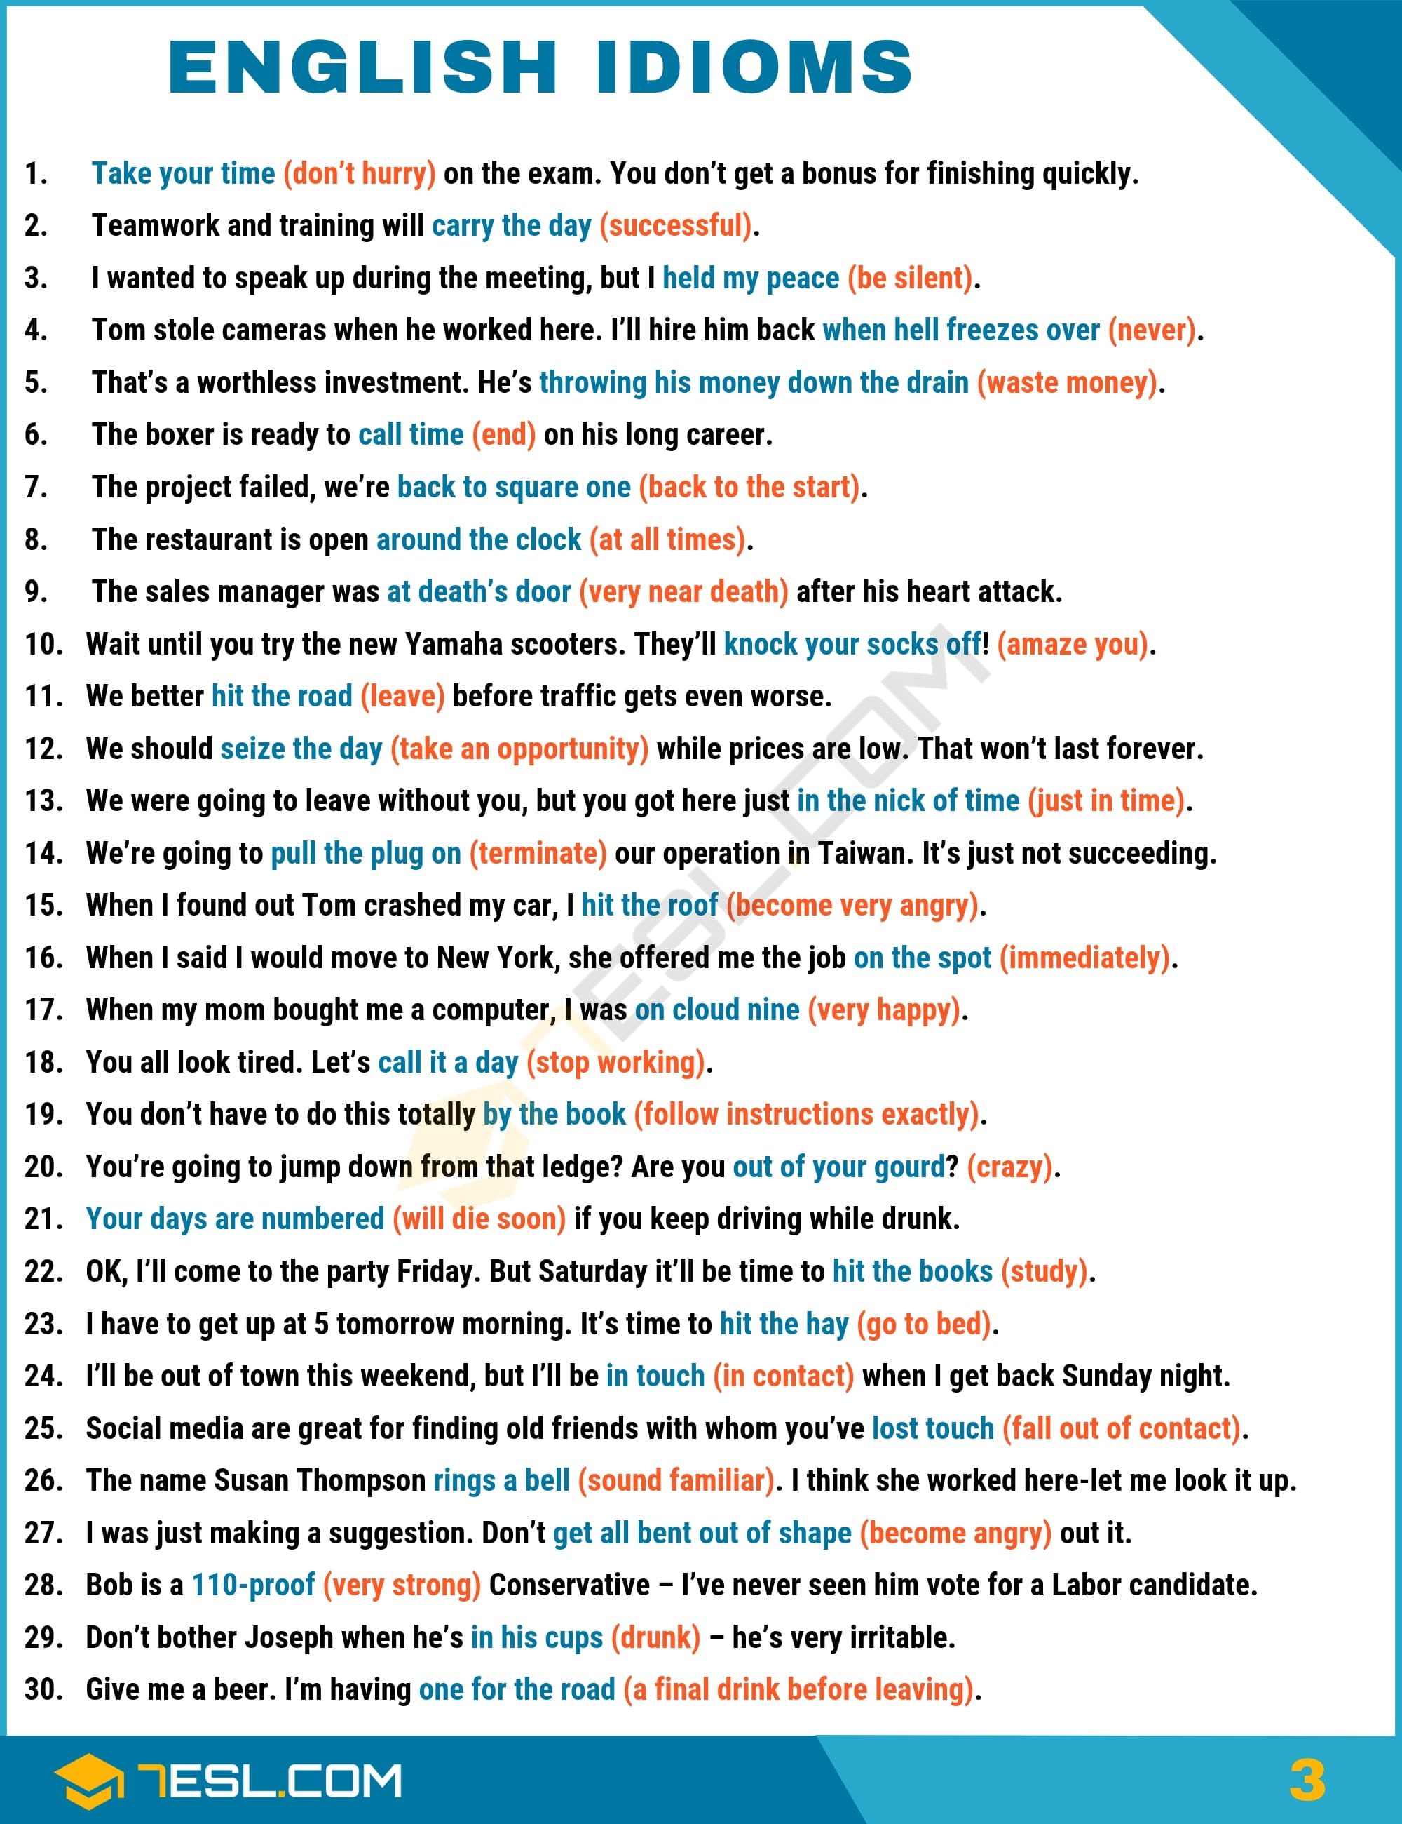Pin

Idioms (G)
List of English idioms that start with G.
Game of Chicken: A conflict situation in which neither side will back down for fear of seeming cowardly (chicken)
Get A Charley Horse: To develop a cramp in the arm or the leg
Get A Word In Edgewise: Be able to say something while someone else is talking a lot
Get Along (with Someone): To have a satisfactory relationship
Get Bent Out of Shape: Become angry, upset
Get Carried Away: Become overly enthusiastic
Get In on the Ground Floor: Invest in or join something while it is still small
Get in Shape: Undertake a program of physical conditioning; exercise regularly
Get Off Scot Free: Be accused of wrongdoing but pay no penalty at all
Get Off Scot Free: Be accused of wrongdoing but pay no penalty at all
Get One’s Ducks in a Row: Have everything organized; get oneself organized
Get One’s Hands Dirty: To do the unpleasant parts of a job
Get Someone’s Goat: To irritate someone deeply
Get To Grips With: To begin to understand and deal with something
Get the Ball Rolling: Do something to begin a process
Get the Picture: Understand what’s happening
Get the Runaround: Be given an unclear or evasive answer to a question
Get the Sack, Be Sacked: To be fired
Get the Third Degree: To be questioned in great detail about something
Get Wind of: Hear about
Get With the Program: Figure out what everyone else already knows. Often used sarcastically, as a command
Go Along (With): Agree to something, often provisionally
Go Ape: Express wild excitement or anger
Go Ballistic: Fly into a rage
Go Bananas: To become irrational or crazy
Go Bananas: To become irrational or crazy
Go Belly Up: To go bankrupt
Go Berserk: To go crazy
Go Bonkers: To be or become wild, restless, irrational, or crazy; to act in such a way
Go Cold Turkey: Stop using an addictive substance suddenly, without tapering off
Go Down in Flames: Fail in a spectacular way
Go Mental: To suddenly become extremely angry
Go Nuclear: Use an extreme measure; because extremely angry
Go Nuts: To become crazy
Go Off Half-Cocked: To say or something prematurely, with a negative effect
Go Off the Deep End: To unexpectedly become very angry, especially without a good reason
Go Off The Rails: To go wrong, to begin acting strangely or badly
Go Out on a Limb: Assert something that may not be true; put oneself in a vulnerable position
Go Pear-Shaped: To fail; to go wrong
Go See a Man About a Dog: Go to the bathroom (said as a euphemism)
Go to the Dogs: To become disordered, to decay
Go to the Mattresses: To go to into battle
Go the Extra Mile: Put forth greater-than-expected effort
Go Under the Knife: Undergo surgery
Go Viral: Begin To spread rapidly on the Internet
Go with the Flow: To accept the way things naturally seem to be going
Grab (Take) the Bull by the Horns: To begin forthrightly to deal with a problem
Grasp (Grab) at Straws: To take desperate actions with little hope of success
Grease Monkey: A mechanic, especially an auto mechanic
Grease the Wheels: Do something to make an operation run smoothly
Greasy Spoon: An inexpensive restaurant that fries foods on a grill
Green Around the Gills: To look sick
Green as Grass: Lacking training, naive; often said of young people in new jobs
Grind One’s Teeth: Be very annoyed or angry about something without being able to say anything about it.
Guilty Pleasure: Enjoying something which is not generally held in high regard, while at the same time feeling a bit guilty about it, is called a guilty pleasure.
Guinea Pig: A test subject, a person who is used as a test to see if something will work
Give and Take: Negotiations, the process of compromise
Give ’em Hell (often excl.): Express something passionately to a group
Give Lip Service to: Talk about supporting something without taking any concrete action
Give Lip Service: to Talk about supporting something without taking any concrete action
Give One’s Two Cents (That’s My Two Cents): Offer an opinion, suggest something
Give Someone a Holler: Contact someone
Give Someone a Piece of Your Mind: Angrily tell someone what you think
Give Someone a Run for Their Money: Compete effectively with the leader in a particular field
Give Someone an Earful: angrily express an opinion to someone
Give Someone the Cold Shoulder: act hostile toward someone; to ignore, snub
Give Someone The Old Heave-Ho: Fire someone, remove someone from a group or team
Give Something a Whirl: Attempt something without being totally familiar with it
Give the Green Light: Approve something; allow something to proceed

Idioms (H)
List of English idioms that start with H.
Hail Mary (n. or adj.): A desperate, last-ditch attempt
Hair of the Dog (That Bit You): A small amount of the alcoholic beverage that caused your hangover
Hands are Tied: You are prevented from doing something. It is not within your power
Hands Down: Undoubtedly
Hang It Up: To retire, to end an activity one has pursued for a long time
Hang Tough: Maintain one’s resolve
Hanging by a Thread: In great danger of elimination or failure
Happy-Go-Lucky: If you are a happy-go-lucky person, you are cheerful and carefree all the time.
Hard Nut to Crack: A difficult problem or a difficult person
Has the Cat Got Your Tongue?: Why are you not saying anything?
Hat Trick: Scoring three goals in hockey or soccer (football), or accomplishing three of anything.
Hatchet Job: A strong attack on someone’s reputation; intentionally destructive criticism; calumny
Haul Over the Coals: To scold someone severely
Have (one’s) head in the clouds: Not know what is happening around you or out of touch with reality
Have A Ball: To have a very enjoyable time
Have a Bone to Pick (with Someone): To want to discuss something someone has done that has angered or annoyed you.
Have a Bone to Pick (with Someone): To want to discuss something someone has done that has angered or annoyed you.
Have a Chip on One’s Shoulder: To harbor resentment; to have an angry attitude
Have a Dog in the Hunt (Fight, Race): To support a certain person in a competition
Have a Lead Foot: A tendency to drive very fast
Have a Lot on One’s Plate: Be busy, be in the middle of many ongoing tasks
Have a Lot Riding On (Something): Be depending on the successful outcome or development of something
Have a Nose for (Something): To have natural ability at something, a talent for finding something
Have a Screw Loose: Be slightly unbalanced or crazy
Have a Tough Row to Hoe: Be faced with a task that is difficult because of unfavorable conditions
Have A Whale of A Time: To enjoy yourself very much
Have an Ace Up One’s Sleeve: To have a hidden advantage
Have Bigger Fish to Fry: Have more important things to do
Have Egg on Your Face: They are made to look foolish or embarrassed
Have Foot-in-Mouth Disease: To embarrass oneself through a silly mistake
Have Hand of Aces/Hold All the Aces: To be in a very strong position in a competition
Have It Out with Someone: To have an argument with someone in order to settle a dispute
Have One Foot in The Grave: To be near death (usually because of old age or illness)
Have One Over the Eight: A person is slightly drunk.
Have One Too Many: Drink too much alcohol
Have One’s Cake and Eat It, Too: To want two incompatible things (usually used in the negative)
Have Skin in the Game: Be risking something in an undertaking
Have Something in the Bag: Be certain to win
Have the Hots for (Somebody): To be (sexually) attracted to somebody
Have the Hots for Somebody: Finding somebody extremely attractive
Have The Time of Your Life: If you have the time of our life, you enjoy yourself very much.
Have the Time of Your Life: To have a very fun, exciting, or enjoyable time
Have Your Nose in the Air: Have a snobbish or disdainful attitude
Have Your Say: Express your opinion on something
Have Your Thumb Up Your Ass: Have nothing to do
He Who Laughs Last Laughs Best: Being victorious is often a matter of simply surviving a conflict
He Would Put Legs Under A Chicken: He will talk your head off; he is very talkative
Head (Go) South: Decline, get worse
Head and Shoulders Above: Far superior to
Head and Shoulders: Above Far superior to
Head Start: An advantage over everyone else
Heads Up (excl.): Get ready! Be prepared
Heads Up!: Be careful!
Heads Will Roll (Are Going to Roll): People will be fired
Heads Will Roll (Are Going to Roll): People will be fired
Hear (Something) Through the Grapevine: To learn something via gossip
Heart and Soul: With all one’s energy or affection
Heavens Open: Start to rain heavily
Heavy Hitter: A powerful, influential person
Helicopter Parenting: Overattentive child-raising
Hell for Leather: Very fast, as fast as possible
High as a Kite: Strongly under the influence of drugs or intoxcants
High as a Kite: Strongly under the influence of drugs or intoxcants
High as a Kite: Strongly under the influence of drugs or intoxcants
Hightail It (Out of There): Flee
Highways and Byways: You take large and small roads to visit every part of the country.
Hit a Wall: suddenly stop making forward progress
Hit It Out of the Park: Succeed brilliantly
Hit the Books: To study (generally said of students
Hit the Ground Running: To begin a job or project with no learning or training period needed
Hit the Hay: To go to bed
Hit the Jackpot: Do something that brings great success
Hit the Nail on the Head: To be absolutely correct (said of an utterance)
Hit the Road: To leave
Hit the Roof: Explode in rage; become extremely angry
Hit the Roof: To become very angry
Hit the Sack: To go to bed
Hit the Spot: Be very satisfying (said of something eaten)
Hive Mind: The knowledge of humans as a group
Hobson’s Choice: A choice among bad options
Hold One’s Liquor: Be able to drink a large amount without being affected
Hold One’s Peace: Be silent
Hold the Phone: Wait a moment (whether you’re on the phone or not)
Hold the Phone: Wait a moment (whether you’re on the phone or not)
Hold Your Horses (generally excl.): Stop; restrain yourself; don’t be so excited
Home Away from Home: A habitual hangout; a place one frequents often and where one feels welcome
Home Truths: Honest, often painful criticism
Honor System: A system of payments that relies on the honesty of those paying
Hot Mess: Something or someone in a state of extreme disorder
Hot on the Heels (of): In close pursuit
Hot on the Heels (of): In close pursuit
Hot Potato: A controversial subject or difficult project that is best avoided
English Idioms Examples with Idiom Meaning | Image 4
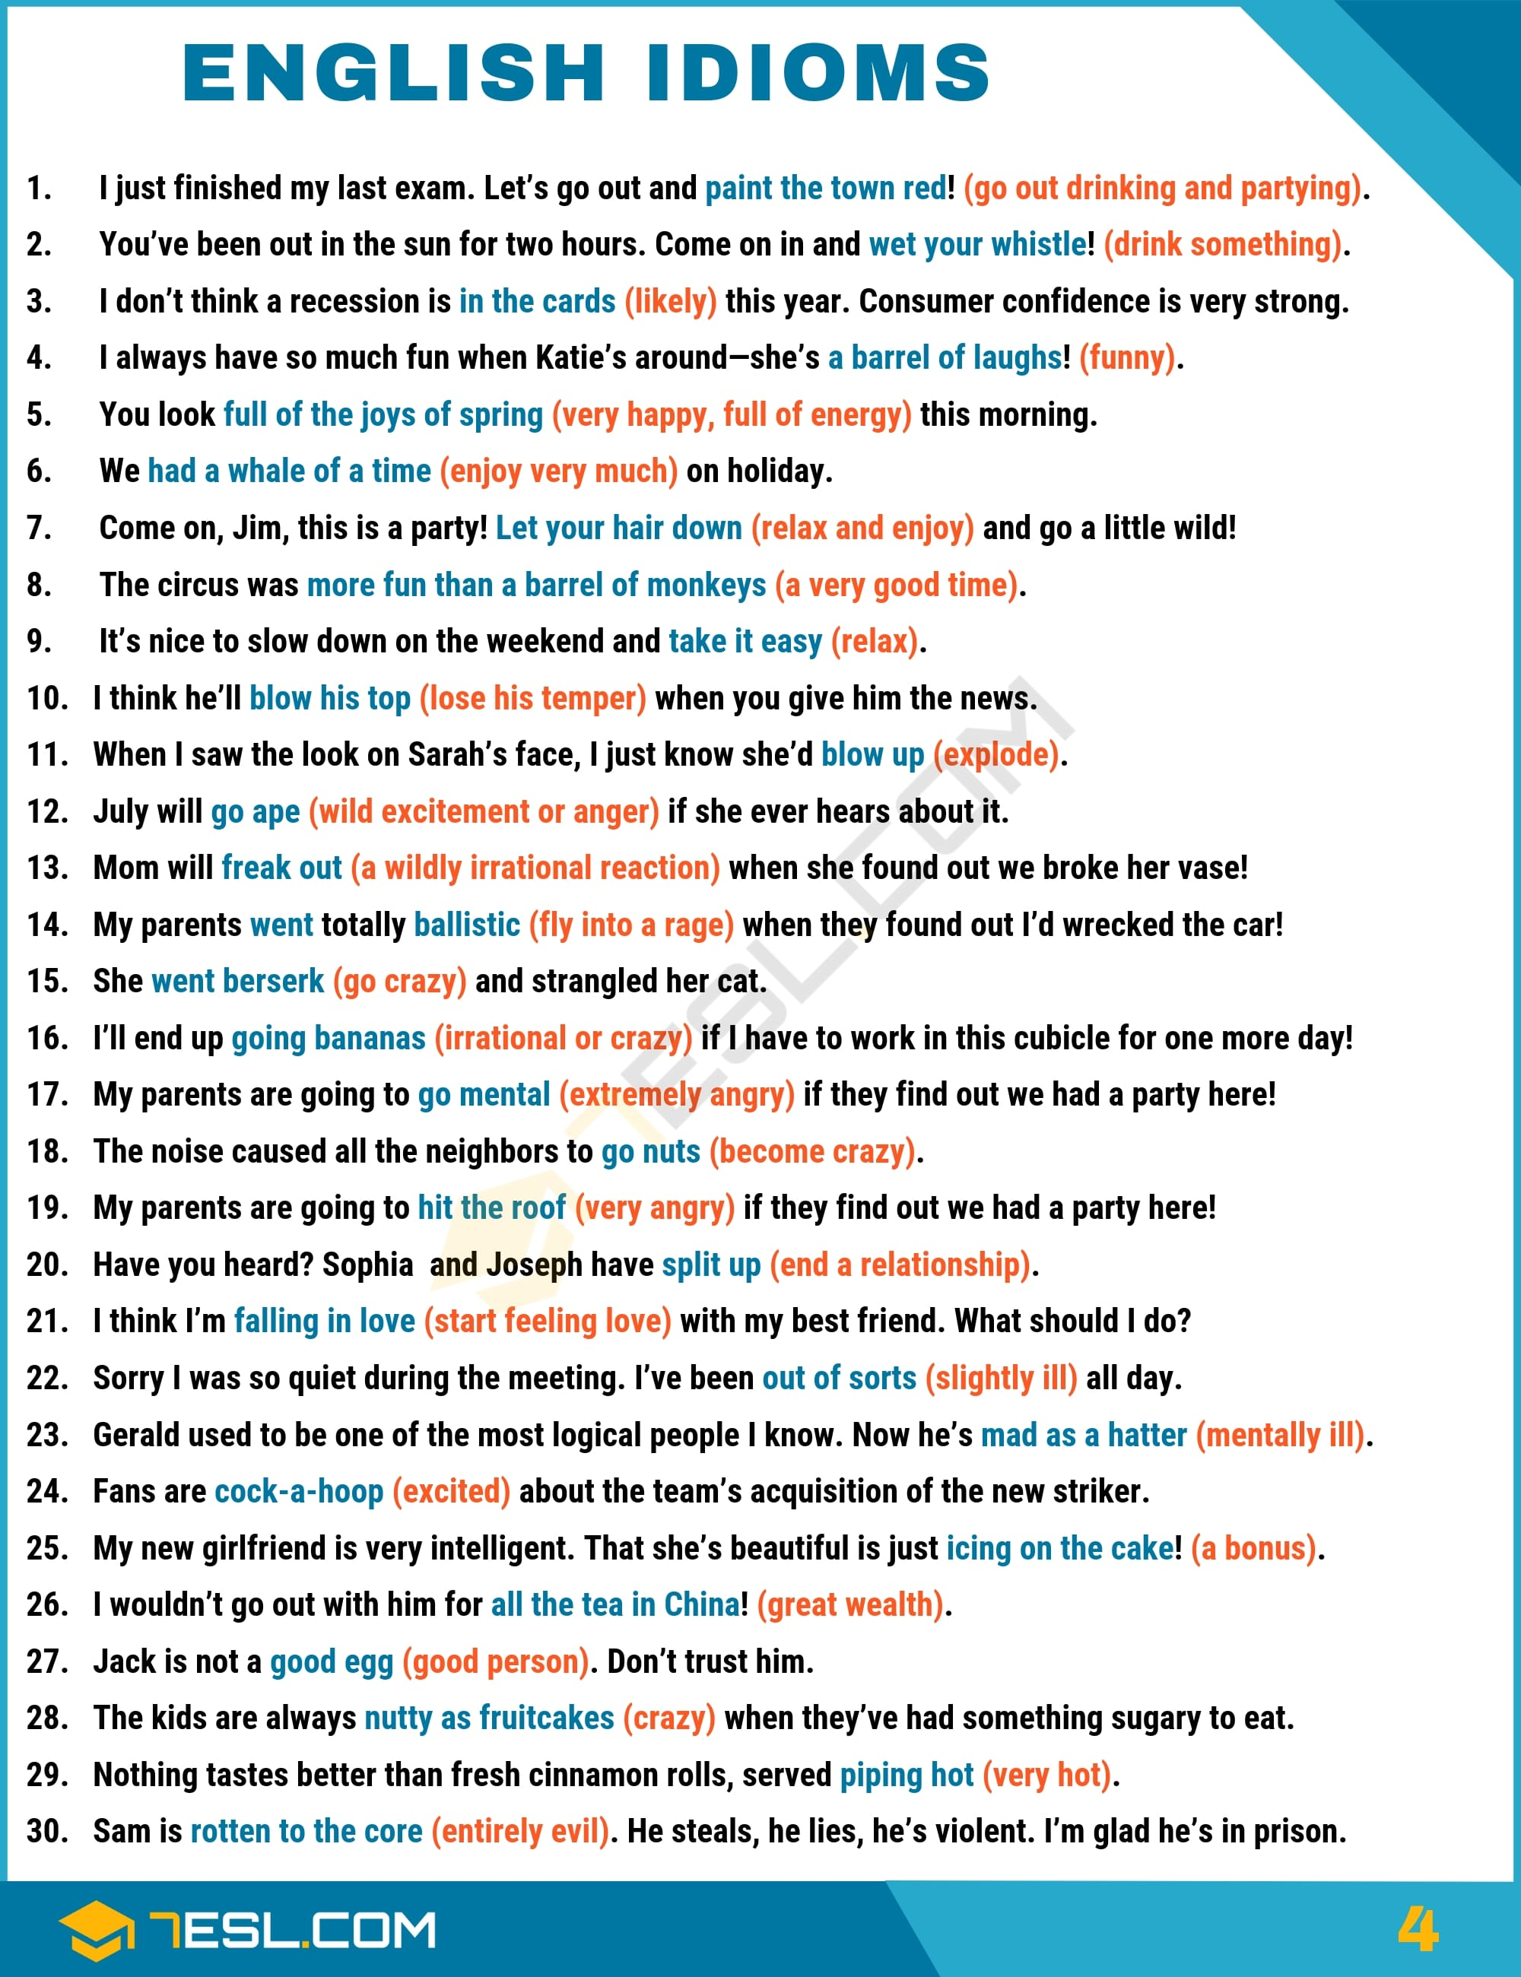Pin

Idioms (I)
List of English idioms that start with I.
I Wouldn’t Put It Past (Someone): I think it’s quite possible that [this person] would do this.
If It Had Been a Snake, It Would Have Bitten Me: It was very obvious, but I missed it.
If the Shoe Fits, Wear It: If this description of you is accurate, accept it.
I’m All Ears: You have my attention, so you should talk
In a Fog: Confused, not mentally alert
In a Heartbeat: Immediately. This is especially used in hypothetical situations
In a Jam: In need of help, in a difficult spot
In a New York Minute: Very quickly
In a Nutshell: Expressed in a few words
In a Pickle: In need of help, in a difficult spot
In a Rut: Confined by routine, bored and seeking new experiences
In Broad Daylight: When something occurs in broad daylight, it means the event is clearly visible
In Clover: Benefiting from a positive financial situation
In For a Penny, In for a Pound: Committed to something even though the risks are increasing
In Full Swing: When something, such as an event, gets into full swing, it is at its busiest or liveliest time.
In His Cups: Drunk
In Hot Water: In need of help; in trouble
In One Fell Swoop: All at once, in a single action
In One’s Element: In a situation which is entirely suitable, familiar, or enjoyable.
In Someone’s Wheelhouse: In someone’s strongest area of competence or enthusiasm
In Touch: In contact
In the Blink of an Eye: Quickly, seemingly instantaneously
In the Cards: Likely; likely to occur
In the Crosshairs (Cross Hairs): Targeted for blame or criticism
In the Dark: Not informed
In the Dark: Unaware of something
In the Driver’s Seat: In a dominant position, in control
In the Hot Seat: Undergoing criticism or scrutiny; under pressure publicly
In the Interim: It denotes a period of time between something that ended and something that happened afterwards
In the Limelight, In the Spotlight: Receiving large amounts of publicity or attention
In the Long Run: Over an extended period of time
In the Nick of Time: Just in time; with no time to spare
In the opinion of the speaker, a person has just spent money unnecessarily and is, therefore, a fool.
In the Pipeline: Being prepared for the marketplace, being worked on
In the Red: Losing money; (of a market index) below a specified starting point
In the Same Boat: In a similar situation; similarly vulnerable
In the Toilet: In disastrous condition
In the Works: Under development; coming soon
Iron Out (Problems, Difficulties): To resolve
Is the Pope Catholic?: Isn’t the answer obvious?
It Never Rains but It Pours: Bad luck and bad things tend to happen at the same time
It Takes Two to Tango: When something goes wrong involving two people, it’s likely that they share the blame; cooperation is necessary
It Takes Two to Tango: You say this when you think that a difficult situation or argument cannot be the fault of one person alone.
It Won’t Fly: It won’t work; it won’t be approved.
Itchy Feet: A person who has itchy feet is someone who finds it difficult to stay in one place and likes to travel and discover new places.
It’s a Wash: A positive and a negative development cancel each other out, so the situation has neither improved nor gotten worse
It’s All Greek to Me: It is unintelligible, impossible to understand
It’s No Skin off My (Your) Nose (Back): The outcome will not affect me personally
It’s Not Over Till the Fat Lady Sings: Do not give up too soon; things may improve.
It’s Not Rocket Science: It’s not difficult to understand.
I’ve Had It Up to Here: My patience is almost exhausted.

Idioms (J)
List of common English idioms that start with J.
Jack of All Trades: A person with a wide variety of skills
Jam Session: Playing improvised music in an informal setting
Jim Crow: The system of racial segregation in the American South prior to the American civil rights movement.
Join the Club (excl.): I feel sympathy for you because I have experienced something similar.
Jump in with Both Feet: Begin a new experience wholeheartedly
Jump on the Bandwagon: To follow a trend or craze
Jump on the Bandwagon: To follow a trend; follow the crowd
Jump the Gun: Start doing something too soon
Jump the Shark: To pass peak quality and begin to decline. Often used to describe television programs or movie series.
Jump the Track: To shift suddenly from one activity or line of thought to another
Jump Through Hoops: Complete a series of tasks in order to satisfy someone
Just Around the Corner: Occurring soon
Just for the Record: I would like to make it clear that …
Just What the Doctor Ordered: Exactly the thing that is or was needed to help improve something or make one feel better

Idioms (K)
List of common English idioms that start with K.
Kangaroo Court: A court of law where proper procedures are not followed at all; a sham judicial proceeding
Keep (Something) at Bay: Maintain a distance from something or someone
Keep a Stiff Upper Lip: Control one’s emotions; not give in to fear or grief
Keep an Eye On: To keep an eye on something or someone is to watch it periodically, to keep it under surveillance.
Keep an Eye Peeled: Be observant; watch out for something
Keep It Under Your Hat: Don’t tell anyone; don’t reveal this secret
Keep Someone at Arm’s Length: Avoid close interaction or cooperation
Keep Your Nose Clean: Avoid trouble or situations that compromise one’e honesty
Keep Your Powder Dry: Do not attack until you are ready.
Keeping One’s Nose to the Grindstone: Working hard on something repetitive or tedious
Kick Ass, Kick Butt: 1) Defeat badly; 2) be excellent or highly effective (only kick ass would be used for 2)
Kick the Bucket: To die
Kick the Can Down the Road: Postpone an important decision
Kill a Fly With an Elephant Gun: Approach a problem with excessive measures
Kill Two Birds with One Stone: Act in such a way as to produce two desirable effects
Kill Two Birds with One Stone: Solve two problems with one move
Kill the Goose That Laid the Golden Egg: To destroy a source of ongoing profits or benefits
Kink in One’s Neck: A cramp in one’s neck that causes pain
King of the Hill: At the top of one’s field; the most influential person in a given field or area
Kiss and Make Up: Make peace after an argument
Kith and Kin: Family (collectively)
Knock on Wood; Touch Wood: Let’s hope I have good luck or continue to have good luck.
Knock Some Sense Into: To beat someone in order to teach him/her a lesson. May be used figuratively.
Knock Someone’s Socks Off: Amaze someone
Knock Up: To impregnate a woman. Often used in the form knocked up.
Knockout: An extremely beautiful woman
Know (Something) Like the Back of One’s Hand: To be very familiar with something, especially an area

Idioms (L)
List of common English idioms that start with L.
Larger Than Life: Conveying a sense of greatness, imposing
Last But Not Least: What I have just said does not reflect a ranking in importance.
Laughter is the Best Medicine: Laughing a lot is a very effective means of recovering from physical or mental injury
Learn the Ropes: Become more familiar with a job or field of endeavor; be trained
Leave Someone in the Lurch: Abandon someone in a difficult situation
Lend an Ear: Listen
Let Bygones Be Bygones: Agree to forget about a past conflict
Let Bygones Be Bygones: Agree to forget about a past conflict
Let Off Steam: To express anger and frustration in a way that does no damage
Let One’s Hair Down: To relax and enjoy themselves.
Let Sleeping Dogs Lie: To avoid stirring up a problem; to leave things alone
Let the Cat Out of the Bag: Reveal a secret, usually a secret you or others are trying to keep
Let the Genie Out of the Bottle: Reveal something hitherto suppressed
Letter of the Law: The explicit meaning of a law, as opposed to the spirit of the law, the law’s general intention
Lick One’s Wounds: Rest after a bad defeat
Life is A Bowl of Cherries: Life is wonderful or very pleasant
Light a Fire Under Someone: Inspire someone to work very hard
Light at the End of the Tunnel: A sign of hope after a long period of difficulties
Like a Kid in a Candy Store: To be so excited about one’s surroundings that one acts in a childlike or silly way
Like a Moth to a Flame: Drawn to something or someone despite the dangers
Like Father, Like Son: Sons inherit their fathers’ traits and preferences, often even without realizing it.
Like Shooting: Fish in a Barrel Very easy
Like Taking Candy from a Baby: Very easy
Like Two Peas in a Pod: Bearing a strong resemblance
Like The Cat That Got The Cream: Looking particularly self-satisfied, often to the annoyance of others
Lion’s Den: Any dangerous or frightening place.
Lion’s Share: The largest part of something
Live Large: Have a luxurious lifestyle
Living in Cloud Cuckooland: Having unrealistic or foolish beliefs or plans.
Living on Borrowed Time: Following an illness or near-death experience, may people believe they have cheated death
Living Under a Rock: Ignorant of important events. Usually used as a question: Have you been living under a rock?
Loaded for Bear: Prepared for problems, well prepared for a challenge
Loan Shark: A predatory lender; one who makes high-interest loans to desperate people
Lock Horns: To lock horns is to argue, to come into conflict.
Long Shot: Something with little chance of success
Look the Other Way: Take no notice of violations of laws or rules, unofficially condone something
Look What the Cat Dragged In: Someone unwelcome has arrived.
Loose Cannon: Someone out of control; someone who speaks or acts recklessly
Lose It: To suddenly become unable to behave or think in a sensible way
Lose One’s Touch: Suffer a decline in one’s skill at doing something
Lose Touch: To fall out of contact
Lose the Thread: Be unable to follow someone’s reasoning
Love at First Sight: Falling in love with somebody the first time you see them
Love Rat: Somebody who cheats on his/her partner
Love Someone With All of One’s Heart And Soul: To love someone completely
Lower the Boom: Implement a punishment; reprimand severely
Low-Hanging Fruit: Easy parts of a task; solutions easy to obtain
English Idioms Examples with Idiom Meaning | Image 5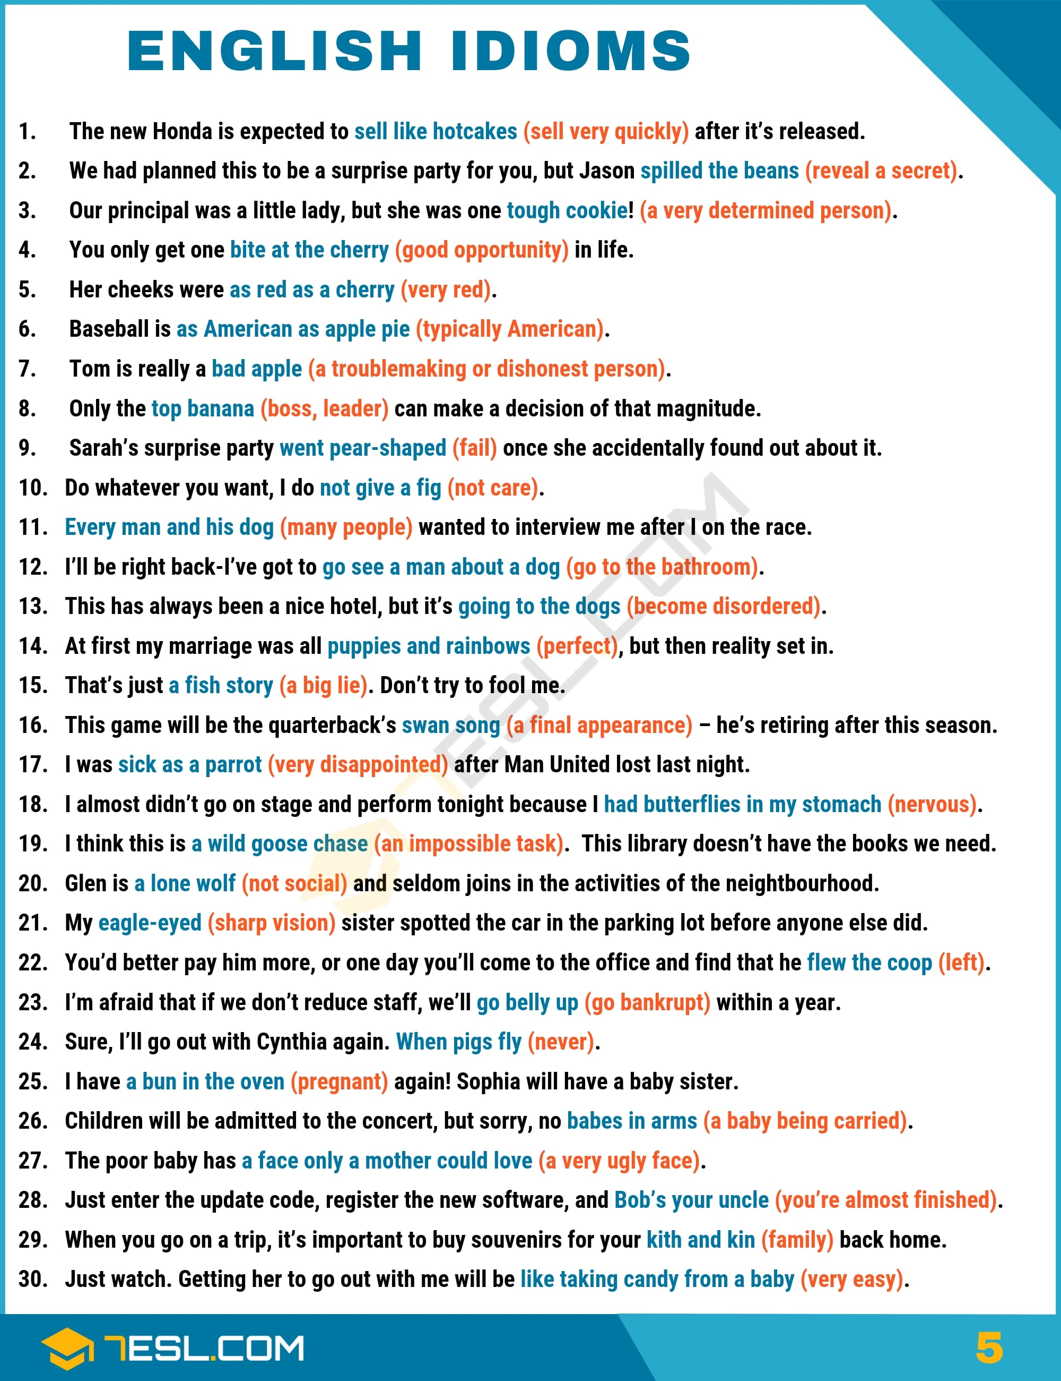Pin

Idioms (M)
List of common English idioms that start with M.
Mad As A Box Of (Soapy) Frogs: extremely mentally unstable; psychotic; detached from reality.
Mad as A Hatter: Mentally ill, psychotic
Main Squeeze: Committed romantic partner
Make a Break for It: Try to escape, run off
Make a Mountain out of a Molehill: To take something too seriously; to make too much of something
Make a Silk Purse out of a Sow’s Ear: Turn something ordinary or inferior into something refined and beautiful
Make Ends Meet: Have enough money to cover basic expenses
Make Hay (While the Sun Shines): To take advantage of an opportunity at the right time.
Make Love: To have sexual intercourse
Make Nice: Act cordial despite conflict
Make One’s Mark: Attain influence or recognition
Make Someone’s Day: Do something pleasing that puts someone in a good mood
Make Waves: Cause controversy, disturb a calm group dynamic
Man Cave: A part of the house, often the basement, that is left to the man of the household, perhaps with a workshop, a television for watching sports, etc.
March to the Beat of Your Own Drum: When someone does things the way they want to, without taking anybody else or anything else into consideration.
Match Made in Heaven: A relationship in which the two people are great together, because they complement each other so well
May-December (adj.): Significantly different in age. Said of couples where one member is much older. The most common usage is May-December romance.
May-December Marriage: A marriage between a younger and an older partner, typically a young woman and an old man.
Me Time: Activities undertaken for one’s own enjoyment, free from responsibilities to others.
Meeting of the Minds: Strong instinctive agreement on something
Mend Fences: Improve relations after a dispute
Mind One’s P’s and Q’s: Be attentive to details; be on one’s best behavior
Miss the Boat: Be too late for something; miss an opportunity
Monday Morning Quarterback: Someone who offers criticisms or comments after already knowing the outcome of something
Month of Sundays: A long time, many months
More Fun Than A Barrel of Monkeys: A very good time; a pleasant occasion
Mother Nature: The natural world
Move Heaven and Earth: Take all possible steps in trying to accomplish something
Move the Needle: Have a measurable effect on something
Move Up in the World: Become more successful
Movers and Shakers: Influential people, especially in a particular field
Much Of A Muchness: Essentially equal, not significantly different (said of a choice)
Mum’s the Word: This is secret; don’t talk about this. Often used as an answer to a request not to talk about something.
Music to My Ears: Good to hear; welcome news
Mutton Dressed Up as Lamb: A woman who dresses in a style appropriate to someone of a younger age
My Dogs Are Barking: My feet hurt.
My Old Man, My Old Lady: My spouse
My Way or the Highway: If you do not do things the way I want or require, then you can just leave or not participate.

Idioms (N)
List of common English idioms that start with N.
Nail-Biter: A suspenseful event
Nailing Jelly/Jello/Pudding To A Wall/Tree: An impossible task
Neck and Neck: Very close in a competition, with neither of two entities clearly in the lead
Neck of the Woods: A region, especially one’s home region
Nest Egg: Retirement savings; wealth saved for a future purpose
Never in A Million Years: Absolutely never
Never Look a Gift Horse in the Mouth: It’s rude to examine a gift closely; accept gifts politely.
New Wrinkle: A novel aspect to a situation, a new development
Nice Chunk of Change: A large amount of money
Nickel and Dime: To negotiate over very small sums; to try to get a better financial deal, in a negative way
Nine Times Out of Ten: Almost always
Nine-to-Five Job: A routine job in an office that involves standard office hours
Nip (Something) In The Bud: Deal with a problem before it becomes large
No Holds Barred (usually adj., often hyphenated): Unrestricted, without rules
No Love Lost Between: There is a mutual animosity between two people
No Names, No Pack Drill: By not accusing anyone specifically, I may avoid trouble.
No Names, No Pack Drill: If no one can be identified, no one will be punished.
No Rhyme or Reason (to): Without logic or pattern
No Room to Swing A Cat: Very small, not big enough
No Shit, Sherlock: That’s very obvious!
No Tree Grows to the Sky: Growth cannot continue indefinitely.
Not Cut Out for (Something): Not naturally skillful enough to do something well
Not Enough Room to Swing a Cat: A very small space
Not Give A Fig: To not care at all about something
Not Have A Cat In Hell’s Chance: Have no possibility of succeeding, coming to pass, or achieving something
Not Have a Prayer: Have no chance of success
Not Know Jack: Not know anything
Not Lift a Finger: Do nothing to help
Not Mince Words: Moderate or weaken a statement
Not One’s Cup of Tea: Not something one is interested in
Not Playing with A Full Deck: Stupid, mentally deficient or impaired
Not Ready for Prime Time: Not yet perfected; inexperienced
Not Sit Well with (Someone): Be difficult to accept; make someone uncomfortable
Nothing to Write Home About: Unspectacular, ordinary
Nuts and Bolts: Everyday details of something
Nutty as a Fruitcake: Crazy; idiotic; wacky.

Idioms (P)
List of common English idioms that start with P.
Pack Heat: Carry a gun
Paddle One’s Own Canoe: To be able to act independently.
Page-Turner: A page-turner is an exciting book that’s easy to read, a book that’s difficult to put down.
Pain in the Ass; Pain in the Butt;
Pain in the Neck: Someone or something making your life difficult
Paint the Town Red: Go out drinking and partying
Par for the Course: What would normally be expected. This has a negative connotation.
Pass the Buck: Transfer a problem to someone else
Pass With Flying Colors: To succeed brilliantly, as on an exam or other test
Passing Fancy: A temporary interest or attraction
Pay Through the Nose (For Something): Pay a large amount of money
Peaches and Cream: A situation, process, etc., that has no trouble or problems
Pecking Order: Hierarchy, rank of importance
Pencil Something In: Make tentative arrangements
Penny-Pinching: Frugal, avoiding expenses whenever possible
Pep Talk: An encouraging speech given to a person or group
Perfect Storm: A rare combination of disastrous occurrences
Pet Peeve: A small thing that you find particularly annoying
Pick a Fight: Intentionally provoke a conflict or fight with someone
Pick Up the Slack: Do something that someone else is not doing; assume someone else’s responsibilities
Pick Up the Tab: To pay a bill presented to a group, especially in a restaurant or bar
Pie in the Sky: Something that is unrealistic or that cannot be achieved
Piece of Cake: Very easily done
Pin Someone Down: Demand a decision or clear answer
Pinch Pennies: To be careful with money, to be thrify
Pink Slip: A layoff notice; loss of a job, typically because of layoffs
Pipe Dream: An unrealistic hope, a fantasy
Piping Hot: Very hot (generally said of food)
Pipped to the Post: Defeated by a narrow margin
Pissing Contest: A meaningless argument or competition, typically between males
Play Ball: Cooperate, agree to participate
Play Cat And Mouse: Trying to trick someone into making a mistake so you can defeat them.
Play Hardball: Adopt a tough negotiating position; act aggressively
Play it by Ear: To play a piece of music without referencing sheet music or a recording
Play It by Ear: To respond to circumstances instead of having a fixed plan
Play the Percentages: Bet on or rely on what is most likely to happen
Play the Ponies: Bet on horse racing.
Play With Fire: Do something very risky
Play Your Cards Right: Exploit a situation to your best advantage
Point of No Return: A place from which it is impossible to go back to the starting point
Point the Finger At: Blame (someone)
Point the Finger: At Blame (someone)
Poison Pill (n): A provision or feature added to a measure or an entity to make it less attractive, an undesirable add-on
Poison Pill: A provision or feature added to a measure or an entity to make it less attractive, an undesirable add-on
Pop One’s Clogs: To die
Pop One’s Cork: To release one’s anger; to blow one’s top
Pop the Question: Propose marriage
Pot Calling the Kettle Black: Accusing someone of something of which you are also guilty; being hypocritical
Pour (Rub) Salt into (on) the Wound (an open wound): Worsen an insult or injury; make a bad situation worse for someone
Powder Keg: An explosive situation, a situation in which people are angry and ready to be violent
Powder Keg: An explosive situation, a situation in which people are angry and ready to be violent
Powder One’s Nose: To use the restroom (lavatory). This is used by women
Preach to the Choir, Preach to the Converted: To make an argument with which your listeners already agree
Preaching to the Choir: Making arguments to those who already agree with you
Pretty Penny: A lot of money; too much money (when referring to the cost of something)
Price Yourself Out of the Market: Try to sell goods or services at such a high price that nobody buys them.
Puddle Jumper: A small airplane, used on short trips
Pull Out All the Stops: Do everything possible to accomplish something
Pull Strings: Use influence that’s based on personal connections
Pull the Plug On: Terminate (something)
Pull Yourself Together: Control your emotions; recover from a strong emptional upset
Puppies And Rainbows: Perfect, ideal (usually used slightly sarcastically, in contrast with a less ideal situation)
Puppy Dog Eyes: A begging look
Puppy Love: Adolescent love or infatuation, especially one that is not expected to last
Pure as the Driven Snow: To be innocent and chaste (frequently used ironically)
Push the Envelope: Go beyond common ways of doing something, be innovative
Pushing Up Daisies: Dead
Pushing Up Daisies: Dead and buried
Put a Thumb on the Scale: Try to influence a discussion in an unfair way, cheat
Put Down Roots: Establish oneself in a place; settle
Put in One’s Two Cents: Say your opinion
Put Lipstick on a Pig: Make cosmetic changes to something bad
Put one’s Face On: Apply cosmetics
Put Out Feelers: Make discreet, informal suggestions, ask around
Put Someone on the Spot: Force someone to answer a question or make a decision immediately
Put That in Your Pipe and Smoke It: Accept and consider what I’m saying, even if you don’t like it!
Put the Best Face On (Something): Emphasize the positive aspects of a bad situation
Put the Brakes On: Slow something down
Put the Cart Before The Horse: To do things in the wrong order
Put the Cart Before the Horse: To do things out of the proper order.
Put the Cat Among The Pigeons: Say or do something that causes trouble or controversy
Put the Genie Back in the Bottle: Try to suppress something that has already been revealed or done
Put the Pedal to the Metal: Drive as fast as possible
Put Up with (Something): Tolerate, accept
Put Words Into Someone’s Mouth: Attributing an opinion to someone who has never stated that opinion
Put Your Foot Down: Use your authority to stop negative behavior
Put Your Foot In Your Mouth: Say something that you immediately regret
Put Your Money Where Your Mouth Is: Back up your opinions with a financial commitment
English Idioms Examples with Idiom Meaning | Image 6
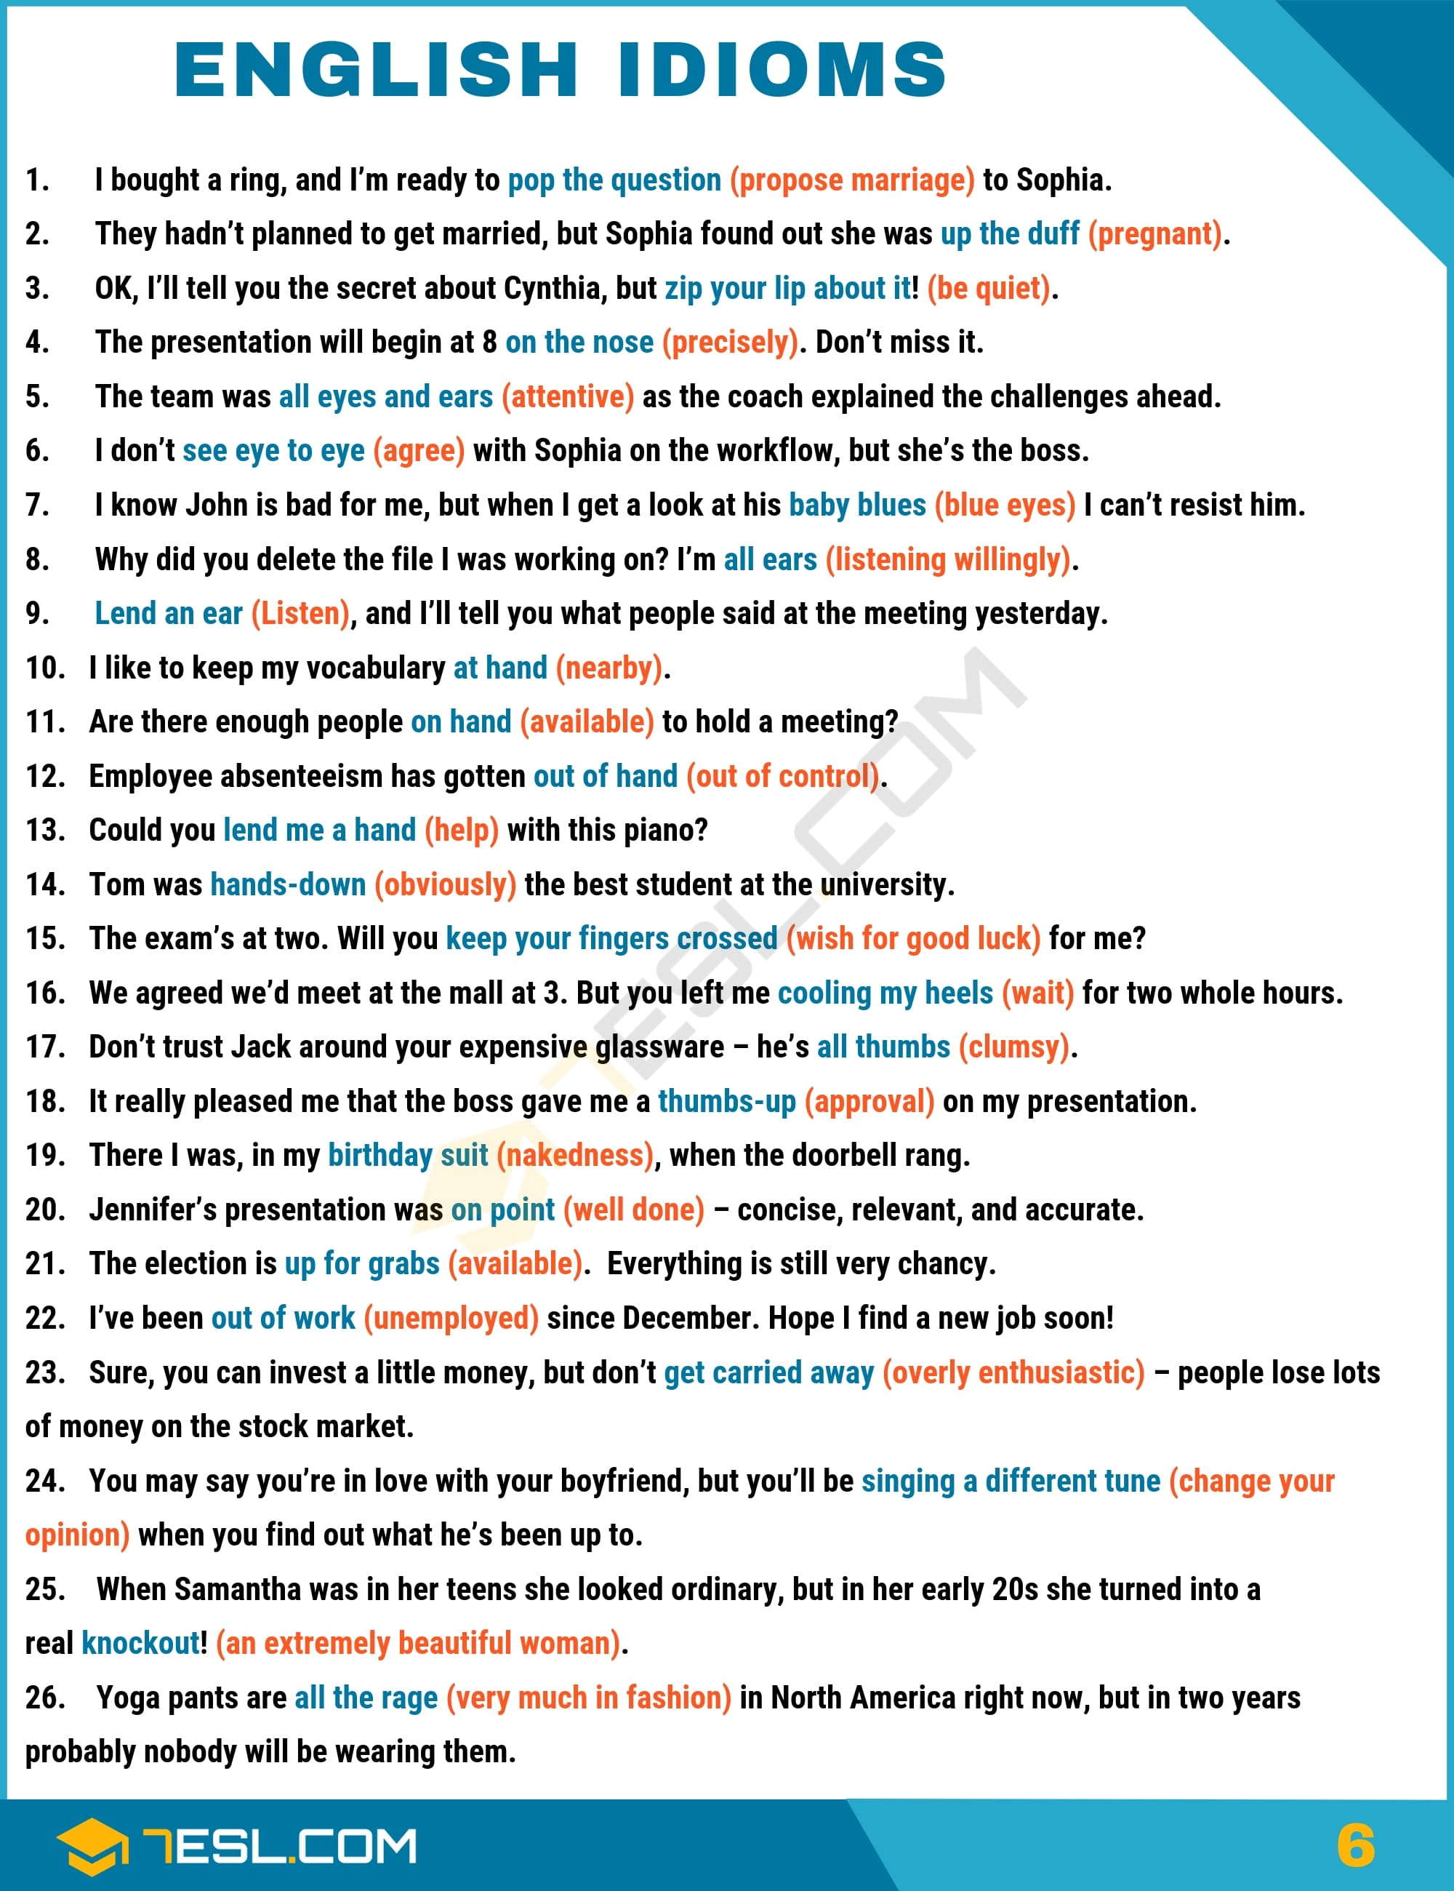Pin

Idioms (Q)
List of common English idioms that start with Q.
Quake In One’s Boots: To be very frightened
Quarter Past: Fifteen minutes after the hour
Quarter To/Of: Fifteen minutes before the hour
Queer the Pitch: Interfere with someone’s plans; make something more difficult
Quick as a Flash: Very fast
Quick-and-Dirty: Approximate, hastily done
Quote Unquote: Ironically speaking; suggesting that if a phrase were written out, it would be in quotation marks to convey sarcasm

Idioms (R)
List of commonly used English idioms that start with R.
Race Against Time: To rush to meet a deadline, to be forced to do something very quickly
Rain Cats And Dogs: Rain heavily
Rain Cats and Dogs: Rain very heavily
Rain on Someone’s Parade: Spoil someone’s plans
Raise (Someone’s) Hackles: Make someone angry and defensive
Raise One’s Voice: Talk loudly
Raise Red Flags: Warn of trouble ahead
Raise the Bar: Increase standards in a certain competition or area of endeavor
Raise the Roof: Make a great deal of noise (said of a crowd)
Rake (Someone) Over the Coals: To scold someone severely
Rake Over the Ashes: Restart a settled argument; examine a failure
Rake Someone Over the Coals: Scold severely
Rank and File: The ordinary members of an organization
Read Between the Lines: Perceive what is not explicitly stated
Read the Tea Leaves: Predict the future from small signs
Rear Its Ugly Head (said of a problem or something unpleasant): Appear, be revealed
Rearrange the Deck Chairs on the Titanic: Taking superficial actions while ignoring a much larger and perhaps fatal problem
Red Flag: A warning; a sign of trouble ahead
Red Herring: A misleading clue; something intended to mislead
Red Meat: Political appeals designed to excite one’s core supporters; demagoguery
Red Tape: Bureaucracy; difficult bureaucratic or governmental requirements
Red-Light District: A neighborhood with many houses of prostitution
Reinvent the Wheel: Devise a solution to a problem for which a solution already exists
Riding High: Enjoying success
Right as Rain: Absolutely correct
Right Under (One’s) Nose: In an obvious location, yet overlooked
Right-Hand Man: Chief assistant
Right-Hand Man: Chief assistant
Ring a Bell: Sound familiar
Ring a Bell: When something seems familiar
Rob Peter to Pay Paul: Pay off a debt with another loan; solve a problem in such a way that it leads to a new problem
Rob the Cradle: To be sexually or romantically involved with someone who is very young
Rob the Cradle: To be sexually or romantically involved with someone who is very young
Rock Bottom: An absolute low point
Rock the Boat: Cause a disruption in a group. Often used in the negative: don’t rock the boat.
Roll the Dice On: Take a risk
Roll With the Punches: Deal with problems by being flexible
Rome Wasn’t Built in a Day: Complex projects take time
Rookie Mistake: An error made by an inexperienced person
Rotten to the Core: Entirely evil
Rub (Something) in Someone’s Face: Humiliate someone by repeating and criticizing his or her mistake
Rub It In: Say something that makes someone feel even worse about a mistake
Rub Someone’s Nose in (Something): Humiliate someone by repeating and criticizing his or her mistake
Rubber-Stamp (v.): Approve something without consideration, as a formality
Rule of Thumb: A general principle or guideline, not a specific formula
Run a Tight Ship: Manage an organization in a strict, well-regulated way
Run in the Family: Be inherited (as a trait) by multiple members of a family
Run in the Family: To be a common family characteristic
Run into a Buzz: Saw Encounter severe and unexpected problems
Run into a Buzz: Saw Encounter severe and unexpected problems
Run off at the Mouth: Talk a lot about unimportant things, talk incoherently
Run on Fumes: To be in a situation where one’s energy or resources is almost exhausted
Run Out of Steam: Lose momentum, become tired
Run the Table: Win every game or contest

Idioms (S)
List of commonly used English idioms that start with S.
Sacred Cow: An indvidual or organization that one cannot criticize
Saving Grace: Something that redeems a bad situation
Scare the Living Daylights Out of Someone: Frighten someone severely
Scorched Earth (Tactics, Policy, etc.): Ruthless, extremely destructive
Screw The Pooch: To make a serious error
School Of Hard Knocks: Difficult real-life experiences from which one has learned
Second Banana: A person in a subservient position
Second Stringer: A substitute player in a sport; a substitute for a job who is not the most talented person
Second Wind: Renewed energy
See Eye to Eye: To concur, agree
See Something Out of the Corner of Your Eye: Use peripheral vision
Seize (Take) the Bull By the Horns: Attack a problem directly
Seize the Day: Take an opportunity
Sell (Someone) a Bill of Goods: Trick someone; be deceptive
Sell Like Hotcakes: Be sold very quickly
Selling Point: An attractive feature of something for sale
Set in Stone: Fixed; unchangeable
Set something to Music: To write a piece of music to accompany a set of words
Set the Bar (Too) High: To set a high standard for something
Set the Thames on Fire: Do something amazing. Usually used in the negative.
Set the World on Fire: Do something amazing; have a brilliant stretch in one’s career
Shake the Dust off Your Shoes (Feet): Make a clean break with a relationship or situation
Shape Up or Ship Out: Behave properly or leave the organization
Sharp as A Tack: Mentally agile
Shell Game: A method of deception in which you conceal your actions by moving something frequently
Shift Gears: Change the subject, or change what one is doing
Shipshape And Bristol Fashion: Tidy, clean
Shit a Brick: Be extremely fearful.
Shoot from the Hip: Talk or act without consideration
Shoot Off One’s Mouth: Talk without considering one’s words
Shoot Oneself In The Foot: Do something that damages oneself or one’s own cause
Short Fuse: A quick temper; a tendency to anger quickly
Shot Across the Bow: A warning of more serious actions to come
Shoulder A Weight Off Your Shoulders: You no longer worry about something or deal with something difficult
Show Me an X And I’ll Show You a Y: There is a consequence to X that you may not have thought of.
Show One’s True Colors: Reveal one’s true nature
Show Your Cards: Reveal your resources or plans
Sick and Tired of: Extremely annoyed by something that occurs repeatedly
Sick as a Dog: Extremely ill.
Sick as a Parrot: Very disappointed
Sight for Sore Eyes: A sight that makes you happy
Silver Bullet: Something simple that resolves a difficult problem
Simmer Down: Become less angry; regain one’s composure
Sink or Swim: Fail or succeed
Sing a Different Tune: Change your opinion
Sit On (Something): Delay revealing or acting on something
Sit Tight: Wait and do not go anywhere
Sitting Duck: Something or someone easily attacked or criticized
Sitting Pretty: In a favorable situation
Six Feet Under: Dead and buried
Six Feet Under: Dead and buried
Six of One, a Half Dozen of the Other: The two choices have no significant differences.
Six Ways to (from) Sunday: In every possible way
Slam Dunk: An effort that is certain to succeed
Sleep Like a Baby: To experience a very deep and restful sleep; to sleep soundly
Sleep with the Fishes: Dead, often by murder
Slip Someone a Mickey: Add a drug to an alcoholic drink in order to knock someone out
Slippery Slope: A series of undesirable effects that, one warns, could result from a certain action
Slower than Molasses: Exceptionally slow or sluggish; not fast at all.
Small Beer: Unimportant, insignificant
Small Fry: People or organizations with little influence; children
Small Potatoes: Unimportant, insignificant
Smell a Rat: Suspect deception
Smoking Gun: indisputable evidence of a crime
Snafu: A malfunction; a chaotic situation
Snake Oil: A useless medicine; a quack remedy; a product or measure promoted as a solution that really does nothing to help
Snake Oil: Medicine of unproven value; fraudulent medicine
Sneak Peek: A sneak peek is an opportunity to view something in advance of its official opening or debut
Soak Up the Sun: To enjoy the sun
Sold On (Something): Convinced of something
Some Eggs: Achieving a major goal requires the ability to tolerate some problems
Someone’s Fingerprints Are All Over (Something): Someone’s influence is evident
Something to Crow: About Something to be proud of, an accomplishment about which one is justified in bragging
Son of a Gun: 1) A rogue. 2) An exclamation of surprise.
Sore Point: A sensitive topic for a particular person
Sour Grapes: Disparagement of something that has proven unattainable
Sour Grapes: Spiteful disparagment of a goal one has failed to achieve
Spare The Rod And Spoil The Child: It is necessary to physically punish children in order to raise them right.
Speak of the Devil (and He Shall Appear): The person we have just been talking about has entered.
Speak with A Plum in (one’s) Mouth: To speak in a manner that is indicative of a high social class.
Spick and Span: Clean and neat
Spill the Beans: Reveal a secret
Spin A Yarn: Tell a story
Spin One’s Wheels: Engaging in activity that yields no progress; getting nowhere
Spit into The Wind: Wasting time on something futile
Spoiling for a Fight: Combative, wanting conflict, eager to argue or fight
Spoiling for a Fight: Combative, wanting conflict, eager to argue or fight
Square the Circle: Attempt an impossible task
Stab Someone in the Back: To betray (somebody)
Stalking Horse: Someone who tests a concept in advance of its application; a candidate who enters a political race in order to test the strength of the incumbent
Stand (Someone) In Good Stead: Be useful in the future
Stand On One’s Own Two Feet: To be independent and self-sufficient
Stand One’s Ground: Refuse to back down; insist on one’s position
Start with a Clean Slate: To start (something) again with a fresh beginning; to work on a problem without thinking about what has been done before
Steal Someone’s Thunder: Upstage someone
Stem the Tide: To stop or control the growth of something, usually something unpleasant.
Step Up One’s Game: Work to advance to a higher level of a competition
Step Up to the Plate: Prepare to take action, be the person in a group who takes action
Stick It to the Man: Do something that frustrates those in authority
Stick Your Nose into Something: Intrude into something that is not your affair
Sticker Shock: Surprise at the high price of something
Stick-in-the-Mud: A person who dislikes or adapts slowly to new ideas
Sticky Wicket: A difficult, tricky situation
Stiff-Necked: Stubborn; excessively formal
Storm in a Teacup: A commotion that dies down quickly, about something unimportant
Stormy Relationship: Relationship that has a lot arguments and disagreement
Stumbling Block: An obstacle, physical or abstract
Straight Arrow: An honest, trustworthy person
Strain at a Gnat and Swallow a Camel: To make a fuss over something unimportant while ignoring larger issues
Strike A Chord: Used to describe something that is familiar to you, reminds you of something or is connected to you somehow.
Sugar Daddy: A rich man who is generous with younger women in return for sexual favors
Sure-Fire: Certain to occur
Swan Song: A final appearance
Swan Song: This expression is used to describe a final act before dying or ending something.
Sweep Under the Carpet: Attempt to temporarily conceal a problem or error
Sweep Under the Rug: Attempt to temporarily conceal a problem or error
Sweet Dreams!: Sleep well!
Sweeten the Deal: Add something to an offer during a negotiation
Sweeten the Pot: Increase the amount of winnings potentially available in a game of chance, especially poker
Swim Against the Tide: Do something contrary to a trend or usual opinion
Swim with Sharks: To take a major risk
Swim with the Fishes: Have been killed, especially with involvement of organized crime
Swing for the Fences: Attempt to achieve the largest accomplishment possible
Swing for the Fences: Attempt to achieve the largest accomplishment possible
Sword of Damocles: Something that causes a feeling of constant threat.

Idioms (T)
List of useful English idioms that start with T.
Take (Someone) to the Cleaners: 1) Swindle; 2) defeat badly
Take a Deep Dive (Into): Explore something extensively
Take a Flyer: To take a rise; especially to make a speculative investment
Take a Gander: Go to take a look at something
Take a Hike: Go away
Take A Powder: To leave, especially in order to avoid a difficult situation
Take a Rain Check: Decline an invitation but suggest that you’ll accept it at a later time.
Take Five (Ten): Take a short break of five (ten) minutes
Take Five: To take one brief (about five minutes) rest period
Take It Easy: 1) Relax, rest; 2) (as a command) Calm down!
Take It Easy: Don’t hurry; relax; don’t get angry
Take It Easy: When you relax, or do things at a comfortable pace, you take it easy.
Take It on The Chin: Be attacked; suffer an attack
Take It or Leave It (command): You must decide now whether you will accept this proposal
Take Someone to Task: Reprimand someone strongly
Take Something with a Pinch (grain) of Salt: If you take what someone says with a pinch of salt, you do not completely believe it.
Take the Cake: Be the most extreme instance
Take the Edge Off (of Something): To slightly improve something negative
Take the Fifth: Refuse to answer because answering might incriminate or cause problems for you
Take the Gloves Off: Negotiate in a more aggressive way
Take the High Road: Refuse to descend to immoral activities or personal attacks
Take The Mickey (Piss) (Out Of Someone): Make fun of or ridicule someone
Take the Shine Off (Something): To do something that diminishes a positive event
Take the Starch out of (Someone): Make someone less confident or less arrogant
Take The Wind Out of Someone’s Sails: To reduce someone’s confidence, ofte by doing something unexpected
Take Your Life in Your Hands: Undergo extreme risk
Take Your Medicine: Accept something unpleasant, for example, punishment, without protesting or complaining
Take Your Time: Don’t hurry, work at a relaxed pace
Taste of Your Own Medicine: The same unpleasant experience or treatment that one has given to others
Teach an Old Dog New Tricks: To change someone’s long-established habits. Usually used in the negative: You can’t teach an old dog new tricks.
Tear One’s Hair out: Be extremely worried or frustrated
Tear-Jerker: A film or book that makes you cry
Tee Many Martoonies: Too many martinis, scrambled to suggest drunkenness
Tell It to the Marines: I don’t believe you; you must think I’m gullible.
Tempest in a Teapot: A commotion about something unimportant
Ten a Penny: Ordinary, inexpensive
Ten to One: Something very likely
Test the Waters: Experiment with something cautiously
Test the Waters: Try something out in a preliminary way
Tie the Knot: Get married
Tighten the Screws: Increase pressure on someone
Tight-Lipped: secretive, unwilling to explain something
Til the Cows Come Home: For a very long time
Time is Money: time is valuable, so don’t waste it.
Tip of the Iceberg: A small, visible part of a much larger problem
Tip One’s Hand: Reveal one’s advantages; reveal useful information that one possesses
TLC: Tender Loving Care
To be A Peach: Someone or something that is extremely good, impressive, or attractive
To be Smitten With Someone: To be completely captivated by someone and feel immense joy
To be someone’s One and Only: To be unique to the other person
To be the Apple of Someone’s Eye: To be loved and treasured by someone
To Bear Fruit: To develop in a profitable or positive way
To Bear Fruit: To develop in a profitable or positive way
To Carpool: To travel to the same place with a group of people in one car. e.g. work/school
To Each His Own: People have different tastes.
To Get Cold Feet: To experience reluctance or fear
To Have a Chip on One’s Shoulder: To be combative, to be consistently argumentative
To Have Butterflies In Your Stomach: To be nervous
To Have One For the Road: To have one last (alcoholic) drink before you go home
To Pay an Arm and a Leg: A very high cost
To Pop (one’s) Cherry: To do something for the first time
To Pull Someone’s Leg: Lie playfully
To Run Hot and Cold: To be unable to make up one’s mind
To the Letter: Exactly (said of instructions or procedures)
Toe the Line: Accept authority, follow the rules
Tone-Deaf: Not good at perceiving the impact of one’s words, insensitive
Tongue-in-Cheek: Said ironically; not meant to be taken seriously
Too Busy Fighting Alligators to Drain the Swamp: So occupied with multiple challenges that one can’t keep the big picture in mind
Too Many Cooks Spoil the Broth: A project works best if there is input from a limited number of people
Too Many Chiefs and Not Enough Indians: Everyone wants to be a leader, and no one wants to do the actual work
Too Many To Shake A Stick At: A large number
Toot Your Own Horn: Brag; emphasize one’s own contributions
Top Banana: The boss, the leader
Toss a Wrench (Spanner) Into: Sabotage; cause a process to stop
Touch Base: Meet briefly with someone
Touch One’s Heart: Affect someone emotionally, be touching
Touch Water: Be launched. Said of a boat.
Tough Cookie: A very determined person
Tough Cookie: Someone who can endure hardship; especially: a strong negotiator
Tough Sledding: Difficult progress
Turn a Blind Eye: (to) Choose not to notice something
Turn on a Dime: Quickly reverse direction or position
Turn Someone Inside Out: To cause strong emotional turmoil; to completely change someone
Turn Something on Its Head: Reverse something, cause something to be done in a new way
Turn Turtle: Capsize, turn over
Turn the Corner: To begin to improve after a problem
Turn the Tables: Reverse a situation
Turnabout Is Fair Play: If you suffer from the same suffering you have inflicted on others, that’s only fair
Twenty-Four Seven: At any time
Twist the Knife (in Deeper): Make someone’s suffering worse
Twist the Knife (in Deeper): Make someone’s suffering worse
Two a Penny: Ordinary, inexpensive
Two Peas in A Pod: Two people who are very similar in appearance
Thank God It’s Friday (TGIF): Let’s be happy that the workweek is over!
That Ship Has Sailed: That opportunity has passed.
That’s Music to My Ears: I am very happy to hear this.
That’s a Stretch: What you are suggesting is very difficult to believe; I am very skeptical
That’s All She Wrote: That was the end of the story.
The Apple Never Falls Far From the Tree: Family characteristics are usually inherited
The Birds and the Bees: Human sexuality and reproduction
The Cat Is Out of the Bag: The secret has been revealed.
The Coast Is Clear: We are unobserved; it is safe to proceed.
The Cherry On the Cake: The final thing that makes something perfect
The Deck Is (The Cards Are): Stacked Against You Unfavorable conditions exist.
The Jig Is Up: A secret illicit activity has been exposed; your trickery is finished
The More Things Change, The More They Stay The Same: Although something may seem superficially new, it has not altered the basic situation.
The Only Game in Town: The sole option for a particular service.
The Powers That Be: People in charge, often used when the speaker does not want to identify them.
The Real McCoy: A genuine item
The Story Has Legs: People are continuing to pay attention to the story.
The Time is Ripe: If you say that the time is ripe, you mean that it is a suitable point for a particular activity
The Walls Have Ears We: may be overheard; be careful what you say
The Walls Have Ears: We may be overheard; be careful what you say
The Whole Enchilada: All of something.
The Whole Shebang: Everything, all the parts of something
The World Is Your Oyster: You have many opportunities and choices.
There But For The Grace Of God Go I: I could easily have done what that person did.
There’s More Than One Way to Skin a Cat: There’s more than one way of achieving a certain goal.
There’s No Such Thing as a Free Lunch: Nothing is given to you without some expectation of something in return.
Thin On The Ground: Rare, seldom encountered
Think Big: Consider ambitious plans; avoid becoming overly concerned with details
Think Outside the Box: Try to solve a problem in an original way; think creatively
Think Tank: A group of experts engaged in ongoing studies of a particular subject; a policy study group
Think Tank: A group of experts engaged in ongoing studies of a particular subject; a policy study group
Third Rail: A topic so sensitive that it is dangerous to raise. This is especially used in political contexts
Third Time’s a Charm: Even if you fail at something twice, you may well succeed the third time.
Thirty-Thousand-Foot View: A very broad or general perspective
This Has (Person X) Written All Over It: [Person X] would really like or be well suited to this.
This Is Not Your Father’s ____: This item has been much updated from its earlier versions.
Three Sheets to the Wind: Very drunk
Through the Grapevine: Via gossip
Through Thick and Thin: In good times and bad
Throw a Wet Blanket on (Something): Discourage plans for something
Throw a Wrench Into: To sabotage; to cause to fail
Throw Caution to the Wind: To act in a daring way, without forethough
Throw Down the Gauntlet: To issue a challenge
Throw Elbows: Be combative; be aggressive (physically or figuratively)
Throw in the Towel: To give up, admit defeat
Throw Someone for a Loop: Deeply surprise someone; catch someone off guard
Throw Someone Under the Bus: Sacrifice someone else’s interests for your own personal gain
Throw the Baby Out with the Bath Water: Eliminate something good while discarding the bad parts of something
Throw the Baby Out with the Bath Water: To discard something valuable or important while disposing of something worthless
Throw The Book At: Prosecute legally as strongly as possible
Throw the Fight: Intentionally lose a contest, usually in collusion with gamblers
Throw the Game: Intentionally lose a contest, usually in collusion with gamblers
Throw the Match: Intentionally lose a contest, usually in collusion with gamblers
Thumbs-Up: Approval
Train Wreck: Anything that develops in a disastrous way
Trash Talk: Insults directed at one’s opponent in a sporting event or contest
Tread Water: Maintain a current situation without improvement or decline
Trial Balloon: A test of someone’s or the public’s reaction
Trip the Light Fantastic: Dance well; do ballroom dancing

Idioms (U)
List of useful English idioms that start with U.
U Turn: A complete change of opinion, direction, etc.
Ugly Duckling: An awkward child or young person who grows into a beautiful person
Under (Below) the Radar: Not generally perceived, below popular consciousness
Under Someone’s Spell: Fascinated, entranced by someone
Under the Impression: Believing something, perhaps mistakenly
Under the Table: Without being officially recorded
Under the Weather: Feeling ill
Under the Weather: Not feeling well
Under Wraps: Temporarily hidden, secret
University of Life: Difficult real-life experience, as opposed to formal education
Until the Cows Come Home: For a long time
Until You’re Blue in the Face: For a long time with no results
Up a Creek: In a very bad situation
Up for Grabs: Available
Up for Grabs: Available for anyone
Up in Arms: Angry, protesting (usually said of a group)
Up in the Air: Not yet decided
Up to One’s Neck: Nearly overwhelmed
Up to Scratch: Meeting a basic standard of competence or quality
Up to Snuff: Meeting a basic standard
Up the Ante: Raise the stakes; increase the importance of something under discussion
Up the Duff: Pregnant
Upset the Apple Cart: To disorganize or spoil something, especially an established arrangement or plan
Use One’s Head: To think, to have common sense

Idioms (V)
List of useful English idioms that start with V.
Vale of Tears: The world in general, envisioned as a sad place; the tribulations of life
Vicious Circle: A situation in which an attempt to solve a problem makes the original problem worse.
Victory Lap: Visible public appearances after a victory or accomplishment
Virgin Territory: Something that has never been explored, physically or intellectually
Vote with One’s Feet: To physically depart from something as a way of showing disapproval

Idioms (W)
List of useful English idioms that start with W.
Waiting in the Wings: Ready to assume responsibilities but not yet active, ready to become a successor
Waka-Jumping: Change political parties (said of politicians themselves)
Wake Up and Smell the Coffee: Stop deluding yourself
Wake Up on the Wrong Side of the Bed: Be grumpy or ill-humored. Generally used in past tense
Walk on Eggshells: To have to act very sensitively in order to avoid offending someone
Walk the Plank: Be forced to resign a position
Wandering Eye: A tendency to look at and desire women or men other than one’s committed romantic partner
Wandering Eye: A tendency to look at and desire women or men other than one’s committed romantic partner
Wash Your Hands of (Something): Decline to take further responsibility; refuse to be involved with something anymore
Water Under the Bridge: Something in the past that’s no longer worth worrying about
Watering Hole: A place where alcoholic beverages are served, a bar
Weekend Warrior: Someone who has an office job but enjoys contact sports on weekends; a member of a military reserve force (whose exercises are typically on weekends)
We’ll Cross That Bridge: When We Come to It We’ll deal with that problem if and when it comes up
Welsh (Welch) on a Deal: Not observe the terms of an agreement
Wet Behind the Ears: inexperienced, immature, new to something
Wet Behind the Ears: Inexperienced, immature, new to something
Wet Blanket: Someone who dampens a festive occasion
Wet Your Whistle: Drink something
What Do You Make of (Him)?: What is your evaluation of this person?
What Goes Around Comes Around: The kind of treatment you give to others will eventually return to you; things go in cycles
What’s Good for the Goose Is Good for the Gander: What’s OK for a man is OK for a woman, too
When Hell Freezes Over: Never
When In Doubt, Leave It Out: When unsure about something, omit it.
When in Rome, Do as the Romans Do: When you visit a new place, follow the customs of the people there
When It Rains, It Pours: Problems tend to come in groups.
When Pigs Fly: Never
When the Chips Are Down: When a situation becomes urgent or difficult
Where (When) the Rubber: Meets the Road In reality; where an idea meets a real-world test
Where There’s a Will, There’s a Way: If you have a strong desire to accomplish something, you will achieve it even in the face of considerable odds.
Where There’s Smoke, There’s Fire: If there is typical evidence of something, the most likely explanation is that it is actually occurring.
Whisper Sweet Nothings (in Someone’s Ear): Speak meaningless romantic utterances
Whistle in the Dark: To be unrealistically confident or brave; to talk about something of which one has little knowledge
Whistle Past the Graveyard: Remain optimistic despite dangers; be clueless
Whistling Dixie: Being unrealistically optimistic
White Elephant: An unwanted item that is difficult to sell or dispose of
Who’s She, the Cat’s Mother?: Why does she have such a high opinion of herself?
Wild Goose Chase: An impossible or futile search or task
Window Dressing: A misleading disguise intended to present a favorable impression
Window Shop: To look at merchandise in a store without intending to buy it
Witch Hunt: An organized attempt to persecute an unpopular group of people and blame them for a problem.
With Bells On: Eagerly, willingly, and on time.
Work One’s Fingers to the Bone: Work very hard over an extended period
Worn to a Frazzle: Exhausted, completely worn out
Wouldn’t Be Caught Dead: Would absolutely not allow myself to do this
Writing (Handwriting) on the Wall: Hints of coming disaster

Idioms (Y)
List of useful English idioms that start with Y.
Year In, Year Out: Annually without change
You Can Lead a Horse to Water, but You Can’t Make It Drink: It’s very hard to force someone to do something against his or her will.
You Can Say That Again!: I agree totally!
You Can Take It to the Bank: I absolutely guarantee this
You Can’t Judge a Book by Its Cover: You can’t know people (or things) well by their external appearances.
You Can’t Make an Omelet (Omelette): Without Breaking
You Can’t Make Fish of One and Fowl of the Other: People must be treated equally.
You Know the Drill: You are already familiar with the procedure.
You Snooze, You Lose: If you delay or are not alert, you will miss opportunities
Young at Heart: Having a youthful outlook, regardless of age
Your Guess Is as Good as Mine: I don’t know; I have no idea
Your Mileage May Vary: You may get different results. This does not necessarily refer to a car, although it may.
Your Number Is Up: You are going to die (or suffer some bad misfortune or setback)
You’re Driving Me Nuts: To make someone giddy or crazy
Yours Truly: Me

Idioms (Z)
List of useful English idioms that start with Z.
Zero In On: Focus closely on something; take aim at something
Zig When One Should Be Zagging: To make an error; to choose an incorrect course
Zip One’s Lip: Be quiet

Idiom Examples
List of idioms categorized by different topics with meaning and example sentences.

Health Idioms Examples
List of health idiom example sentences with idiom meaning.
- My grandfather was as pale as a ghost (extremely pale) when he entered the hospital.
- The sales manager was at death’s door (very near death) after his heart attack.
- My mother is back on her feet (healthy again) after being sick for two weeks.
- I have been feeling on top of the world (feel very healthy) since I quit my job.
- I’m going under the knife (undergo surgery) next month to try to solve my knee problems. Hope it helps!
- My colleague was looking a little green around the gills (sick) when he came to work today.
- My uncle is very sick and has one foot in the grave (near death).
- Did you have a good vacation? – Not really. I was sick as a dog (extremely ill) the whole time.
- My boss has been under the weather (not feeling well) all week and has not come to work during that time.

Clothes Idioms Examples
List of clothing idiom example sentences with idiom meaning.
- A few years ago Uggs were all the rage (very fashionable), but now you don’t see them so much.
- Jacob is unpredictable. He won’t leave the office for weeks, but then he’ll take off for New York at the drop of a hat (suddenly).
- Wait until you try the new Yamaha scooters. They’ll knock your socks off! (amaze you)
- The carmaker’s sales declined because many consumers found their designs old hat (old-fashioned).

Sports Idioms Examples
List of sport idiom examples with idiom meaning.
- A ballpark figure (a rough estimate) for the cost of the new stadium would be $150,000,000.
- Francesca hit it out of the park (succeed brilliantly) with her speech today. It was fabulous.
- Madrid won most of our matches during the season, but we kicked ass (defeat badly) in the playoffs.
- I’ll call you back in an hour. The speaker is almost finished, and I’m on deck (next).
- I thought I was totally exhausted after mile nine of the race. But then I got my second wind (renewed energy).
- I’ve helped him as much as I can in that class. Now he’s going to have to sink or swim (fail or succeed).
- Maybe you could take a hike (go away) while we discuss salaries.
- After losing his queen, the chess player threw in the towel (give up) and resigned.
- Our competitor’s model dominates the market, so ours is facing tough sledding (difficult progress).
Idiom Examples Image 2
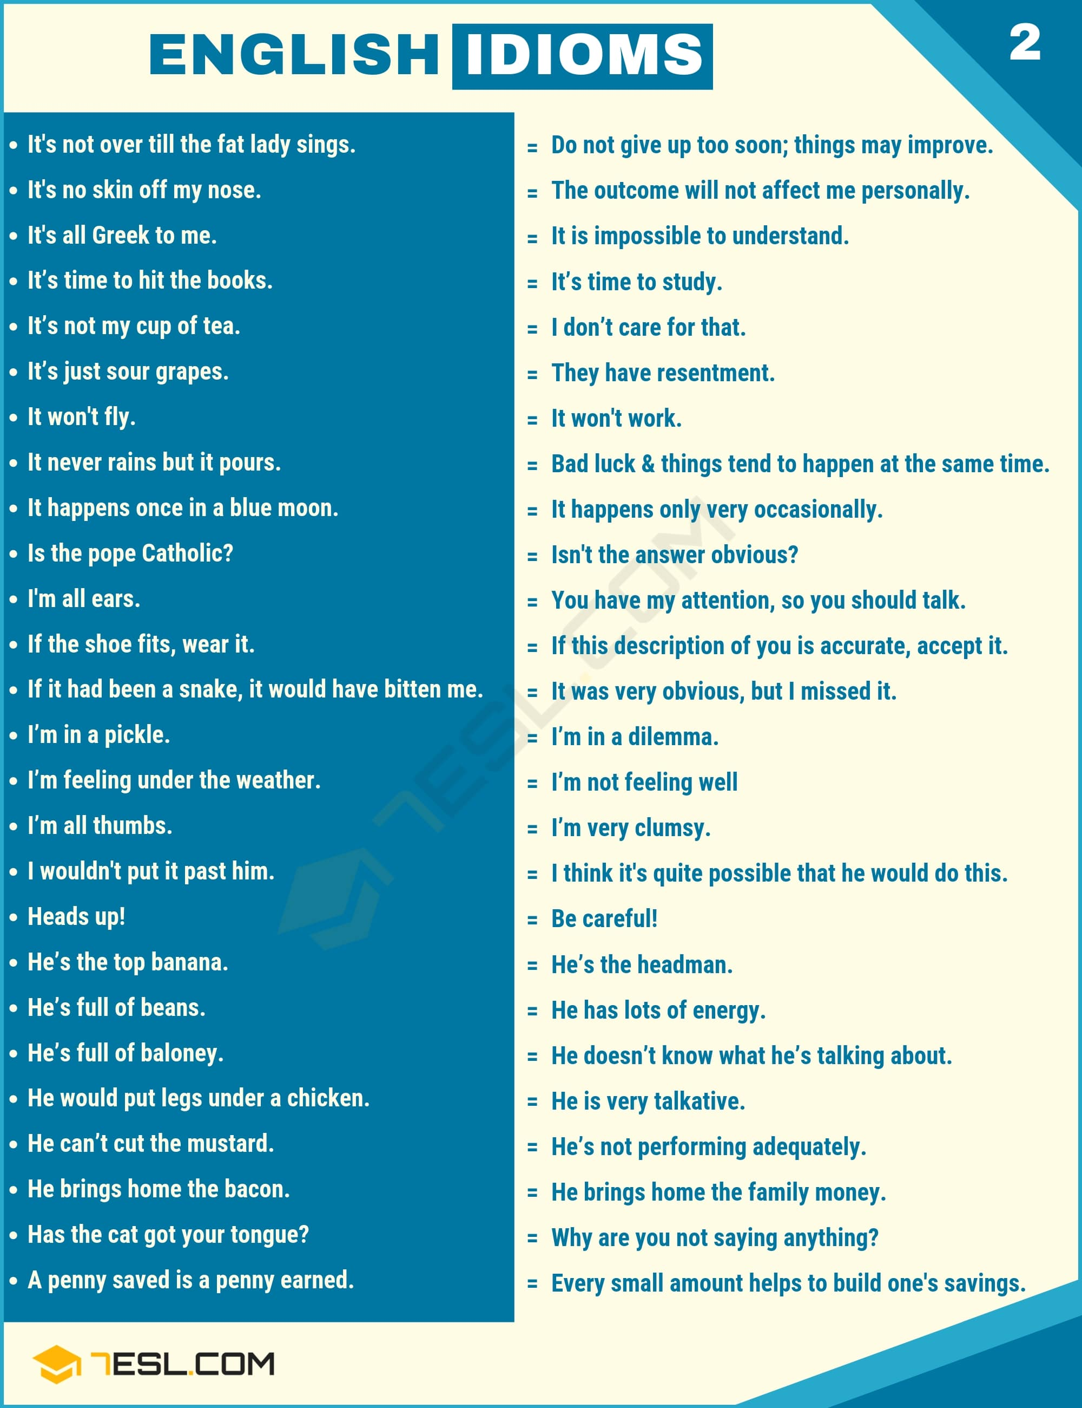Pin

Music Idioms Examples
List of music idiom examples with idiom meaning.
- Can you guys please be quiet? Your chin music (meaningless talk) is distracting me from my work.
- News of the new president was music to my ears (good to hear) – she’s terrific.
- You may say you’re in love with your boyfriend, but you’ll be singing a different tune (change your opinion) when you find out what he’s been up to.
- If you think you can get a ticket for under $200 at Christmastime, you’re whistling Dixie (unrealistically optimistic).

Time Idioms Examples
List of time idiom examples with idiom meaning.
- The restaurant is open around the clock (at all times).
- Blackberry phones used to be extremely popular, but now many people think they’re behind the times (old-fashioned).
- The boxer is ready to call time (end) on his long career.
- You all look tired. Let’s call it a day (stop working).
- Teamwork and training will carry the day (successful).
- Your days are numbered (will die soon) if you keep driving while drunk.
- I’d buy that car in a New York minute (very quickly) if I had the money.
- I had a beautiful family, a nice home, and lots of money. And then, in the blink of an eye (instantaneously), it was all gone.
- Kevin says he was completely in the dark (unaware) about the CEO’s plans to sell the company.
- We were going to leave without you, but you got here just in the nick of time (just in time).
- I’m glad you dropped by! It’s been a month of Sundays (a long time) since I saw you last.
- When I said I would move to New York, she offered me the job on the spot (immediately).
- Once in a blue moon (very rarely) you see the Aurora here, but it’s not like farther north.
- I don’t want to live in the city, but I enjoy visiting once in a while (occasionally).
- We should seize the day (take an opportunity) while prices are low. That won’t last forever.
- Take your time (don’t hurry) on the exam. You don’t get a bonus for finishing quickly.
- If you have problems, call me twenty-four seven (at any time); it doesn’t matter if I’m sleeping.
- Our holiday party is such a bore. Year in, year out (annually without change) the owner makes the same dumb jokes.

Number Idioms Examples
List of number idiom examples with idiom meaning.
- I have a million and one (many) ideas.
- He got home from the party all in one piece (safely).
- The project failed, we’re back to square one (back to the start).
- I’ve been in seventh heaven (extremely happy) ever since I got engaged!
- You don’t have to do this totally by the book (follow instructions exactly).
- I can’t drive, I had one too many (drink too much alcohol).
- Never in a million years (absolutely never) did I think that I would actually win the lottery!
- Nine times out of ten (almost always) your first choice turns out to be the right one.
- I wouldn’t want a nine-to-five job (a routine job).
- When my mom bought me a computer, I was on cloud nine (very happy).
- I put in my two cents (say your opinion) at the meeting.
- Ten to one (very likely) I’m going to win.
- I can try, but completing the whole ad campaign by the end of the month is a tall order (a difficult task).
- The runner was far ahead for most of the race, but at the end she won only by a whisker (a very short distance).

Travel & Transport Idioms Examples
List of travel idiom examples with idiom meaning.
- I’m not really part of your group. If I come to the party I’ll just be a fifth wheel (a superfluous person).
- We better hit the road (leave) before traffic get seven worse.
- New Year’s Eve is just around the corner (occurring soon). Have you made party plans yet?
- My brother just spent a lot of money on really questionable stocks. I think he’s off his trolley (insane).
- I’ll eat dinner on the fly (while traveling) and meet you at 8.
- It’s too late for you to ask her to marry you – she’s involved with someone else now. That ship has sailed (that opportunity has passed).

Car & Driving Idioms Examples
List of car idiom examples with idiom meaning.
- Higher coal prices put the brakes on (slow down) industrial activities in the second quarter.
- I’m late for my best friend’s wedding. Put the pedal to the metal! (drive as fast as possible)
- After work I drove home hell for leather (very fast), but I still missed my daughter’s birthday party.
- It will take time to get the final cost, but a quick-and-dirty (approximate) estimate would be $45,000.
- I’ll have the order done quick as a flash (very fast) – probably by the time you get back to your office.

Technology Idioms Examples
List of technology idiom examples with idiom meaning.
- Sure, come into the office, and we can get the documents you need chop chop (Quickly).
- We’re going to pull the plug on (terminate) our operation in Taiwan. It’s just not succeeding.
- Passing this quiz will be like shooting fish in a barrel (very easy). I’ve studied a lot.
- Jim is a straight arrow (an honest, trustworthy person).

Home Idioms Examples
List of home idiom examples with idiom meaning.
- I’ve locked the door. They’re as safe as houses (very safe).
- She said he’s out of the house of correction (prison).
- After struggling with my homework, I finally threw in the towel (give up) and went to bed.
- That’s a worthless investment. He’s throwing his money down the drain (waste money).
- When I found out Tom crashed my car, I hit the roof (become very angry).
- Jeff smokes like a chimney (smoke a lot). I worry about his health.
- His diet went out the window (disappear) during the holidays.
- Please come in and make yourself at home (make yourself comfortable).
- Cutting-edge (innovative) musical styles often originate in Britain.
- There are just a few difficulties to iron out (resolve), and then we’ll be ready to sign the contract.

Plant Idioms Examples
List of plant idiom examples with idiom meaning.
- You’re going to jump down from that ledge? Are you out of your gourd? (crazy)
- Life isn’t always going to be a bed of roses (comfortable situation). You have to learn to deal with adversity.
- There are a few problems with the new website, but they don’t amount to a hill of beans (unimportant). We did it!
- As anyone who has experienced a hurricane knows, Mother Nature (the natural world) can be a frightening force.
- I’ll be pushing up daisies (dead) before my daughter decides to get married.
- I heard through the grapevine (via gossip) that Ivan and Amber are going out. Is it true?
- Two years ago we had the field to ourselves with this project. Now there are too many competitors to shake a stick at (a large number).

Weather Idioms Examples
List of weather idiom examples with idiom meaning.
- It’ll be a cold day in July (never happen) when our team wins the championship. We’re terrible.
- If you think I’m going to climb that rickety ladder, you’re all wet! (completely mistaken!)
- I stayed up all night studying for that exam, and then it turned out to be a breeze! (very easy!)
- Come hell or high water (no matter what happens), we will be in New York for the meeting tomorrow morning.
- I listen to the music every day, come rain or shine (do regularly).
- Let’s come back soon before the heavens open! (start to rain heavily)
- I made a huge mistake. I stayed up all night studying, and I was in a fog (confused) when it came time to start the exam.
- Old Man Winter (Winter) is hanging around this year-it’s the middle of March, and we still have a lot of snow.
- Cindy was on cloud nine (extremely happy) after her boyfriend proposed to her.
- It’s been raining cats and dogs (rain heavily) all day. I’m afraid the roof is going to leak.
- Once again, John is right as rain (absolutely correct). We should sell the Chicago office building.
- I’m sorry to rain on your parade (spoil someone’s plans), but the park is closed tomorrow, so we can’t have our picnic there.
- Let’s go out and soak up some sun (enjoy the sun).
- If you keep asking him about his ex-girlfriend, you’ll be on thin ice (in a risky situation).
- Tom stole cameras when he worked here. I’ll hire him back when hell freezes over (never).

Appearance Idioms Examples
List of appearance idiom examples with idiom meaning.
- She’s no spring chicken (young), but she’s still very good looking.
- She’s a dead ringer (similar in appearance) for her older sister.
- When Samantha was in her teens she looked ordinary, but in her early 20s she turned into a real knockout! (an extremely beautiful woman).
- Let me just put my face on (apply cosmetics), and I’ll meet you at the restaurant in 15 minutes.

People Idioms Examples
List of people idiom examples with idiom meaning.
- He never made a will, to the best of my knowledge (as far as you know).
- Don’t lend her money. I trust her about as far as I can throw (only slightly) her.
- My grandmother is 92 years old, but she’s still sharp as a tack (mentally agile).
- I’d tell you if you were going around the bend (crazy).

Daily Routines Idioms Examples
List of daily activities idiom examples with idiom meaning.
- OK, I’ll come to the party Friday. But Saturday it’ll be time to hit the books (study).
- I have to get up at 5 tomorrow morning. It’s time to hit the hay (go to bed).
- I’ll be out of town this weekend, but I’ll be in touch (in contact) when I get back Sunday night.
- Social media are great for finding old friends with whom you’ve lost touch (fall out of contact).
- You’re playing with fire (very risky) if you keep driving that car-the floor under the seat is almost completely rusted out.
- The name Susan Thompson rings a bell (sound familiar). I think she worked here-let me look it up.

Social Life Idioms Examples
List of social life idiom examples with idiom meaning.
- I was just making a suggestion. Don’t get all bent out of shape (become angry) out it.
- I’d better work late at the office – my husband is on the warpath (very angry) because I put a big scratch in his new car.
- Sophia acted like she was my friend. But then she stabbed me in the back (betray) and went out with my boyfriend.
- Bob is a 110-proof (very strong) Conservative – I’ve never seen him vote for a Labor candidate.
- The beer market used to be controlled by large companies, but now many small firms are producing the amber nectar (beer).
- Don’t bother Joseph when he’s in his cups (drunk) – he’s very irritable.
- Give me a beer. I’m having one for the road (a final drink before leaving).
- I just finished my last exam. Let’s go out and paint the town red! (go out drinking and partying).
- You’ve been out in the sun for two hours. Come on in and wet your whistle! (drink something).
- The new engine design is our ace in the hole (a hidden advantage) – but we have to keep it secret from our competitors.
- I don’t think a recession is in the cards (likely) this year. Consumer confidence is very strong.
- I’m going to roll the dice on (take a risk) the plant renovation. If the market collapses we’ll be in trouble, but I think it’s needed.
- I like to go out to the bars with John-he’s a real babe magnet (a man to whom women are attracted), so I get to meet lots of women too.

Happy Idioms Examples
List of happy idiom examples with idiom meaning.
- I always have so much fun when Katie’s around—she’s a barrel of laughs! (funny).
- You look full of the joys of spring (very happy, full of energy) this morning.
- The kids really had a ball (have a very enjoyable time) at the birthday party—they won’t stop talking about it!
- We had a whale of a time (enjoy very much) on holiday.
- Come on, Jim, this is a party! Let your hair down (relax and enjoy) and go a little wild!
- The circus was more fun than a barrel of monkeys (a very good time).
- It’s nice to slow down at the week-end and take it easy (relax).

Crazy Idioms Examples
List of crazy idiom examples with idiom meaning.
- I think he’ll blow his top (lose his temper) when you give him the news.
- When I saw the look on Sarah’s face, I just know she’d blow up (explode).
- July will go ape (wild excitement or anger) if she ever hears about it.
- Mom will freak out (a wildly irrational reaction) when she found out we broke her vase!
- My parents went totally ballistic (fly into a rage) when they found out I’d wrecked the car!
- She went berserk (go crazy) and strangled her cat.
- I’ll end up going bananas (irrational or crazy) if I have to work in this cubicle for one more day!
- My parents are going to go mental (extremely angry) if they find out we had a party here!
- The noise caused all the neighbors to go nuts (become crazy).
- My parents are going to hit the roof (very angry) if they find out we had a party here!

Love Idioms Examples
List of love idiom examples with idiom meaning.
- I didn’t know Chris and Sue were an item (having a romantic relationship). They didn’t even look at each other at dinner.
- Have you heard? Sophia and Joseph have split up (end a relationship).
- I think I’m falling in love (start feeling love) with my best friend. What should I do?
- Don’t be angry! Yes, I was talking to that other girl, but you know you’re my main squeeze!( committed romantic partner).
- An old flame (a former boyfriend or girlfriend) has come back into my life. I’m seeing her tomorrow night.
- When are you and Jenny going to tie the knot (get married)? – This year, but we haven’t set a date yet.

Feeling Idioms Examples
List of emotion idiom examples with idiom meaning.
- Yoga pants are all the rage (very much in fashion) in North America right now, but in two years probably nobody will be wearing them.
- Sure, you can invest a little money, but don’t get carried away (overly enthusiastic) – people lose lots of money on the stock market.
- John’s suggestions in the meeting were ridiculous. Sometimes I think he’s not playing with a full deck (stupid).
- Sorry I was so quiet during the meeting. I’ve been out of sorts (slightly ill ) all day.
- Have you heard Dmitri is going to try to climb Mt. Rinjani in the rainy season? He must be off his rocker (crazy, insane).
- John is on the ball (competent, alert). I think we can leave the office under his supervision for a few days.
- Gerald used to be one of the most logical people I know. Now he’s mad as a hatter (mentally ill).
- You’ve been down in the dumps (depressed) all week. Let’s go to the football game – that’ll cheer you up.
- Fans are cock-a-hoop (excited) about the team’s acquisition of the new striker.
Idiom Examples Image 3
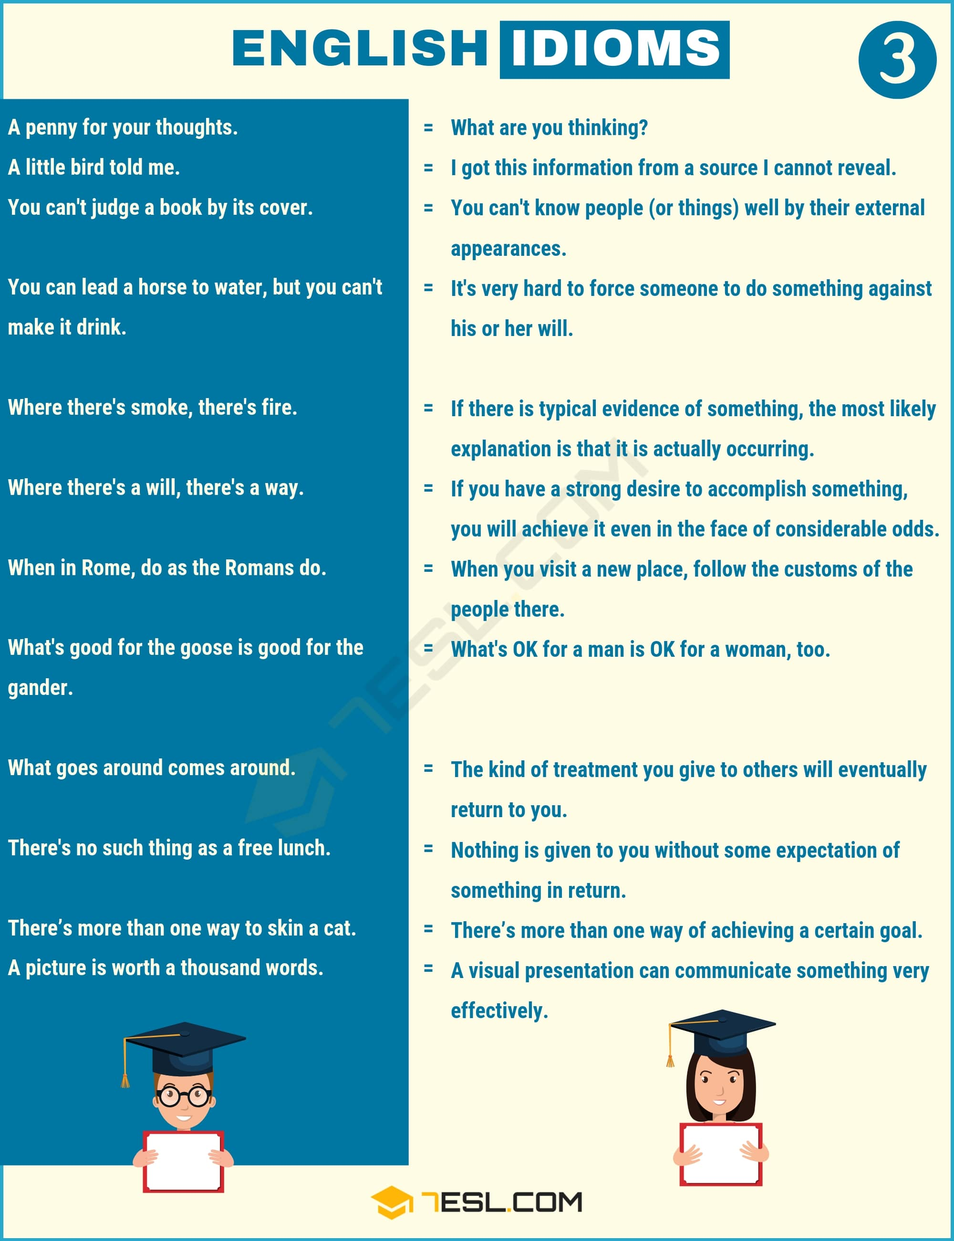Pin

Food Idioms Examples
List of food idiom examples with idiom meaning.
- The problem of how to motivate employees can be a tough nut to crack (a difficult problem) sometimes.
- Fred had egg on his face (embarrassed) after claiming he could climb the tree but then having to give up.
- James will tell you all about his adventures in Africa, but take it with a grain of salt (be skeptical).
- My new girlfriend is very intelligent. That she’s beautiful is just icing on the cake! (a bonus).
- I can’t help you with your presentation right now. I have bigger fish to fry (have more important things to do).
- I just have a lot on my plate (a lot to do) right now while I’m finishing up my degree and doing this huge project for work.
- I wouldn’t go out with him for all the tea in China! (great wealth).
- James is a bad egg (not to be trusted). Don’t trust him.
- Have you tried the new iPhone? It’s the greatest thing since sliced bread (an innovative development).
- My husband may not be the world’s most glamorous guy, but he brings home the bacon (earn money for the family).
- Amazon started out as a bookseller, but now they offer everything from soup to nuts (everything).
- We went to Mark’s Midtown for lunch. I had a grilled chicken sandwich, and it really hit the spot (very satisfying).
- You should apply to the university now. There are lots of reasons, but in a nutshell, it will end up costing
- I’m really in a pickle (in need of help). I spent all the money I had saved, and I have no way to pay next semester’s tuition bill.
- The kids are always nutty as fruitcakes (crazy) when they’ve had something sugary to eat.
- I’ve already done the difficult parts – finishing the presentation tonight will be a piece of cake (easily done).
- Nothing tastes better than fresh cinnamon rolls, served piping hot (very hot).
- Sam is rotten to the core (entirely evil). He steals, he lies, he’s violent. I’m glad he’s in prison.
- The new Honda is expected to sell like hotcakes (sold very quickly) after it’s released.
- We’re wasting our time on small potatoes (unimportant). Let’s get to the big news that made us have this meeting.
- We had planned this to be a surprise party for you, but Jason spilled the beans (reveal a secret).
- Our principal was a little lady, but she was one tough cookie! (a very determined person).

Fruit Idioms Examples
List of fruit idiom examples with idiom meaning.
- You only get a bite at the cherry (good opportunity) in life.
- Her cheeks were as red as a cherry (very red).
- Baseball is as American as apple pie (typically American).
- Tom is really a bad apple (a trouble making or dishonest person).
- Only the top banana (boss, leader) can make a decision of that magnitude.
- Sarah’s surprise party went pear-shaped (fail) once she accidentally found out about it.
- Do whatever you want, I do not give a fig (not care).

Dog Idioms Examples
List of dog idiom examples with idiom meaning.
- Every man and his dog (many people) wanted to interview me after I on the race.
- Those two fight like cat and dog (continually arguing with each other), so please don’t put them together on the project.
- I’ll be right back-I’ve got to go see a man about a dog (go to the bathroom).
- This has always been a nice hotel, but it’s going to the dogs (become disordered).
- At first my marriage was all puppies and rainbows (perfect), but then reality set in.
- I try to be strict with my daughter, but when she looks at me with those puppy dog eyes (a begging look), I buy her candy.

Cat Idioms Examples
List of cat idiom examples with idiom meaning.
- I’m going to try to squeeze in a cat nap (short sleep during the day) before my next shift starts, or else I’ll be feeling sluggish for the entire evening.
- Who will bell the cat (a difficult or impossible task) and take on the job of reducing corruption in this country?
- She’s waiting for the doctor to call with her test results, so she’s been like a cat on a hot tin roof all day (extremely nervous).
- Inside, there is no room to swing a cat (very small), and everything you see is the most basic junk.

Animal Idioms Examples
List of animals idiom examples with idiom meaning.
- Talk to Jon. He’s the big fish (important person) in the organization. He can help you get things done.
- Picking out this item or that for criticism seems unsportsmanlike, like shooting fish in a barrel (very easy).
- That’s just a fish story (a big lie). Don’t try to fool me.
- This game will be the quarterback’s swan song (a final appearance) – he’s retiring after this season.
- I was sick as a parrot (very disappointed) after Man United lost last night.
- I almost didn’t go on stage and perform tonight because I had butterflies in my stomach (nervous).
- I think this is a wild goose chase (an impossible task). This library doesn’t have the books we need.
- Glen is a lone wolf (not social) and seldom joins in the activities of the neightbourhood.
- When we got married, we were both poor as a church mouse (very poor) and we had to live with my husband’s parents.
- What happened when I asked for comments? Crickets (silence). So I assume you’re all satisfied with the proposal.
- My eagle-eyed (sharp vision) sister spotted the car in the parking lot before anyone else did.
- You’d better pay him more, or one day you’ll come to the office and find that he flew the coop (left).
- I’m afraid that if we don’t reduce staff, we’ll go belly up (go bankrupt) within a year.
- If you want to reach the island with the treasure, you’ve got to swim with sharks (take a major risk) for a while.
- You’re only 22-the world is your oyster (have many opportunities). Don’t feel you have to get married now.
- It may be very crowded in there. I’ll go and take a gander (take a look), and then I’ll send you a text message.
- If you wait for Jeb to finish his part of the project, you’ll be waiting till the cows come home (a long time).
- Sure, I’ll go out with Cynthia again. When pigs fly (never).

Family Idioms Examples
List of family idiom examples with idiom meaning.
- I have a bun in the oven (pregnant) again! Sophia will have a baby sister.
- Children will be admitted to the concert, but sorry, no babes in arms (a baby being carried).
- After learning to drive a stick shift, driving with an automatic transmission is child’s play (a very easy task).
- The poor baby has a face only a mother could love (a very ugly face).
- Big Brother (Government) seems to grow more and more powerful as data about individuals is accumulated on social networks.
- Just enter the update code, register the new software, and Bob’s your uncle (you’re almost finished).
- When you go on a trip, it’s important to buy souvenirs for your kith and kin (family) back home.
- Just watch. Getting her to go out with me will be like taking candy from a baby (very easy).
- I bought a ring, and I’m ready to pop the question (propose marriage) to Sophia.
- They hadn’t planned to get married, but Sophia found out she was up the duff (pregnant).

Body Idioms Examples
List of body idiom examples with idiom meaning.
- You shouldn’t buy a new car until you’ve paid off the debt from your student loan. Use your head! (think).
- It’s too bad you didn’t get the job, but keep your chin up (cheer up) – another one will come along.
- OK, I’ll tell you the secret about Cynthia, but zip your lip about it! (be quiet).
- The presentation will begin at 8 on the nose (precisely). Don’t miss it.
- The team was all eyes and ears (attentive) as the coach explained the challenges ahead.
- I don’t see eye to eye (agree) with Frances on the workflow, but she’s the boss.
- I know John is bad for me, but when I get a look at his baby blues (blue eyes) I can’t resist him.
- Why did you delete the file I was working on? I’m all ears (Listening willingly).
- Lend an ear (Listen), and I’ll tell you what people said at the meeting yesterday.
- This is especially used in hypothetical situations. If Joe asked me, I’d marry him in a heart beat! ( immediately).
- I like to keep my vocabulary at hand (nearby).
- Are there enough people on hand (available) to hold a meeting?
- Employee absenteeism has gotten out of hand (out of control).
- She’ll give you the name of a place to stay – she knows the area like the back of her hand (very well).
- Could you lend me a hand (help) with this piano?
- Tom was hands-down (obviously) the best student at the university.
- Shareholders pointed the finger at (blame) the board of directors for the losses, and voted most of them out.
- The exam’s at two. Will you keep your fingers crossed (wish for good luck) for me?
- We agreed we’d meet at the mall at 3. But you left me cooling my heels (wait) for two whole hours.
- Don’t trust Jack around your expensive glassware – he’s all thumbs (clumsy).
- It really pleased me that the boss gave me a thumbs-up (approval) on my presentation.
- I worry about my son. He’s smart enough to succeed, but he doesn’t have the fire in the belly (strong ambition).
- There I was, in my birthday suit (nakedness), when the doorbell rang.
- Three months ago Jack seemed to be at death’s door, but now he’s fit as a fiddle (in very good health) What happened?
- If you’re on a long drive, it’s helpful to stop and take forty winks (a short nap) every few hours if you can.

Business Idioms Examples
List of business idiom examples with idiom meaning.
- At first I wasn’t ready to accept your offer for the house. But you drive a hard bargain (negotiate effectively).
- Jennifer’s presentation was on point (well done) – concise, relevant, and accurate.
- The election is up for grabs (available). Everything is still very chancy.
- The salary increase is still up in the air (not yet decided) – the boss favors it, but she hasn’t gotten approval from her superiors.
- Sophia is in hot water (in trouble) with her department manager after she blew that sales presentation.
- I’ll be burning the midnight oil (working late ) tonight, but I guarantee I’ll finish the paper before class tomorrow at 9.
- I’ve been out of work (unemployed) since December. Hope I find a new job soon!

English Idioms | Images
We use idioms daily for several reasons. When used as either a part of a conversation or as a part of writing, idioms have a way of making what we are attempting to say better. Idiomatic phrases add color and poetry to what we say and what we write. They also give us a way to make the people on the other end listening think outside the box due to their figurative language. It makes people stop and think “what did they mean by that?” Some idioms even invoke laughter from the listener or reader by making them picture something that seems highly unlikely. Finally, the usage of idioms makes great comparisons and these unlikely comparisons can impress readers and listeners of our work alike.
List of English Idioms with Their Meanings | Image 1
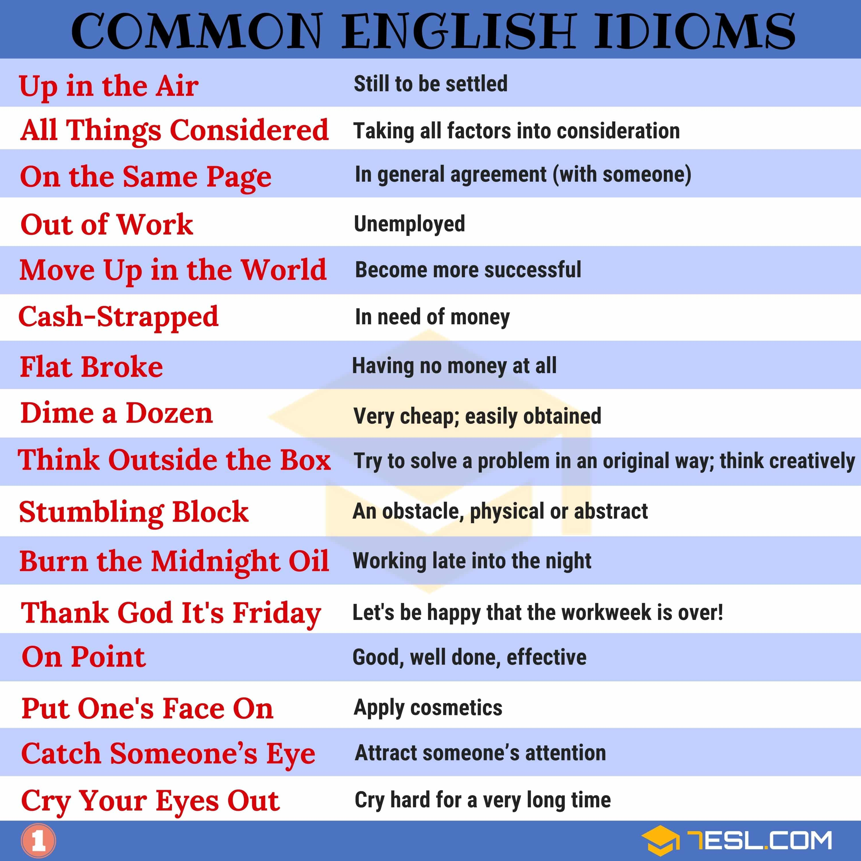Pin
Useful List of English Idioms with Their Meanings | Image 2
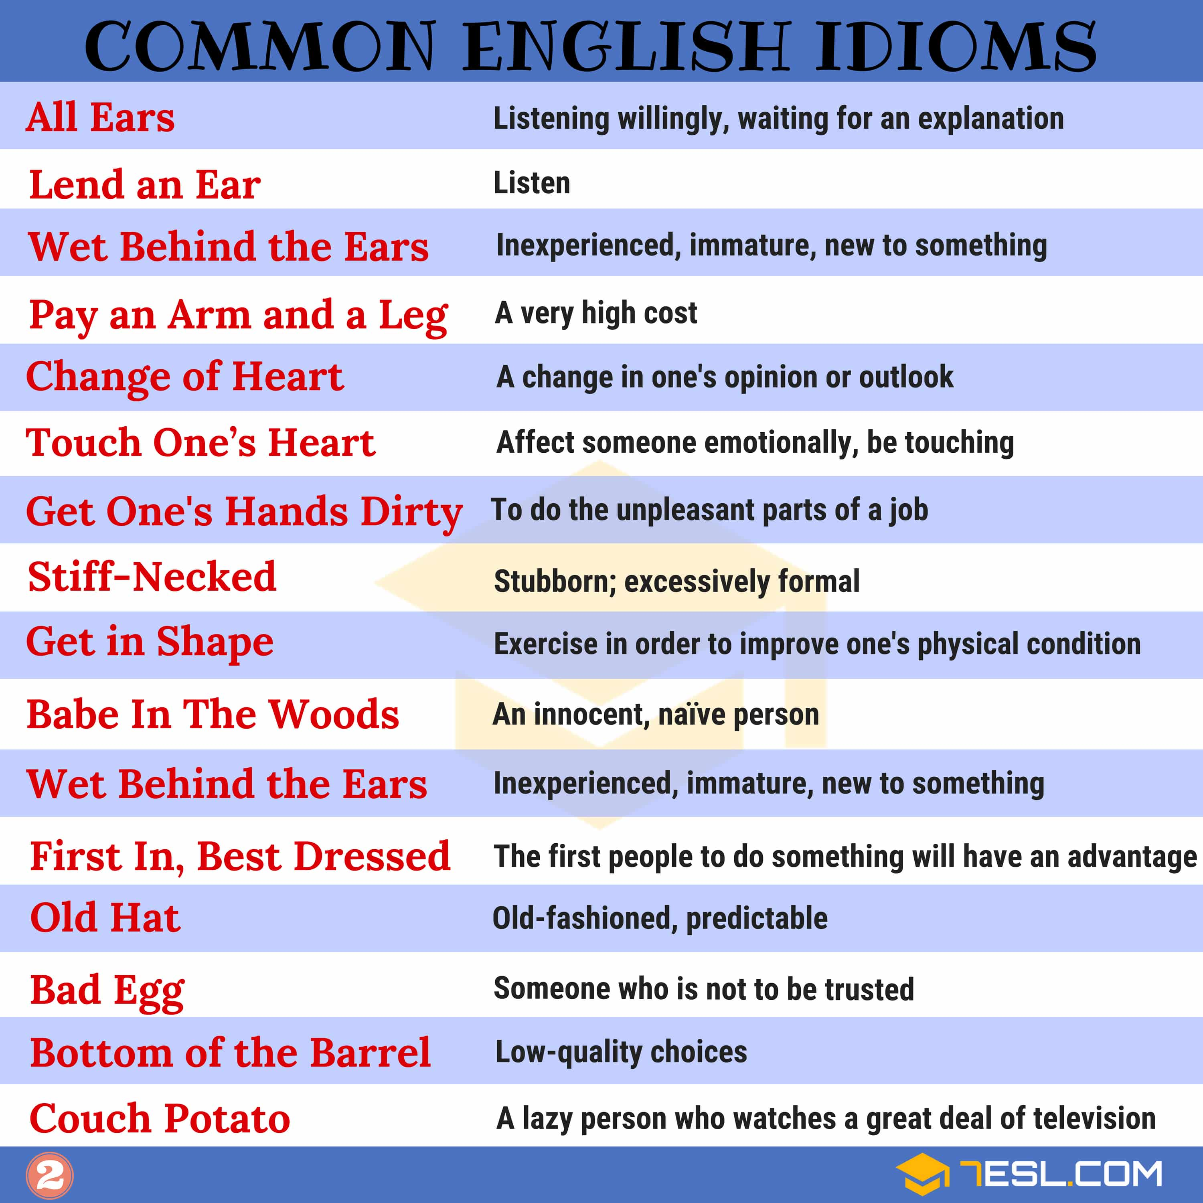Pin
List of Common English Idioms with Their Meanings | Image 3
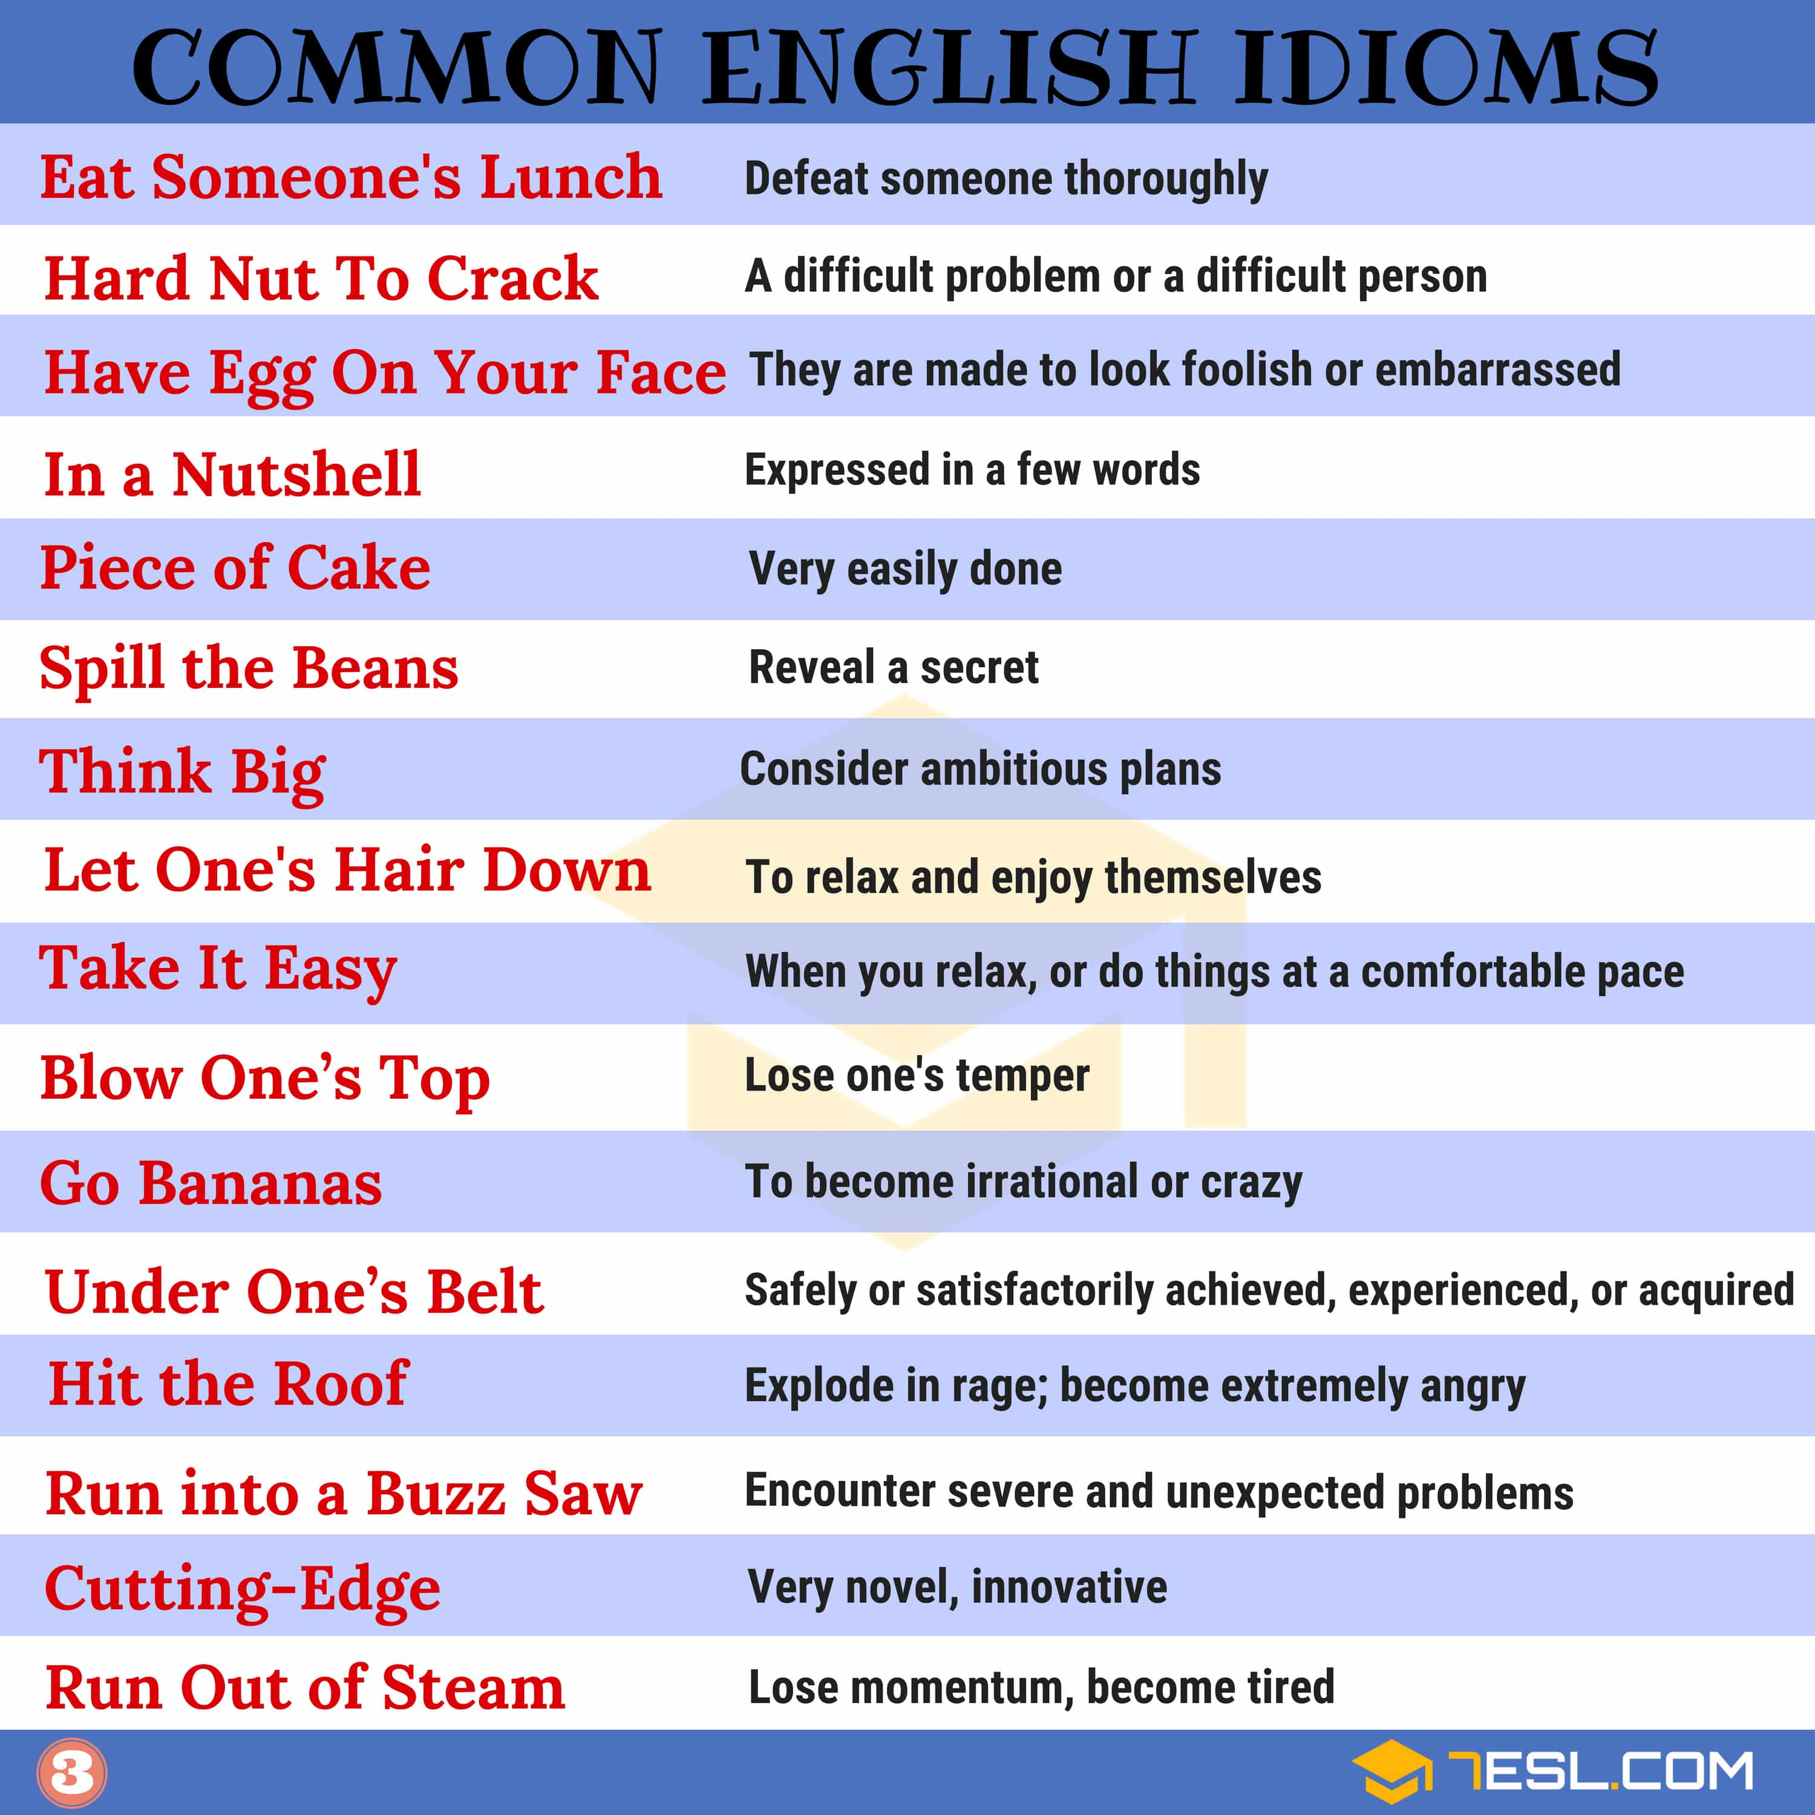Pin
Common English Idioms List with Meaning | Image 4
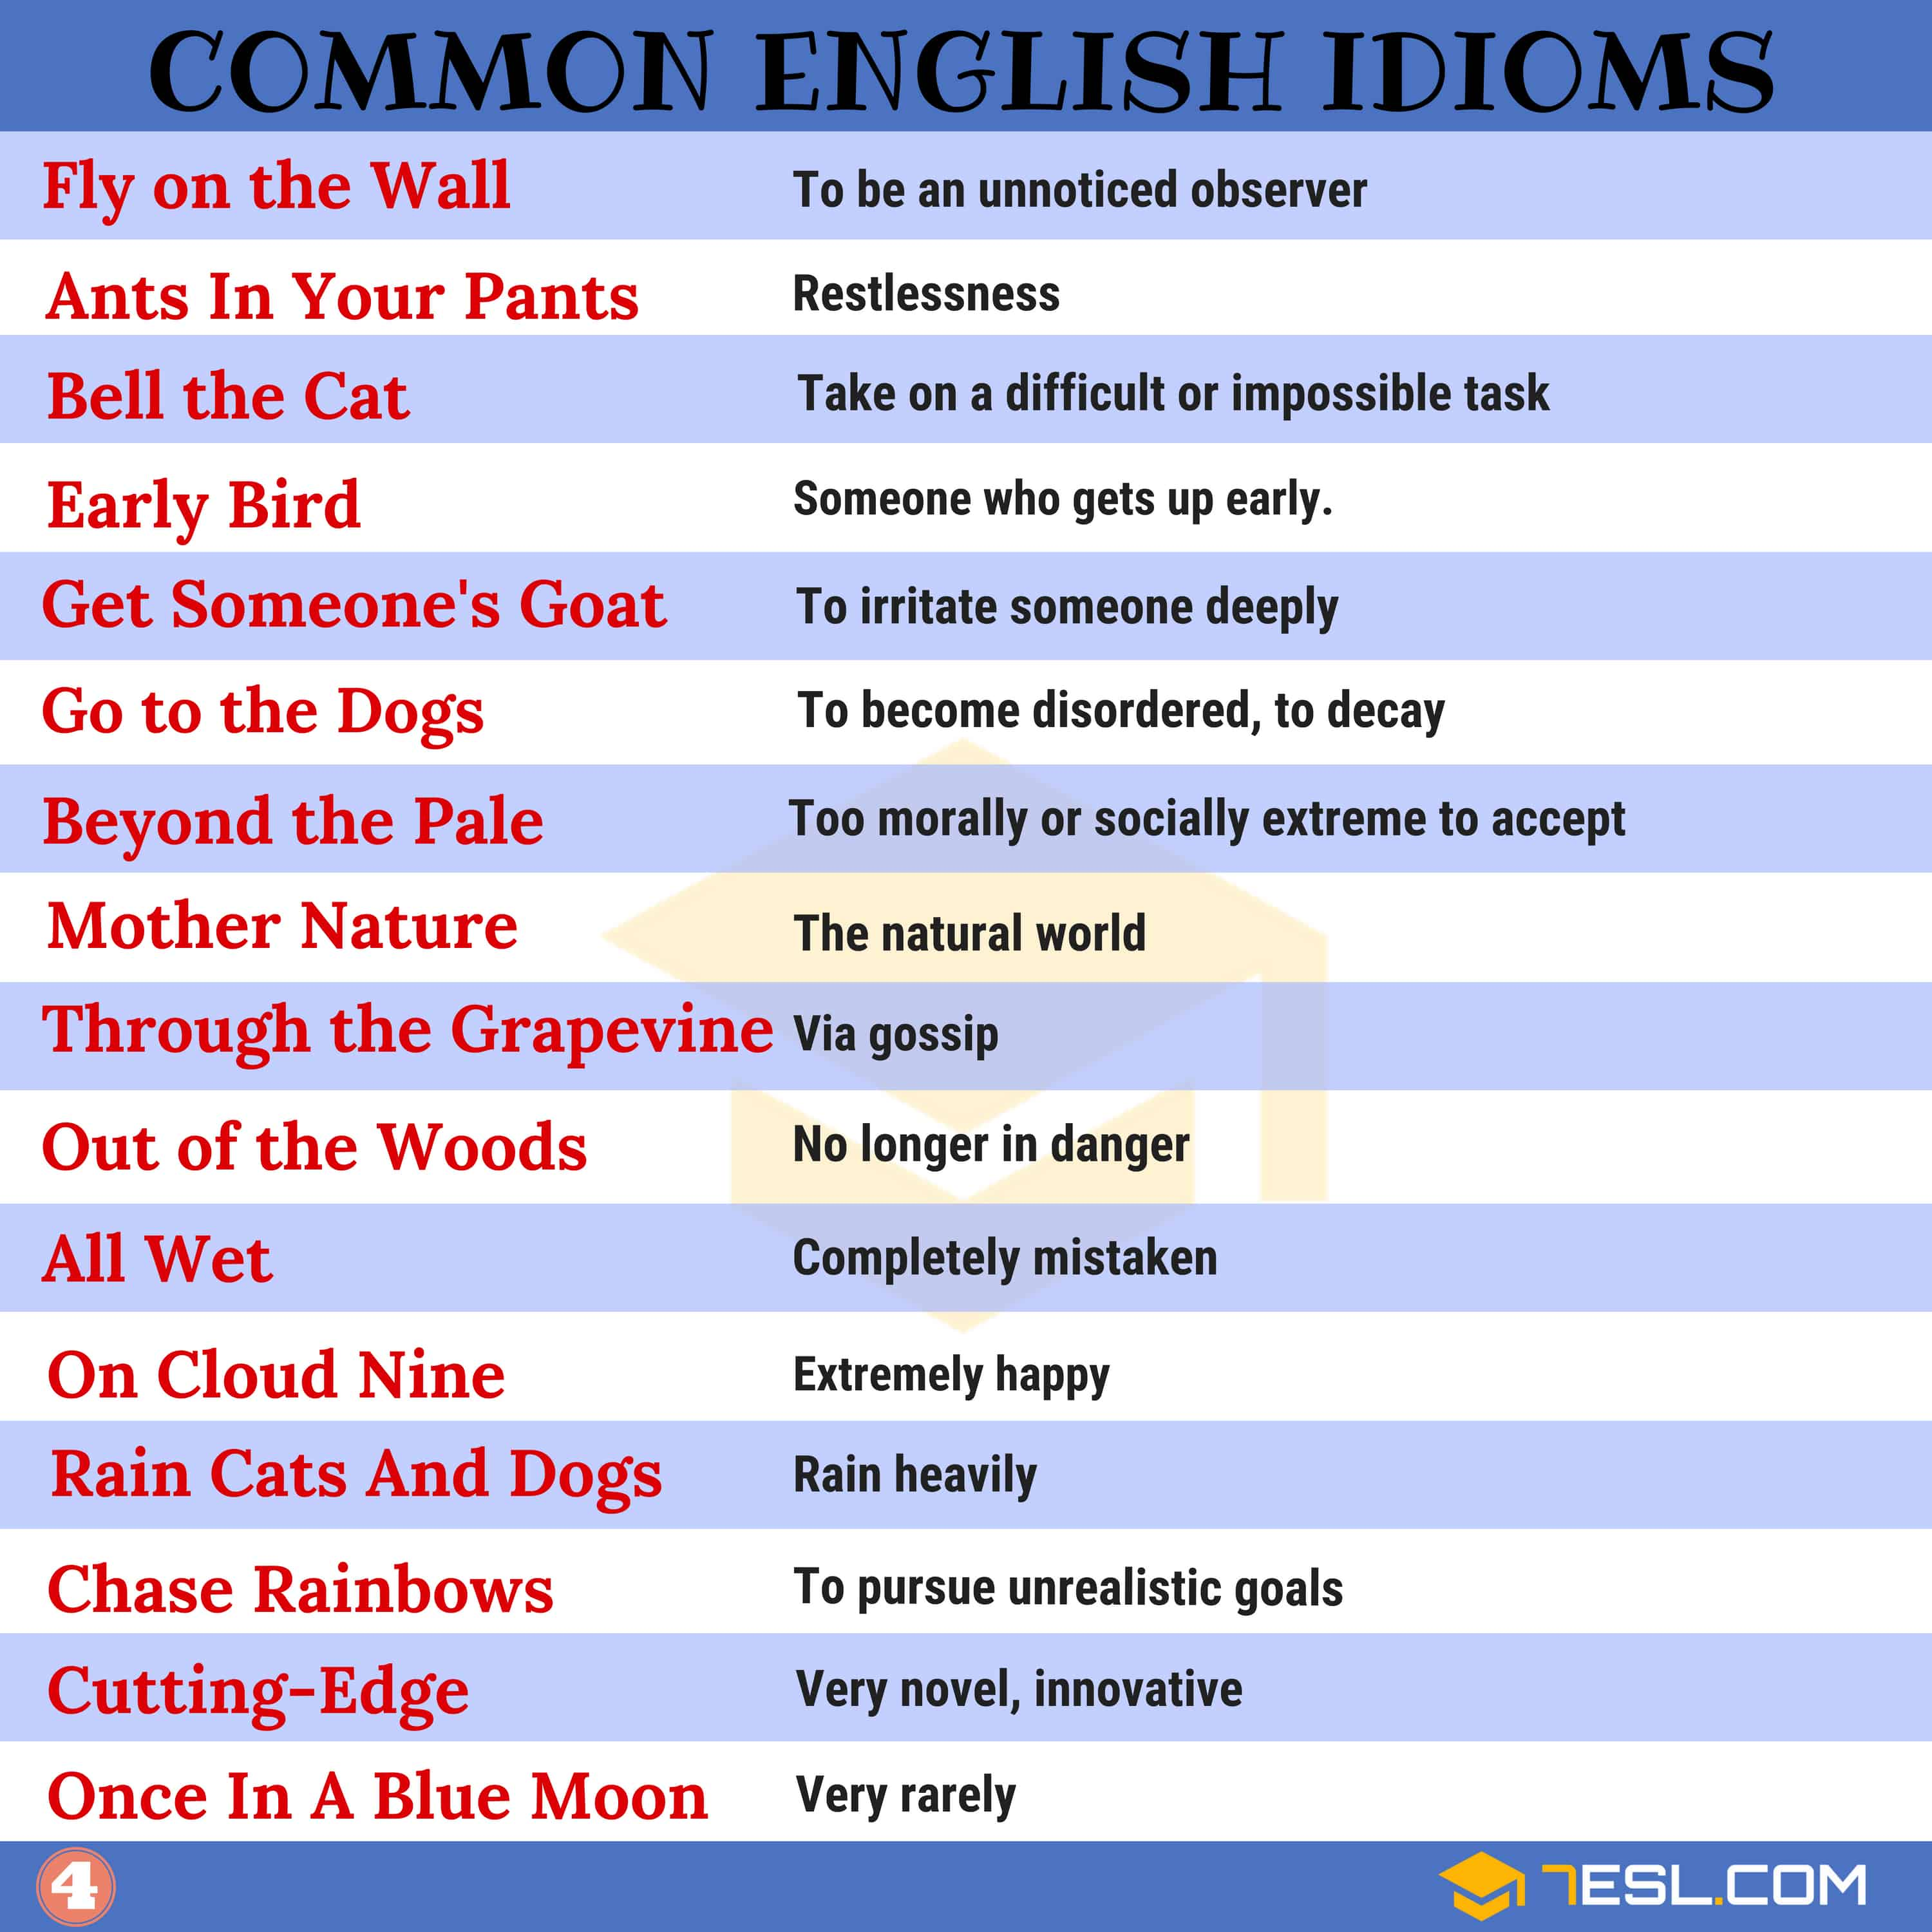Pin
Common English Idioms List with Meaning | Image 5
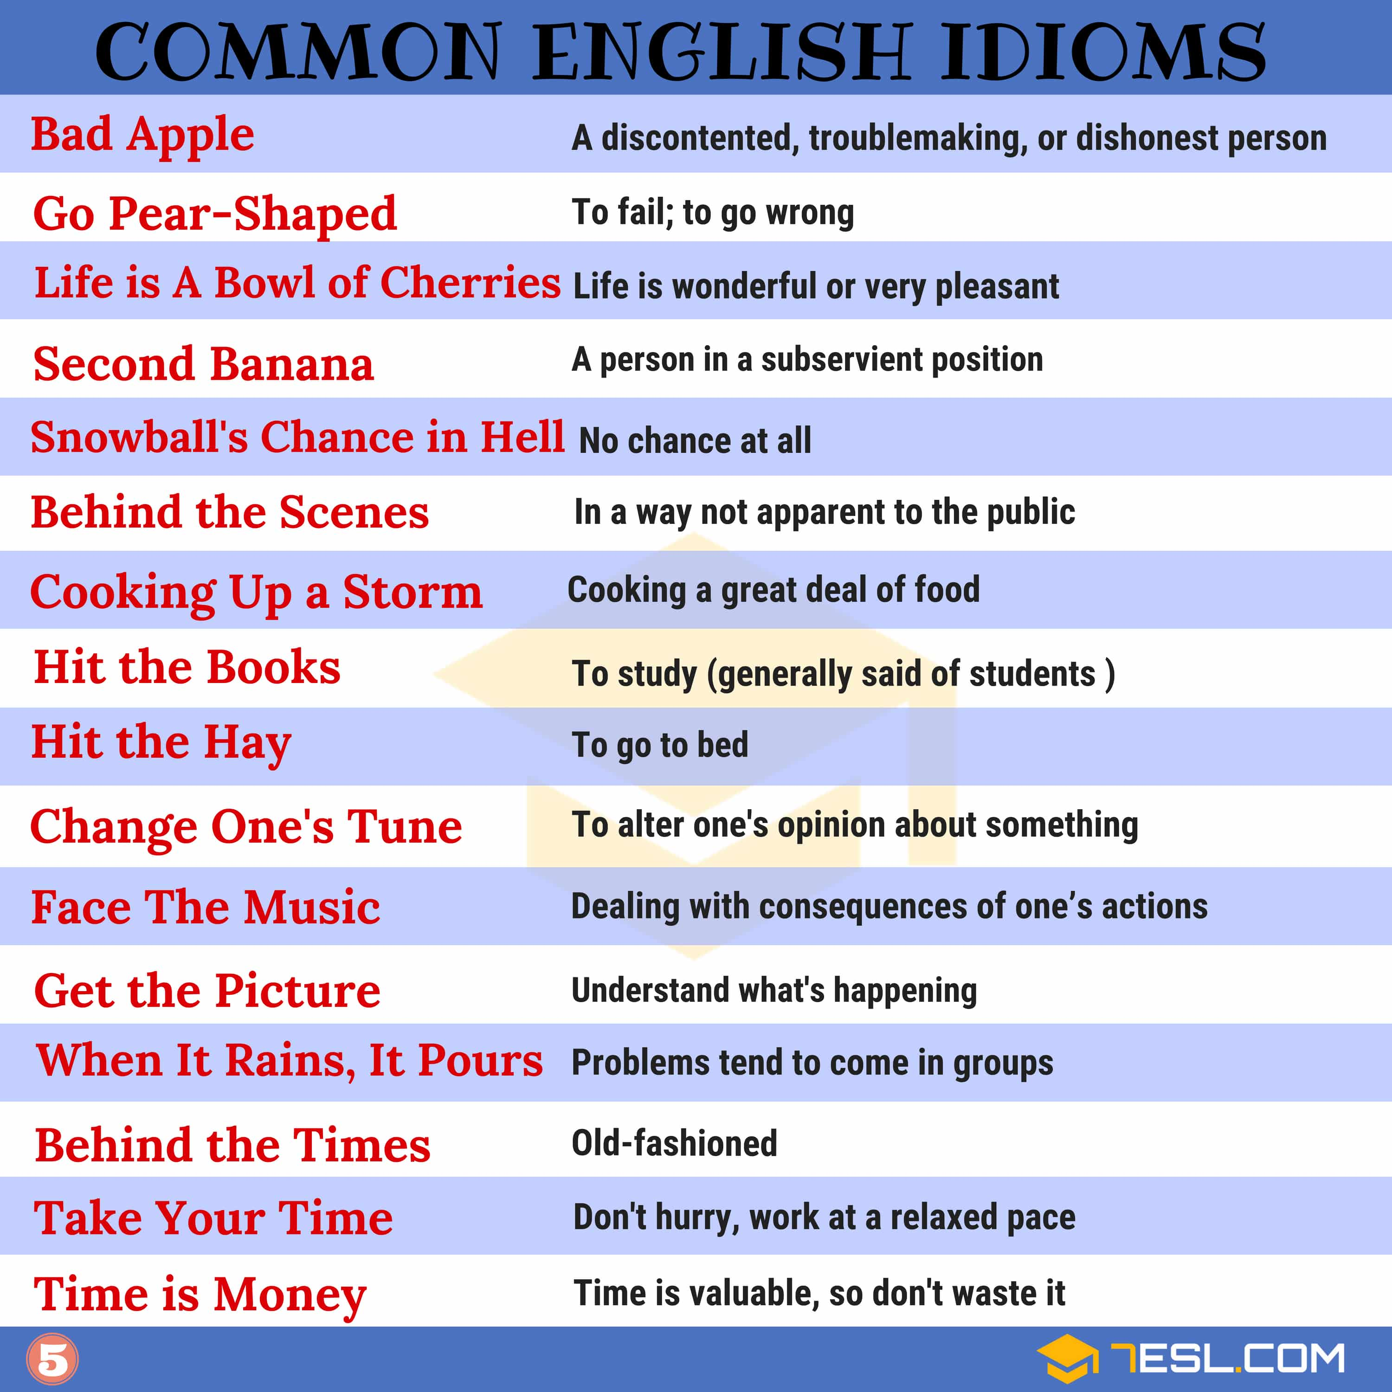Pin
English Idioms Examples with Idiom Meaning | Image 7
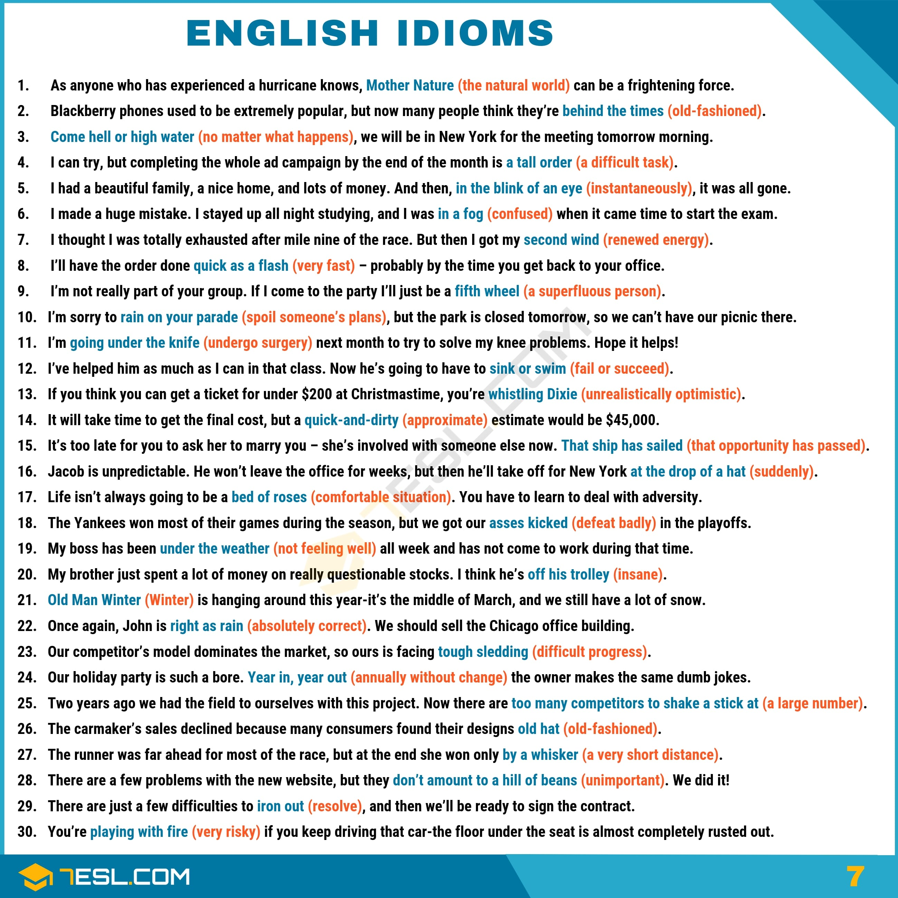Pin
Useful English Idioms Examples with Idiom Meaning | Image 8
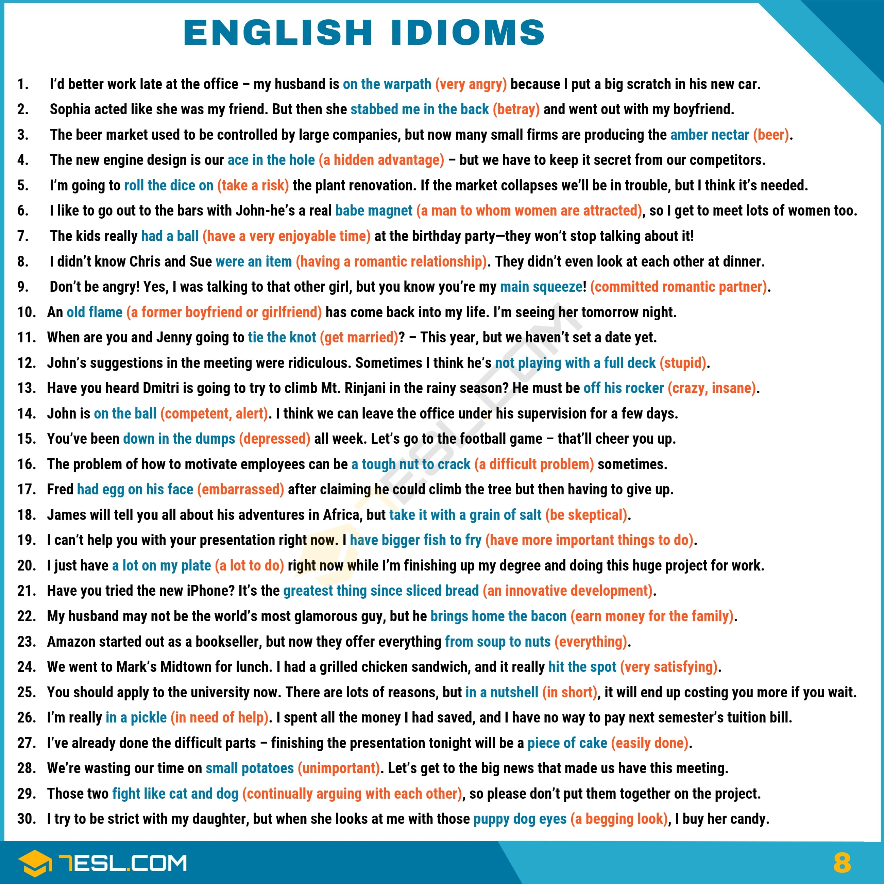Pin
English Idioms Examples with Idiom Meaning | Image 9
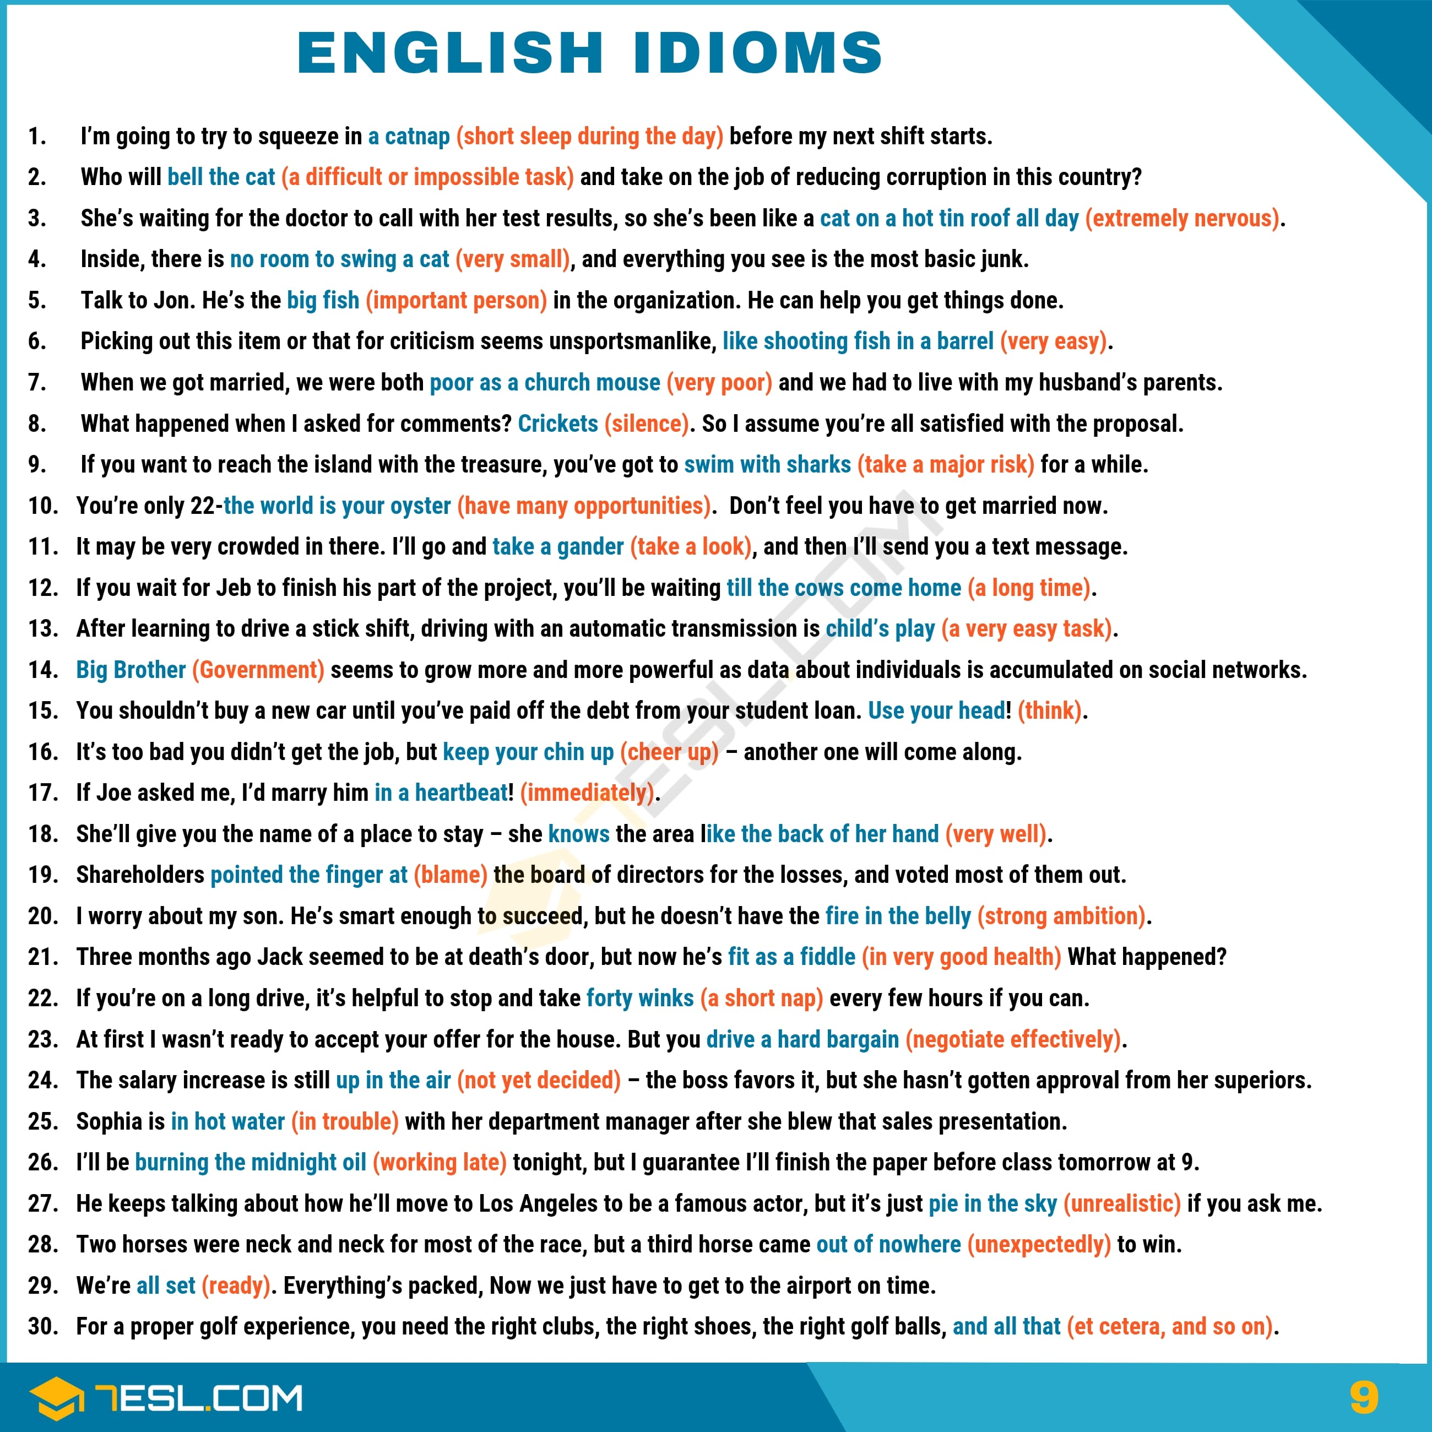Pin

Idiom Videos
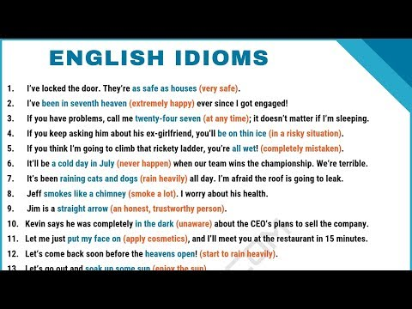
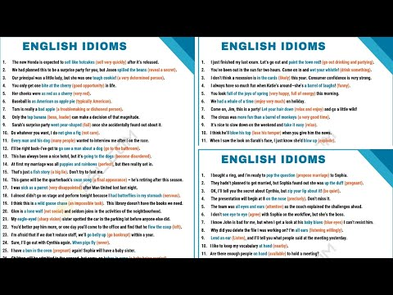

Idioms | Lessons
- Proverbs
- Idioms
  - Idiom Examples
  - 100 Common Idioms
  - 50 Examples of Idioms
  - Short Sayings
- American Idioms
- British Sayings & Idioms
- Animal Idioms
  - DOG Idioms
  - CAT Idioms
  - FISH Idioms
  - BIRD Idioms
- Business Idioms
  - Negotiation Idioms
  - Leadership Idioms
  - Idioms for Making Decisions
  - Problems & Difficulties Idioms
  - Schedules & Planning Idioms
  - Job Idioms
  - Money Idioms
  - Sales & Marketing Idioms
- Body Idioms
  - Head Idioms
  - Face Idioms
    - Nose Idioms
    - Eye Idioms
    - Ear Idioms
  - Heart Idioms
  - Hand Idioms
  - Finger Idioms
  - Foot Idioms
  - Other Body Part Idioms
- Food Idioms
  - Fruit Idioms
- Feelings & Emotions Idioms
  - Love Idioms
  - Happy Idioms
  - Crazy Idioms
- Idiomatic Expressions
  - Number Idioms
  - Time Idioms
  - Music Idioms
  - Sports Idioms
  - Clothes Idioms
  - Idioms about Measurement
  - Health Idioms
  - Weapons Idioms
  - Technology Idioms
  - Building Idioms
  - Home Idioms
  - Household Idioms
  - Construction Idioms
- Law & Politics Idioms
  - Law Idioms
  - Politics Idioms
- Family Idioms
  - Baby Idioms
  - Mother Idioms
- Social Life Idioms
  - Daily Routines Idioms
  - Conflict Idioms
  - Drinking Idioms
  - Gambling Idioms
  - Sexuality Idioms
- People Idioms
  - Personal Names Idioms
  - Appearance Idioms
  - Religion & Ethnicity Idioms
  - Death Idioms
  - Knowledge Idioms
  - Skill Idioms
  - Idioms about Thinking & Learning
- Nature Idioms
  - Plants and Flowers Idioms
  - Weather Idioms
  - Geographical Idioms
- Travel Idioms
  - CAR Idioms

Common Idioms
- Idioms List
- Idioms that Start with A
  - A Bridge Too Far
  - A Cup of Joe
  - A Picture Is Worth A Thousand Words
  - A Stitch In Time Saves Nine
  - A La Mode
  - Abandon All Hope Ye Who Enter Here:
  - Absence Makes the Heart Grow Fonder
  - Ace in the Hole
  - Achilles Heel
  - Actions Speak Louder Than Words
  - Ad Nauseum
  - Adam’s Apple
  - Against The Grain
  - Ahead of the Curve
  - Alas, Poor Yorick
  - All Hands on Deck
  - All Good Things Must Come To An End
  - All Ears Meaning
  - All Is Fair In Love And War
  - All in All
  - All That Glitters Is Not Gold
  - Apropos Of Nothing
  - Apple of my Eye
  - Around The Corner
  - Ask Not for Whom the Bell Tolls
  - As Such
  - Ay Caramba
  - Ashes to Ashes, Dust to Dust
- Idioms that Start with B
  - Back In The Saddle
  - Bad Apple
  - Ball And Chain
  - Baptism by Fire
  - Bane Of My Existence
  - Bag of Tricks
  - Bakers Dozen
  - Bated Breath
  - Bats in the Belfry
  - Bar None
  - Be Still My Heart
  - Be There or Be Square
  - Bear Necessities
  - Bete Noir
  - Benefit of the Doubt
  - Be All and End All
  - Beyond The Pale
  - Bearer Of Bad News
  - Beck And Call
  - Beware the Ides of March
  - Beauty Is in the Eye of the Beholder
  - Better Late Than Never
  - Bees Knees
  - Birds of A Feather Flock Together
  - Big Cheese
  - Birthday Suit
  - Body Politic
  - Bob’s Your Uncle
  - Bogged Down
  - Broken Glass
  - Bigger Fish To Fry
  - Bite The Bullet
  - Blank Check
  - Blood Is Thicker Than Water
  - Blow Me
  - Brownie Points
  - Bread and Butter
  - Break a Leg
  - Brevity Is the Soul of Wit
  - Bring Home the Bacon
  - Boo Boo the Fool
  - Buenas Tardes
  - Bully For You
  - Butt Of The Joke
  - Bust A Nut
  - Bury the Hatchet
  - Burning the Candle at Both Ends
  - Bushel And A Peck
  - By and Large
  - By Hook or By Crook
- Idioms that Start with C
  - Calm Before The Storm
  - Calm Your Tits
  - Carpe Diem
  - Cash and Carry
  - Case And Point
  - Case In Point
  - Cat Burglar
  - Cat’s in the Cradle
  - Catch 22
  - Caught Red Handed
  - Cakes And Ale
  - Change of Heart
  - Chalk and Cheese
  - Chalk It Up
  - Chip On Your Shoulder
  - Chock Full
  - Chop Chop
  - Cheaper by the Dozen
  - Cherchez La Femme
  - Check Out
  - Chicken Head
  - Cock and Bull
  - Cold Hearted
  - Cold Turkey
  - Conniption Fit
  - Cock Of The Walk
  - Clarion Call
  - Close Your Eyes and Think of England
  - Close But No Cigar
  - Cloud Nine
  - Cut and Dry
  - Cup of Tea
  - Curiosity Killed the Cat
  - Curry Favor
  - Crash and Burn
  - Crocodile Tears
  - Cream of the Crop
  - Cry Havoc and Let Slip the Dogs of War
- Idioms that Start with D
  - Damp Squib
  - Davy Jones Locker
  - Dead As A Doornail
  - Deal with It
  - Death and Taxes
  - Do A Barrel Roll
  - Do As I Say, Not As I Do
  - Don’t Let the Bastards Get You Down
  - Don’t Look A Gift Horse in the Mouth
  - Double Down
  - Double Entendre
  - Double Or Nothing
  - Double Edged Sword
  - Dollars to Donuts
  - Down The Rabbit Hole
  - Diamond In the Rough
  - Dressed to the Nines
  - Drop in the Bucket
  - Dumpster Fire
  - Dynamic Duo
- Idioms that Start with E
  - Eat Your Heart Out
  - Ebb And Flow
  - Elephant in the Room
  - Err on the Side of Caution
  - Et tu, Brute
  - Extenuating Circumstances
- Idioms that Start with F
  - Familiarity Breeds Contempt
  - Faint of Heart
  - Fait Accompli
  - Fair Share
  - Fair Winds and Following Seas
  - Fall Back
  - Faustian Bargain
  - Feeling Her Up
  - Fee Fi Fo Fum
  - Food for Thought
  - For Better or For Worse
  - Follow Suit
  - Foregone Conclusion
  - Fortune Favors The Bold
  - Fool Me Once
  - Fight Fire with Fire
  - Fingers Crossed
  - Fits And Starts
  - First Dibs
  - Flotsam and Jetsam
  - Flying by the Seat of My Pants
  - Fig Leaf
  - First and Foremost
  - Flashback Friday
- Idioms that Start with G
  - Gag Me With A Spoon
  - Get Down to Brass Tacks
  - Get Out Of Jail Free Card
  - Get Thee Behind Me, Satan
  - Get Out Of Dodge
  - Gung Ho
  - Giddy Up
  - Gird Your Loins
  - Glass Ceiling
  - Go Figure
  - Good Grief!
  - Going Postal
  - Great Minds Think Alike
  - Grasping At Straws
  - Green With Envy
- Idioms that Start with H
  - Hasta La Vista Baby
  - Hat Trick
  - Happy As A Clam
  - Hand Over Fist
  - Hang In There
  - Hand in Hand
  - Halcyon Days
  - Hair of the Dog
  - Have Fun
  - Head Over Heels
  - Heavens to Betsy
  - Heavens to Murgatroyd
  - Hell Hath No Fury Like A Woman Scorned
  - Heebie Jeebies
  - Hobson’s Choice
  - Hoi Polloi
  - Home Is Where The Heart Is
  - Hook, Line, And Sinker
  - Houston We Have A Problem
  - How You Doing
  - Hunky Dory
  - Hunker Down
  - Hustle And Bustle
- Idioms that Start with I
  - I Spy with My Little Eye
  - Ice Queen
  - If The Shoe Fits
  - I’ll Be Your Huckleberry
  - Ignorance Is Bliss
  - In Vino Veritas
  - Including But Not Limited To
  - In Memory Of
  - In Lieu Of
  - Indian Summer
  - Ins and Outs
  - In Tandem
  - In And Of Itself
  - Imitation Is the Sincerest Form of Flattery
  - It Was A Dark and Stormy Night
  - It Is What It Is
- Idioms that Start with J
  - Jack Of All Trades
  - Jump the Shark
  - Johnny On the Spot
- Idioms that Start with K
  - Kangaroo Court
  - Katy Bar the Door
  - Keep on Truckin’
  - Kiss My Ass
  - Knight in Shining Armor
  - Knick Knacks
  - Knock on Wood
  - Kit and Caboodle
  - Kilroy Was Here
- Idioms that Start with L
  - Layman’s Terms
  - Last But Not Least
  - Let There Be Light
  - Let Sleeping Dogs Lie
  - Let’s Get Down to Business
  - Lock, Stock and Barrel
  - Loose Lips Sink Ships
  - Lo And Behold
  - Lost In Translation
  - Lost in the Sauce
  - Long in the Tooth
  - Lickety Split
  - Lie Back and Think of England
  - Light At The End Of The Tunnel
  - Live Long and Prosper
  - Living the Dream
  - Life of Riley
- Idioms that Start with M
  - Maiden Voyage
  - May You Live in Interesting Times
  - Mea Culpa
  - Menage a Trois
  - Mind You
  - Misery Loves Company
  - Money Talks
  - Moot Point
  - Mortal Coil
  - Manna From Heaven
  - Me In My Place
  - Men in Suits
  - Measure Up
  - Mums the Word
  - Much Obliged
  - Mumbo Jumbo
  - My Cup Runneth Over
- Idioms that Start with N
  - Nasty, Brutish and Short
  - Neck Of The Woods
  - Needless To Say
  - Nip It In the Bud
  - No Man Is An Island
  - Not Safe For Work
  - No Rest for The Wicked
  - No Way Jose
  - Nuts And Bolts
- Idioms that Start with O
  - Off The Hook
  - Off The Beaten Path
  - Off Kilter
  - Okey Dokey
  - Olly Olly Oxen Free
  - On the Lam
  - On The Nose
  - On A Roll
  - On Track
  - On My Behalf
  - One Fell Swoop
  - Once in A Blue Moon
  - Open Sesame
  - Over A Barrel
  - Out Of The Blue
  - Over The Hill
- Idioms that Start with P
  - Passed Away
  - Paint the Town Red
  - Patience of Job
  - Par For The Course
  - Pearls Before Swine
  - Penny for Your Thoughts
  - Physician, Heal Thyself
  - Pipe Dream
  - Piqued My Interest
  - Piss and Vinegar
  - Pie In The Sky
  - Play It By Ear
  - Pomp and Circumstance
  - Pound Sand
  - Pound of Flesh
  - Practice Makes Perfect
  - Preaching to the Choir
  - Procrustean Bed
  - Ps and Qs
  - Pyrrhic Victory
- Idioms that Start with Q
- Idioms that Start with R
  - Raining Cats and Dogs
  - Rain Check
  - Red in Tooth and Claw
  - Reach For The Stars
  - Reap What You Sow
  - Rest Assured
  - Revenge Is A Dish Best Served Cold
  - Riled Up
  - Rose Colored Glasses
  - Rose Tinted Glasses
  - Rock The Boat
  - Rooting For You
  - Round Robin
  - Rule of Thumb
- Idioms that Start with S
  - Salad Days
  - Sally Port
  - Salt of the Earth
  - Sea Change
  - Seize The Day
  - Second To None
  - Shave and A Haircut
  - Shit from Shinola
  - Short End of the Stick
  - Shot In The Dark
  - Shed Some Light
  - Silver Bullet
  - Silver Tongue
  - Silver Lining
  - Silence is Golden
  - Slings And Arrows
  - Skinny Dipping
  - Sleep Tight
  - Snow Bunny
  - Soup To Nuts
  - So to Speak
  - So As To
  - Spur of the Moment
  - Stay Tuned
  - Standing on the Shoulders of Giants
  - Stocking Feet
  - Sticky Wicket
  - Stupid Is As Stupid Does
  - Suspension of Disbelief
  - Survival of the Fittest
  - Suck It Meaning
  - Suss Out
  - Sweet Nothings
  - Swipe Right
  - Swipe Left
- Idioms that Start with T
  - Take Care
  - Take for Granted
  - Take It with a Grain of Salt
  - Taken Aback
  - Tear Apart
  - Tee Off
  - That’s All Folks
  - The Wages of Sin Is Death
  - The World Is Your Oyster
  - The Road to Hell Is Paved with Good Intentions
  - The Whole Shebang
  - The Best Laid Plans of Mice and Men
  - The Whole Nine Yards
  - There But For the Grace of God Go I
  - There’s The Rub
  - The Buck Stops Here
  - Thick as Thieves
  - Three Sheets to the Wind
  - Thumbs Up
  - Thus Far
  - Tit for Tat
  - Tight Ass
  - Tilting At Windmills
  - Time Flies
  - Tie the Knot
  - To A Tee
  - To No Avail
  - To Each Their Own
  - To Each His Own
  - Touching Cloth
  - Tongue in Cheek
  - Tooth and Nail
  - Tools Of The Trade
  - Tow The Line
  - Trials And Tribulations
  - Tried And True
  - Two Peas In A Pod
- Idioms that Start with U
  - Upside Down
  - Uncle Dick
  - Under The Weather
  - Up the Ante
  - Up To Par
- Idioms that Start with V
  - Vice Versa
  - Vim And Vigor
  - Vis a Vis
- Idioms that Start with W
  - Walk The Plank
  - Walk Softly and Carry a Big Stick
  - Wax Poetic
  - Way to Go
  - We Was Robbed
  - White Elephant
  - When It Rains It Pours
  - Winner Winner Chicken Dinner
  - Wing It Meaning
  - Woot Woot
  - Woe Is Me
  - Womp Womp
  - Wolf in Sheep’s Clothing
  - Writ Large
  - Wrapped Around Your Finger
  - Wreak Havoc
- Idioms that Start with Y
  - You Are What You Eat
  - You Don’t Say
  - You Got Me There
  - Youth Is Wasted on the Young
- Idioms that Start with Z
CategoriesEnglish Idioms, Editor Picks
Subscribe

